《JSP程序设计》

实验作品

作品题目： 课表查询系统

院 系： 计算机与信息科学学院

专 业： 软件工程

学 号： 021321752215

姓 名： 舒洪凡

二零二一年十二月

**实验作品评分参考标准表**

|  |  |
| --- | --- |
| **评分标准及分值** | **得分** |
| **选题符合课程内容范围要求（10分）** |  |
| **设计思路和内容具有独特性（10分）** |  |
| **作品设计结构合理、功能完整（40分）** |  |
| **具有一定的实用研究价值（15分）** |  |
| **内容上无明显抄袭现象（15分）** |  |
| **图表格式正确，书写格式规范（10分）** |  |
| **合 计（100分）** |  |

**课表查询系统**

**摘要：**本作品主要实现了一个课表查询系统，采用了SSM（Spring + SpringMVC + MyBatis）的基础架构。后端使用Maven 进行包管理，使用spring-boot框架、模板引擎使用thymeleaf、web模块使用springMVC、数据库连接池使用Druid、数据库访问使用mybatis-plus、工具包使用hutool。前端使用H-ui模板，结合Timetables展示课程表。系统能够实现用户的登录退出，教室、班级、院系、地点、教工、学生、用户、课程、课程表的分页展示、增加、删除（批量）、修改、根据条件查询，排课（课程表增删改查）、课程表通过表格展示（可以通过教师、班级、学年、学期进行筛选）。并且使用拦截器通过session判断用户是否登录。

**目 录**

第一章 作品概述 1

第二章 作品设计 2

2.1作品的构思 2

2.1.1 起源 2

2.1.2 总体架构 2

2.2作品使用的第三方库 3

第三章 作品的实现 4

3.1作品框架 4

3.1.1 数据库设计 4

3.2作品实现要点 12

3.2.1 用户登录模块 12

3.2.2 教务管理系统首页 17

3.2.3 教室模块 23

3.2.4 班级模块 30

3.2.5 院系模块 37

3.2.6 地点模块 43

3.2.7 教工模块 49

3.2.8 用户模块 58

3.2.9 课程模块 72

3.2.10 课程表模块 78

3.2.11 拦截器模块 99

3.2.12 学生模块 102

第四章 总结 111

# 第一章 作品概述

本作品是一个前后端不分离的课程表查询系统，基于SSM（Spring + SpringMVC + MyBatis），拥有信息管理和课表展示功能。

后端使用spring-boot作为基础，使用thymeleaf（基于Servlet）作为服务器端Java模板引擎。使用SpringMVC（spring内置的MVC框架，底层就是Servlet，它解决WEB开发中常见的问题(参数接收、文件上传、表单验证、国际化等等)，而且使用简单，与Spring无缝集成。支持 RESTful风格的URL请求）解决页面代码和后台代码的分离，降低代码的耦合性。使用mybatis-plus（一个 Mybatis 的增强工具，在 Mybatis 的基础上只做增强不做改变，为简化开发、提高效率而生），它已经封装好了一些crud方法，我们不需要再写xml了，直接调用这些方法就行，就类似于JPA。数据库使用MySQL数据库，数据库数据库连接池使用druid(Druid为监控而生的数据库连接池, 是Java语言中最好的数据库连接池)。使用Lombok在JavaBean中通过添加注解的方式，不需要为类编写getter/setter方法,也不需要编写构造器、equals等方法，同时可以自动化日志变量。同时引用hutool工具包，它能为我们自动生成验证码、格式化日期以及简化JDBC的操作。

前台使用H-ui 前端框架模板，它包含后台基本的增删改查页面，我们只要使用thymeleaf模板引擎循环替换H-UI模板的内容，并且更改静态文件路径，在springMVC的控制器中注册路由并且返回页面就能使用浏览器正常访问。课表的展示使用Timetables.js插件，它通过传入一个二维数组来展示课表，发送ajax请求从服务器获取课程表调用change方法进行展示。

系统能够实现用户的登录退出，教室、班级、院系、地点、教工、学生、用户、课程、课程表的分页展示、增加、删除（批量）、修改、根据条件查询，排课（课程表增删改查）、课程表通过表格展示（可以通过教师、班级、学年、学期进行筛选）。并且使用拦截器通过session判断用户是否登录，未登录用户跳转到登录页面。

# 第二章 作品设计

## 2.1作品的构思

### 2.1.1 起源

本作品为了方便学生和老师查询课程表信息，并管理和修改自己的信息。方便对全校的教室、院系、地点、学生、班级、老师、课程、课程表信息进行管理，并通过图表的方式进行查看。

### 2.1.2 总体架构

本作品整体结构如图2.1所示。实现用户的登录退出，教室、班级、院系、地点、教工、学生、用户、课程、课程表的分页展示、增加、删除（批量）、修改、根据条件查询，排课（课程表增删改查）、课程表通过表格展示（可以通过教师、班级、学年、学期进行筛选）。并且使用拦截器通过session判断用户是否登录，未登录用户跳转到登录页面。

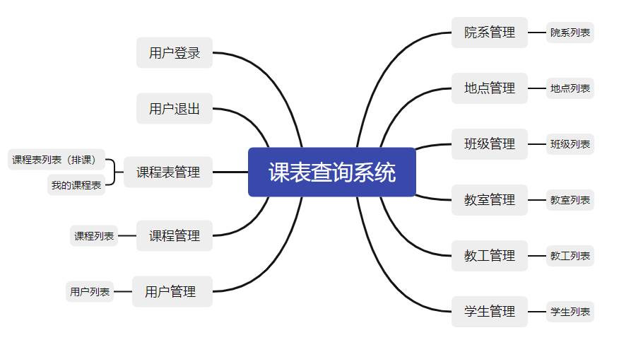

**图2.1 总体架构图**

## 2.2作品使用的第三方库

本作品使用的第三方库包括

1. spring-boot
2. spring-MVC
3. thymeleaf
4. mybatis-plus
5. druid
6. Lombok
7. Hutool
8. H-ui
9. Timetables.js

# 第三章 作品的实现

## 3.1作品框架

### 3.1.1 数据库设计

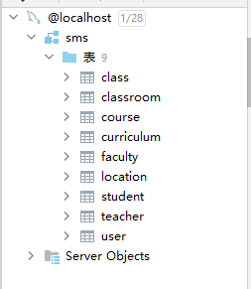

**图3.1 数据库总体架构图**

本课程表系统包含9张表名称如图3.1所示。数据表设计按照第一范式设计，要求字段是对属性的原子性约束，要求属性具有原子性，不可再分解；

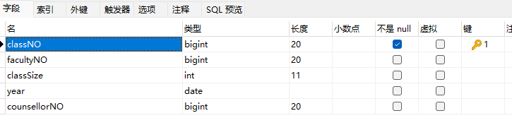

**图3.1.1 班级表字段**

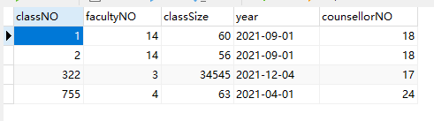

**图3.1.2 班级表数据**

班级表包括5个字段，字段如图3.1.1所示，部分数据如图3.12所示。分别为班级编号（classNO）、院系编号（facultyNO）、班级人数（classSize）、入学年份（year）、辅导员姓名（counsellorNO），院系编号和辅导员分别为院系表和教师表的外键。

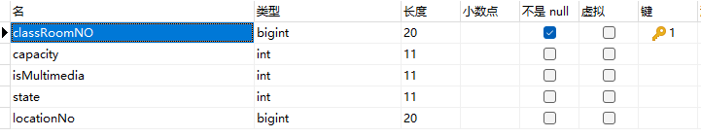

**图3.1.3 教室表字段**

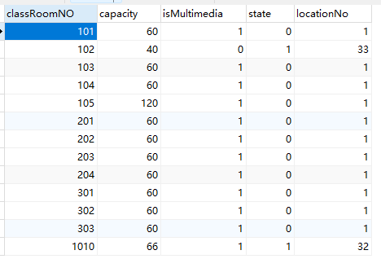

**图3.1.4 教室表数据**

教室包括5个字段，字段如图3.1.3所示，部分数据如图3.1.4所示。分别为教室编号（classRoomNO）、教室容量（capacity）、是否多媒体教室（isMultimedia）、教室状态（state）、教室地点（locationNo），教室地点为为教室表的外键。

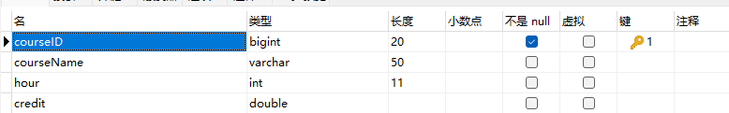

**图3.1.5 课程表字段**

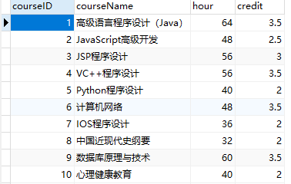

**图3.1.6 课程表数据**

课表表包括4个字段，字段如图3.1.5所示，部分数据如图3.1.6所示。分别为课程编号（courseID）、课程名称（courseName）、学时（hour）、学分（credit）。

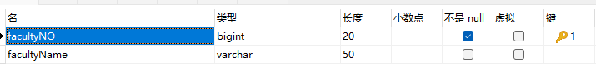

**图3.1.7 院系表字段**

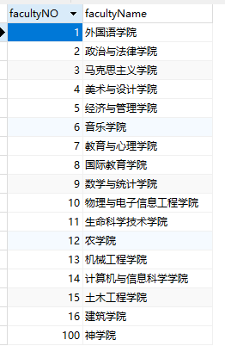

**图3.1.8 院系表数据**

院系表包括2个字段，字段如图3.1.7所示，部分数据如图3.1.8所示。分别为院系编号（facultyNO）、院系名称（facultyName）。

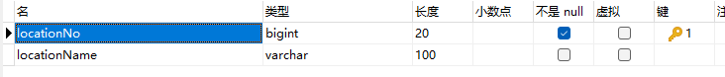

**图3.1.9 地点表字段**

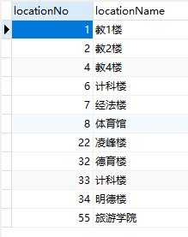

**图3.1.10 地点表数据**

地点表包括2个字段，字段如图3.1.9所示，部分数据如图3.1.10所示。分别为地点编号（locationNo）、地点名称（locationName）。

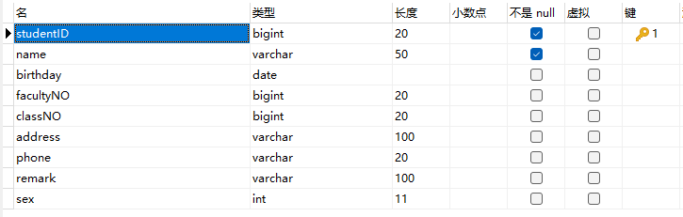

**图3.1.11 学生表字段**

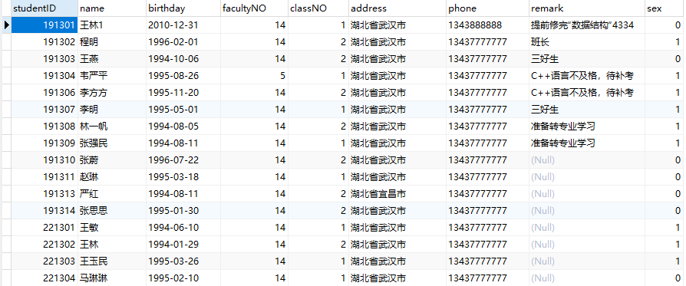

**图3.1.12 学生表数据**

学生表包括9个字段，字段如图3.1.11所示，部分数据如图3.1.12所示。分别为学号（studentID）、姓名（name）、性别（sex）、出生日期（birthday）、院系（facultyNO）、班级（classNO）、家庭地址（address）、联系电话（phone）、备注（remark），其中院系、班级字段分别为院系表和班级表的外键。

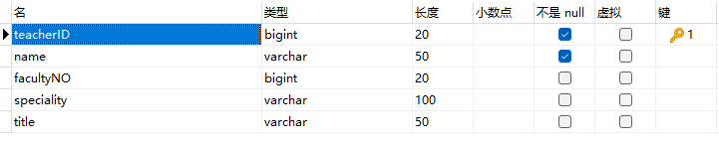

**图3.1.13 教师表字段**

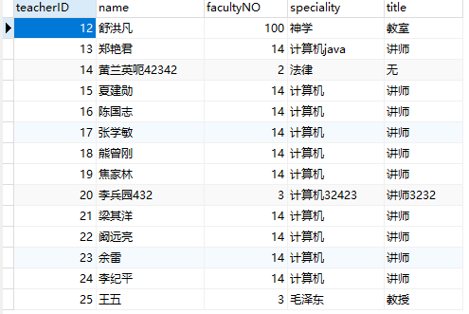

**图3.1.14 教师表数据**

教师表包括5个字段，字段如图3.1.13所示，部分数据如图3.1.14所示。分别为教工编号（teacherID）、姓名（name）、院系号（facultyNO）、主页方向（speciality）、职称（title），其中院系为院系表的外键。

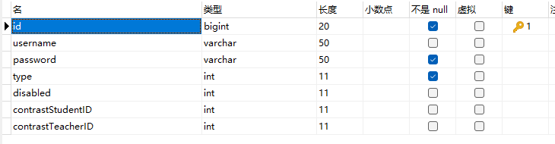

**图3.1.15 用户表字段**

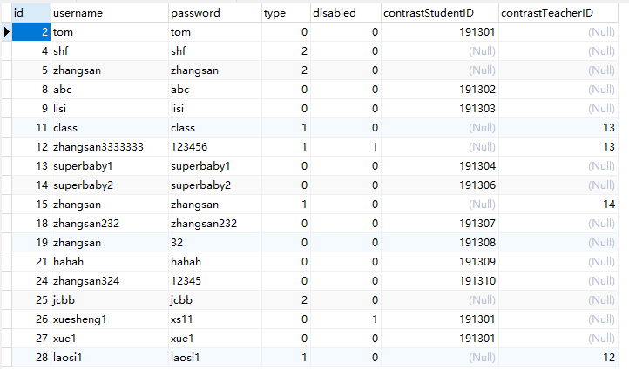

**图3.1.16 用户表数据**

用户表包括7个字段，字段如图3.1.15所示，部分数据如图3.1.16所示。分别为用户ID（id）、登录名（username）、密码（password）、用户类型【0学生 1老师 2管理员】（type）、是否启用【0启用1禁用】（disabled）、对应学生学号（contrastStudentID）、对应老师工号（contrastTeacherID），其中对应学生学号、对应老师工号字段分别为学生表和教师表的外键。

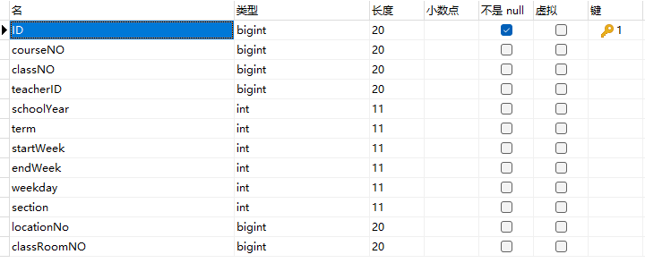

**图3.1.17 课程表 表字段**

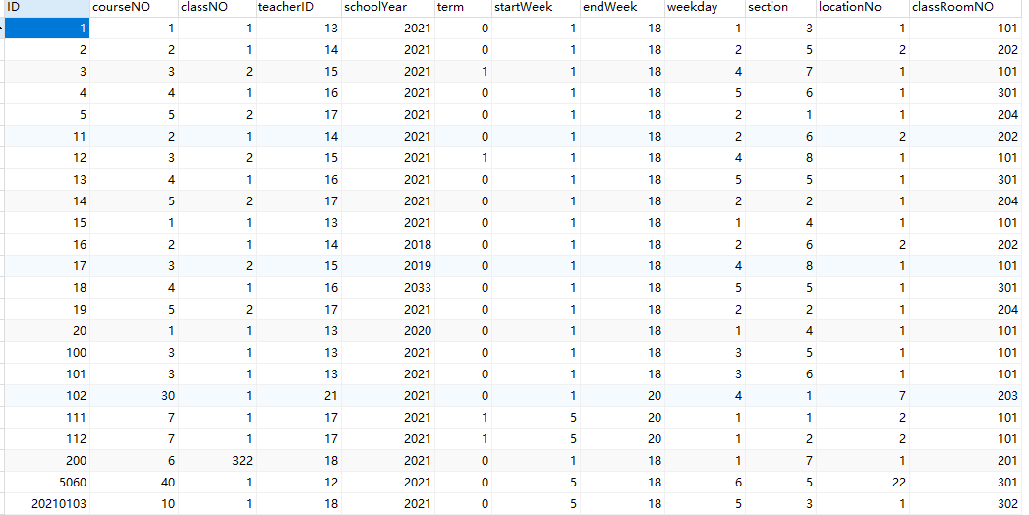

**图3.1.18 课程表 表数据**

课程表表包括12个字段，字段如图3.1.17所示，部分数据如图3.1.18所示。分别为排课（ID）、课程ID（courseNO）、班级ID（classNO）、授课教师ID（teacherID）、开课学年（schoolYear）、学期【上学期0 下学期1】（term）、开课星期（startWeek）、结课星期（endWeek）、上课星期几（weekday）、第几节课上课（section）、地点ID（locationNo）、教室ID（classRoomNO），其中课程ID、班级ID、授课教师ID、教室ID、地点ID字段分别为课程表、班级表、教师表、教室表、地点表的外键。

## 3.2作品实现要点

### 3.2.1 用户登录模块

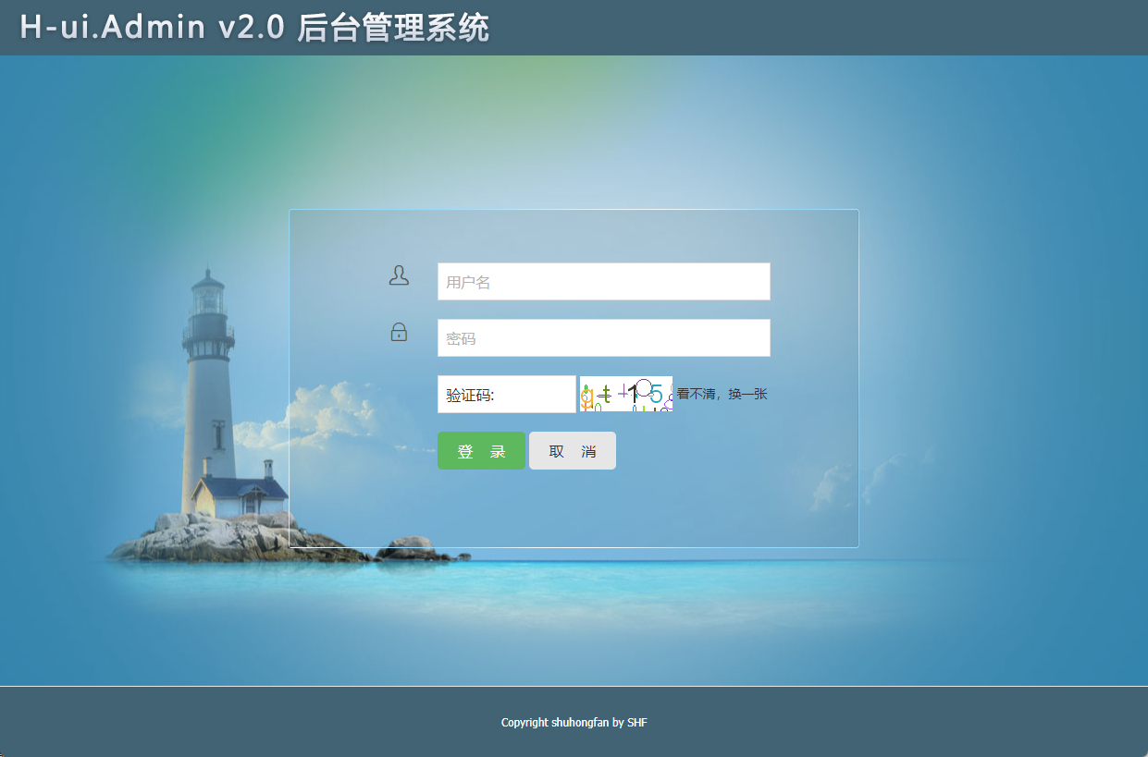

**图3.2.1.1 用户登录**



**图3.2.1.2 用户登录验证码错误**

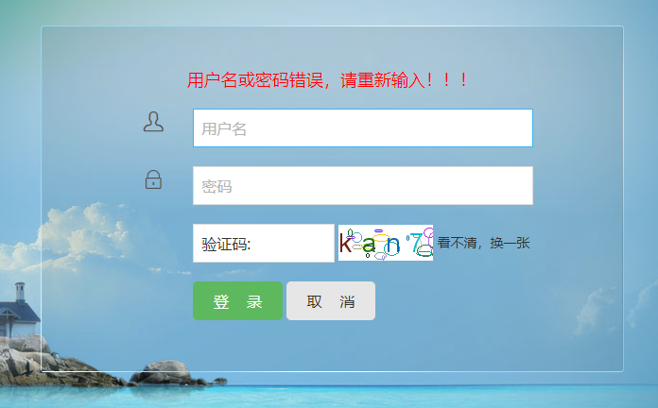

**图3.2.1.3 用户登录用户名或密码错误**

LoginController.java

@Slf4j  
@Controller  
public class LoginController *{* @Autowired  
 private UserMapper userMapper;  
  
 @Autowired  
 private StudentController studentController;  
  
 @Autowired  
 private TeacherController teacherController;  
  
 @GetMapping*(*"/login"*)* public String toLogin*(){* return "login";  
 *}* @PostMapping*(*"/login"*)* public String login*(*User user, HttpSession httpSession, Model model*){  
 log*.info*(*String.*valueOf(*user*))*;  
*// 验证码是否匹配* if *(*user.getCaptcha*()*.equalsIgnoreCase*((*String*)* httpSession.getAttribute*(*"SESSION_KEY_IMAGE_CODE"*))) {  
// 用户是否存在* QueryWrapper*<*User*>* userQueryWrapper = new QueryWrapper*<>()*;  
 userQueryWrapper.eq*(*"username", user.getUsername*())*;  
 User u1 = userMapper.selectOne*(*userQueryWrapper*)*;  
 *log*.info*(*String.*valueOf(*u1*))*;  
 if *(*u1 != null*){  
 // 用户存在 判断密码是否一致* if *(*u1.getPassword*()*.equals*(*user.getPassword*())){* if *(*u1.getDisabled*()*==0*){* model.addAttribute*(*"info","登录成功！！！"*)*;  
 User u = userMapper.selectOne*(*new QueryWrapper*<*User*>()*.eq*(*"username",user.getUsername*()))*;  
 u.setPassword*(*"******"*)*;  
 if *(*u.getContrastStudentID*()*!=null*){* Student student = studentController.getStudentById*(*u.getContrastStudentID*())*;  
 u.setClassNO*(*student.getClassNO*())*;  
 u.setContrastStudentName*(*student.getName*())*;  
 *}* if *(*u.getContrastTeacherID*()*!=null*){* Teacher teacher = teacherController.getTeacherById*(*u.getContrastTeacherID*())*;  
 u.setContrastTeacherName*(*teacher.getName*())*;  
 *}* httpSession.setAttribute*(*"USER",u*)*;  
 return "redirect:index";  
 *}* else *{* model.addAttribute*(*"info","用户已被禁用，请联系管理员！！！"*)*;  
 return "login";  
 *}  
 }* else *{* model.addAttribute*(*"info","用户名或密码错误，请重新输入！！！"*)*;  
 return "login";  
 *}  
 }* else *{  
// 用户不存在* model.addAttribute*(*"info","用户名或密码错误，请重新输入！！！"*)*;  
 return "login";  
 *}  
 }* else *{* model.addAttribute*(*"info","验证码错误，请重新输入！！！"*)*;  
 return "login";  
 *}  
 }  
}*

CaptchaController.java 验证码控制器

@Controller  
@Slf4j  
public class CaptchaController *{* public final static String *SESSION_KEY_IMAGE_CODE* = "SESSION_KEY_IMAGE_CODE";  
  
 @GetMapping*(*"/captcha"*)* public void createCode*(*HttpServletRequest request, HttpServletResponse response*)* throws IOException *{  
 //设置response响应* response.setCharacterEncoding*(*"UTF-8"*)*;  
 response.setHeader*(*"Pragma", "No-cache"*)*;  
 response.setHeader*(*"Cache-Control", "no-cache"*)*;  
 response.setDateHeader*(*"Expires", 0*)*;  
 response.setContentType*(*"image/jpeg"*)*;  
  
 *//定义图形验证码的长、宽、验证码字符数、干扰元素个数* CircleCaptcha captcha = CaptchaUtil.*createCircleCaptcha(*100, 38, 4, 20*)*;  
 System.*out*.println*(*captcha.getCode*())*;  
 *//将验证码放到HttpSession里面* request.getSession*()*.setAttribute*(SESSION_KEY_IMAGE_CODE*, captcha.getCode*())*;  
 *log*.info*(*"本次生成的验证码为：" + captcha.getCode*()* + ",已存放到HttpSession中"*)*;  
  
 *//图形验证码写出，可以写出到文件，也可以写出到流  
 //输出浏览器* OutputStream out = response.getOutputStream*()*;  
 captcha.write*(*out*)*;  
 out.flush*()*;  
 out.close*()*;  
 *}  
}*

### 3.2.2 教务管理系统首页



**图3.2.2 管理员用户首页**



**图3.2.3 学生用户首页**



**图3.2.3 教师用户首页**

Indext.html 部分代码

*<*aside class="Hui-aside"*>  
 <*div th:if="*${*session.USER.type==2*}*" class="menu_dropdown bk_2"*>  
 <*dl id="menu-article"*>  
 <*dt*><*i class="Hui-iconfont"*>*&#xe616;*</*i*>* 教室管理*<*i class="Hui-iconfont menu_dropdown-arrow"*>*&#xe6d5;*</*i*></*dt*>  
 <*dd*>  
 <*ul*>  
 <*li*><*a th:data-href="@{/classRoom/classRoomListPage}" data-title="教室列表" href="javascript:void(0)"*>*教室列表*</*a*></*li*>  
 </*ul*>  
 </*dd*>  
 </*dl*>  
 <*dl id="menu-picture"*>  
 <*dt*><*i class="Hui-iconfont"*>*&#xe613;*</*i*>* 班级管理*<*i class="Hui-iconfont menu_dropdown-arrow"*>*&#xe6d5;*</*i*></*dt*>  
 <*dd*>  
 <*ul*>  
 <*li*><*a th:data-href="@{/class/classListPage}" data-title="班级列表" href="javascript:void(0)"*>*班级列表*</*a*></*li*>  
 </*ul*>  
 </*dd*>  
 </*dl*>  
 <*dl id="menu-product"*>  
 <*dt*><*i class="Hui-iconfont"*>*&#xe620;*</*i*>* 院系管理*<*i class="Hui-iconfont menu_dropdown-arrow"*>*&#xe6d5;*</*i*></*dt*>  
 <*dd*>  
 <*ul*>  
 <*li*><*a th:data-href="@{/faculty/facultyListPage}" data-title="院系列表" href="javascript:void(0)"*>*院系列表*</*a*></*li*>  
 </*ul*>  
 </*dd*>  
 </*dl*>  
 <*dl id="menu-comments"*>  
 <*dt*><*i class="Hui-iconfont"*>*&#xe622;*</*i*>* 地点管理*<*i class="Hui-iconfont menu_dropdown-arrow"*>*&#xe6d5;*</*i*></*dt*>  
 <*dd*>  
 <*ul*>  
 <*li*><*a th:data-href="@{/location/locationListPage}" data-title="地点列表" href="javascript:;"*>*地点列表*</*a*></*li*>  
 </*ul*>  
 </*dd*>  
 </*dl*>  
 <*dl id="menu-teacher"*>  
 <*dt*><*i class="Hui-iconfont"*>*&#xe60d;*</*i*>* 教工管理*<*i class="Hui-iconfont menu_dropdown-arrow"*>*&#xe6d5;*</*i*></*dt*>  
 <*dd*>  
 <*ul*>  
 <*li*><*a th:data-href="@{/teacher/teacherListPage}" data-title="教工列表" href="javascript:;"*>*教工列表*</*a*></*li*>  
 </*ul*>  
 </*dd*>  
 </*dl*>  
 <*dl id="menu-student"*>  
 <*dt*><*i class="Hui-iconfont"*>*&#xe60d;*</*i*>* 学生管理*<*i class="Hui-iconfont menu_dropdown-arrow"*>*&#xe6d5;*</*i*></*dt*>  
 <*dd*>  
 <*ul*>  
 <*li*><*a th:data-href="@{/student/studentListPage}" data-title="学生列表" href="javascript:;"*>*学生列表*</*a*></*li*>  
 </*ul*>  
 </*dd*>  
 </*dl*>  
 <*dl id="menu-admin"*>  
 <*dt*><*i class="Hui-iconfont"*>*&#xe62d;*</*i*>* 用户管理*<*i class="Hui-iconfont menu_dropdown-arrow"*>*&#xe6d5;*</*i*></*dt*>  
 <*dd*>  
 <*ul*>  
 <*li*><*a th:data-href="@{/user/userListPage}" data-title="用户列表" href="javascript:void(0)"*>*用户列表*</*a*></*li*>  
 </*ul*>  
 </*dd*>  
 </*dl*>  
 <*dl id="menu-tongji"*>  
 <*dt*><*i class="Hui-iconfont"*>*&#xe61a;*</*i*>* 课程管理*<*i class="Hui-iconfont menu_dropdown-arrow"*>*&#xe6d5;*</*i*></*dt*>  
 <*dd*>  
 <*ul*>  
 <*li*><*a th:data-href="@{/course/courseListPage}" data-title="课程列表" href="javascript:void(0)"*>*课程列表*</*a*></*li*>  
 </*ul*>  
 </*dd*>  
 </*dl*>  
 <*dl id="menu-system"*>  
 <*dt*><*i class="Hui-iconfont"*>*&#xe62e;*</*i*>* 课程表管理*<*i class="Hui-iconfont menu_dropdown-arrow"*>*&#xe6d5;*</*i*></*dt*>  
 <*dd*>  
 <*ul*>  
 <*li*><*a th:data-href="@{/curriculum/curriculumListPage}" data-title="课程表列表" href="javascript:void(0)"*>*课程表列表*</*a*></*li*>  
 <*li*><*a th:data-href="@{/curriculum/myCurriculumPage}" data-title="我的课程表" href="javascript:void(0)"*>*我的课程表*</*a*></*li*>  
 </*ul*>  
 </*dd*>  
 </*dl*>  
 </*div*>  
 <*div th:if="*${*session.USER.type!=2*}*" class="menu_dropdown bk_2"*>  
 <*dl id="menu-article2"*>  
 <*dt*><*i class="Hui-iconfont"*>*&#xe616;*</*i*>* 课程表管理*<*i class="Hui-iconfont menu_dropdown-arrow"*>*&#xe6d5;*</*i*></*dt*>  
 <*dd*>  
 <*ul*>  
 <*li*><*a th:data-href="@{/curriculum/myCurriculumPage}" data-title="我的课程表" href="javascript:void(0)"*>*我的课程表*</*a*></*li*>  
 </*ul*>  
 </*dd*>  
 </*dl*>  
 <*dl th:if="*${*session.USER.type==1*}*" id="menu-teacher2"*>  
 <*dt*><*i class="Hui-iconfont"*>*&#xe60d;*</*i*>* 教工管理*<*i class="Hui-iconfont menu_dropdown-arrow"*>*&#xe6d5;*</*i*></*dt*>  
 <*dd*>  
 <*ul*>  
 <*li*><*a th:data-href="@{/teacher/teacherPage?teacherID=}+${session.USER.contrastTeacherID}" data-title="教工列表" href="javascript:;"*>*教工列表*</*a*></*li*>  
 </*ul*>  
 </*dd*>  
 </*dl*>  
 <*dl th:if="*${*session.USER.type==0*}*" id="menu-student2"*>  
 <*dt*><*i class="Hui-iconfont"*>*&#xe60d;*</*i*>* 学生管理*<*i class="Hui-iconfont menu_dropdown-arrow"*>*&#xe6d5;*</*i*></*dt*>  
 <*dd*>  
 <*ul*>  
 <*li*><*a th:data-href="@{/student/studentPage?studentID=}+${session.USER.contrastStudentID}" data-title="学生列表" href="javascript:;"*>*学生列表*</*a*></*li*>  
 </*ul*>  
 </*dd*>  
 </*dl*>  
 <*dl id="menu-system2"*>  
 <*dt*><*i class="Hui-iconfont"*>*&#xe62e;*</*i*>* 用户信息管理*<*i class="Hui-iconfont menu_dropdown-arrow"*>*&#xe6d5;*</*i*></*dt*>  
 <*dd*>  
 <*ul*>  
 <*li*><*a th:data-href="@{/user/userPage?username=}+${session.USER.username}" data-title="用户信息" href="javascript:void(0)"*>*用户信息*</*a*></*li*>  
 </*ul*>  
 </*dd*>  
 </*dl*>  
 </*div*>  
</*aside*>*

IndexController.java 首页控制器

@Controller  
public class IndexController *{* @GetMapping*(*value = *{*"/","/index"*})* public String index*(){* return "index";  
 *}* @GetMapping*(*"/welcome"*)* public String welcome*(){* return "welcome";  
 *}  
  
}*

LogoutController.java 用户退出登录

@Controller  
public class LogoutController *{* @GetMapping*(*"/logout"*)* public String logout*(*HttpSession session*){* session.removeAttribute*(*"USER"*)*;  
 return "login";  
 *}  
}*

### 3.2.3 教室模块

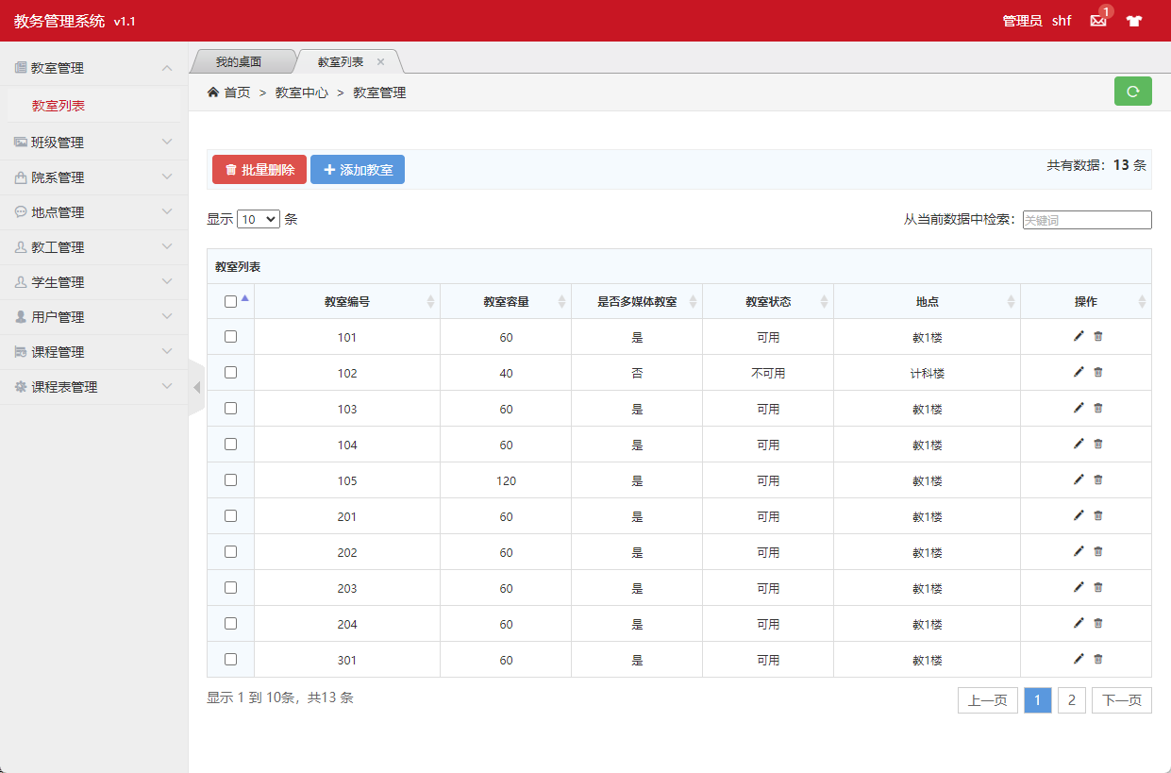

**图3.2.3.1 教室分页列表页面**

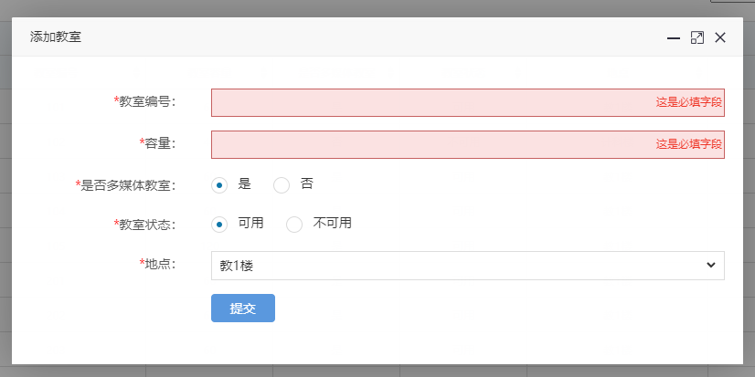

**图3.2.3.2 添加教室页面**

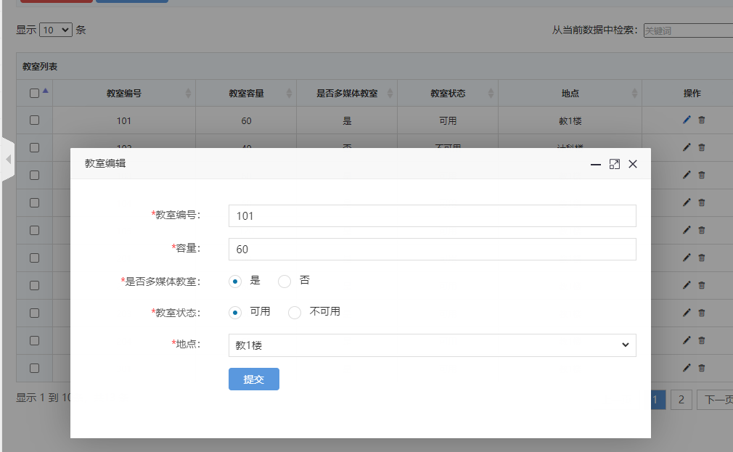

**图3.2.3.3 编辑教室页面**

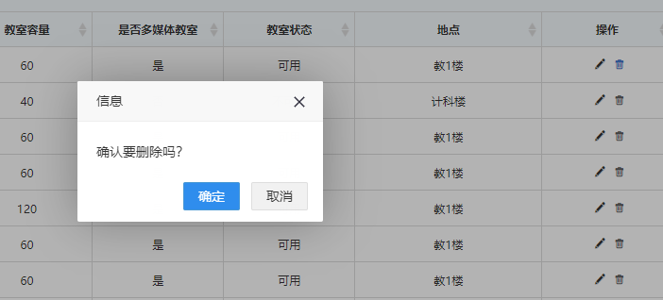

**图3.2.3.3 删除教室页面**

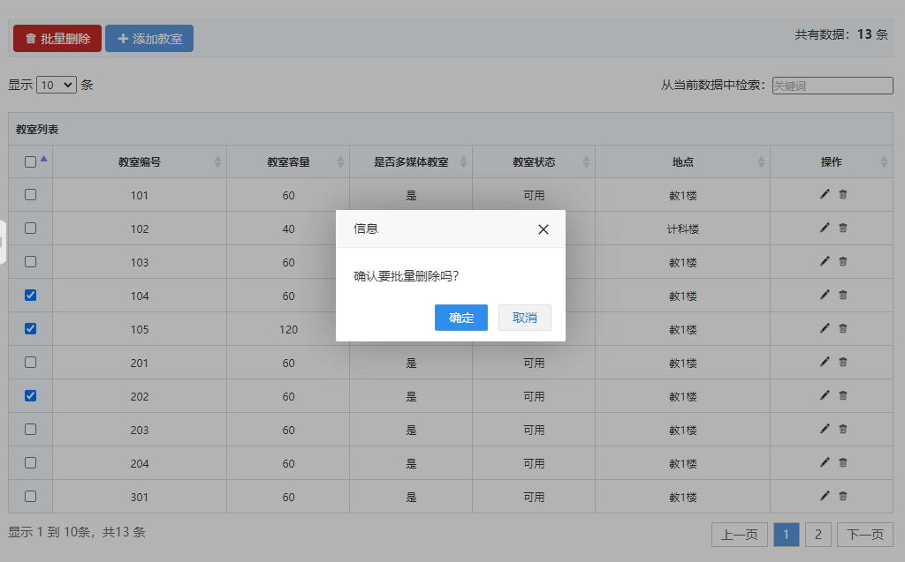

**图3.2.3.3 批量删除教室页面**

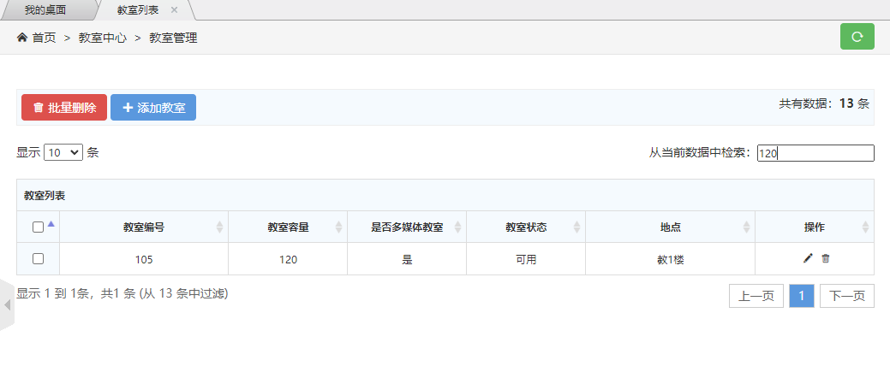

**图3.2.3.4 通过条件查询教室页面**

ClassRoom.java 教室实体类

@Data  
@NoArgsConstructor  
@AllArgsConstructor  
@TableName*(*"classroom"*)*public class ClassRoom implements Serializable *{* @TableId  
 private Integer classRoomNO; *// 教室编号* private Integer capacity; *// 容量* private Integer isMultimedia; *// 是否多媒体教室* private Integer state; *// 教室状态* private Integer locationNo; *// 地点* @TableField*(*exist = false*)* private String locationName; *//验证码  
}*

ClassRoomMapper.java 教室Mapper和Dao

@Repository  
public interface ClassRoomMapper extends BaseMapper*<*ClassRoom*> {  
}*

ClassRoomController.java 教室控制器

@Slf4j  
@Controller  
public class ClassRoomController *{* @Autowired  
 private ClassRoomMapper classRoomMapper;  
  
 @Autowired  
 private LocationController locationController;  
  
 @ResponseBody  
 @GetMapping*(*"/classRoom/isAvailableClassRoomNO"*)* public HashMap*<*String, Object*>* isAvailableClassRoomNO*(*ClassRoom classRoom*){* ClassRoom room = classRoomMapper.selectById*(*classRoom.getClassRoomNO*())*;  
 HashMap*<*String, Object*>* map = new HashMap*<>()*;  
 if *(*room == null*){* map.put*(*"code","100"*)*;  
 map.put*(*"id",classRoom.getClassRoomNO*())*;  
 *}* else *{* map.put*(*"code","500"*)*;  
 map.put*(*"id",classRoom.getClassRoomNO*())*;  
 *}* return map;  
 *}* @ResponseBody  
 @GetMapping*(*"/classRoom/classRoomList"*)* public List*<*ClassRoom*>* toClassRoomList*(){* return classRoomMapper.selectList*(*null*)*;  
 *}* public ClassRoom getClassRoomById*(*Integer id*){* return classRoomMapper.selectById*(*id*)*;  
 *}* @GetMapping*(*"/classRoom/classRoomListPage"*)* public String toClassRoomList*(*Model model*){* List*<*ClassRoom*>* classRoomList = classRoomMapper.selectList*(*null*)*;  
 for *(*ClassRoom classRoom : classRoomList*) {* classRoom.setLocationName*(*locationController.getLocationById*(*classRoom.getLocationNo*())*.getLocationName*())*;  
 *}* model.addAttribute*(*"classRoomList",classRoomList*)*;  
 return "classRoom/admin-list";  
 *}* @ResponseBody  
 @PostMapping*(*"/classRoom/deleteClassRoomById"*)* public HashMap*<*String, Object*>* deleteClassRoomById*(*ClassRoom classRoom*){  
 log*.info*(*classRoom.toString*())*;  
  
 int count = classRoomMapper.deleteById*(*classRoom.getClassRoomNO*())*;  
 *log*.info*(*String.*valueOf(*count*))*;  
  
 HashMap*<*String, Object*>* map = new HashMap*<>()*;  
 if *(*count==1*){* map.put*(*"code","100"*)*;  
 map.put*(*"id",classRoom.getClassRoomNO*())*;  
 *}* else *{* map.put*(*"code","500"*)*;  
 map.put*(*"id",classRoom.getClassRoomNO*())*;  
 *}* return map;  
 *}* @ResponseBody  
 @PostMapping*(*"/classRoom/deleteBatchIds"*)* public HashMap*<*String, Object*>* deleteBatchIds*(*String ids*){* System.*out*.println*(*ids*)*;  
  
 JSON parse = JSONUtil.*parse(*ids*)*;  
 int count = classRoomMapper.deleteBatchIds*((*Collection*<*? extends Serializable*>)* parse*)*;  
 *log*.info*(*String.*valueOf(*count*))*;  
 HashMap*<*String, Object*>* map = new HashMap*<>()*;  
 if *(*count>=1*){* map.put*(*"code","100"*)*;  
 map.put*(*"ids",ids*)*;  
 *}* else *{* map.put*(*"code","500"*)*;  
 map.put*(*"ids",ids*)*;  
 *}* return map;  
 *}* @GetMapping*(*"/classRoom/classRoomAdd"*)* public String toUserAdd*(*Model model*){* List*<*Location*>* locations = locationController.locationList*()*;  
 model.addAttribute*(*"locationList",locations*)*;  
 return "classRoom/admin-add";  
 *}* @ResponseBody  
 @PostMapping*(*"/classRoom/classRoomAdd"*)* public HashMap*<*String, Object*>* classRoomAdd*(*ClassRoom classRoom*){  
 log*.info*(*classRoom.toString*())*;  
  
 int count = classRoomMapper.insert*(*classRoom*)*;  
 *log*.info*(*String.*valueOf(*count*))*;  
  
 HashMap*<*String, Object*>* map = new HashMap*<>()*;  
 if *(*count==1*){* map.put*(*"code","100"*)*;  
 map.put*(*"id",classRoom.getClassRoomNO*())*;  
 *}* else *{* map.put*(*"code","500"*)*;  
 map.put*(*"id",classRoom.getClassRoomNO*())*;  
 *}* return map;  
 *}* @GetMapping*(*"/classRoom/classRoomUpdate/{id}"*)* public String toClassRoomUpdate*(*@PathVariable*(*"id"*)* Integer id, Model model*){* List*<*Location*>* locations = locationController.locationList*()*;  
 model.addAttribute*(*"locationList",locations*)*;  
 ClassRoom t = classRoomMapper.selectById*(*id*)*;  
 model.addAttribute*(*"classRoom",t*)*;  
 return "classRoom/admin-update";  
 *}* @ResponseBody  
 @PostMapping*(*"/classRoom/classRoomUpdate"*)* public HashMap*<*String, Object*>* classRoomUpdate*(*ClassRoom classRoom*){  
 log*.info*(*classRoom.toString*())*;  
  
 int count = classRoomMapper.updateById*(*classRoom*)*;  
 *log*.info*(*String.*valueOf(*count*))*;  
  
 HashMap*<*String, Object*>* map = new HashMap*<>()*;  
 if *(*count==1*){* map.put*(*"code","100"*)*;  
 map.put*(*"id",classRoom.getClassRoomNO*())*;  
 *}* else *{* map.put*(*"code","500"*)*;  
 map.put*(*"id",classRoom.getClassRoomNO*())*;  
 *}* return map;  
 *}  
}*

### 3.2.4 班级模块

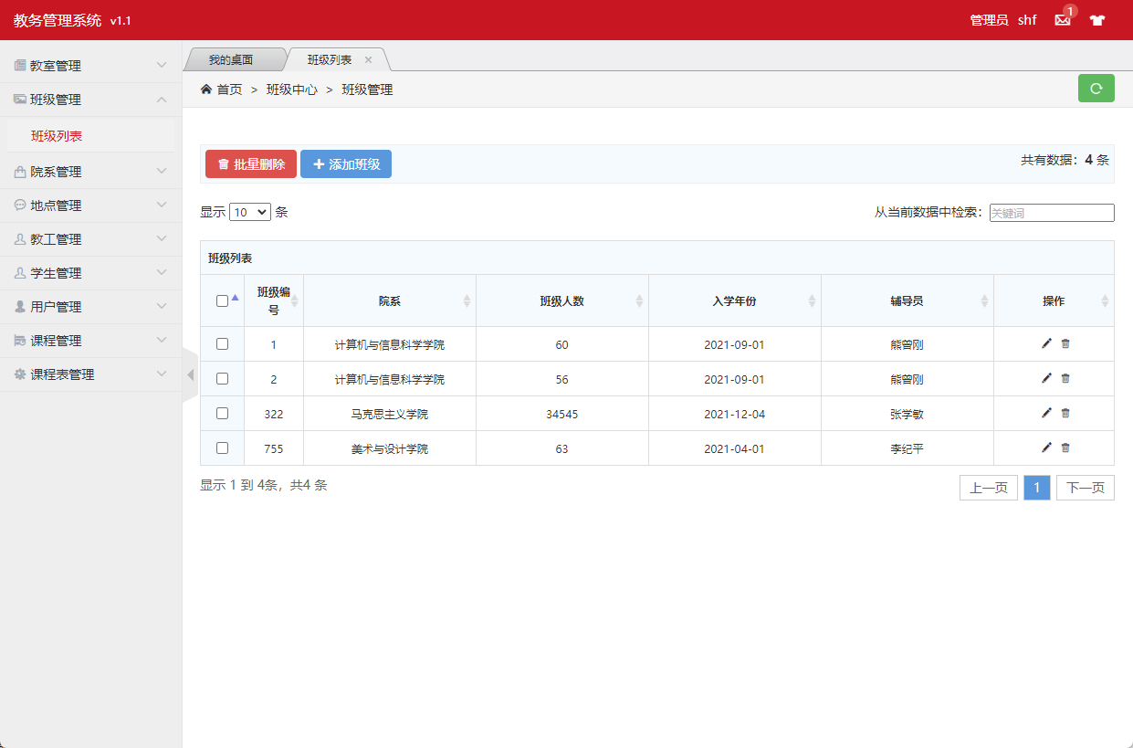

**图3.2.4.1 班级列表页面**

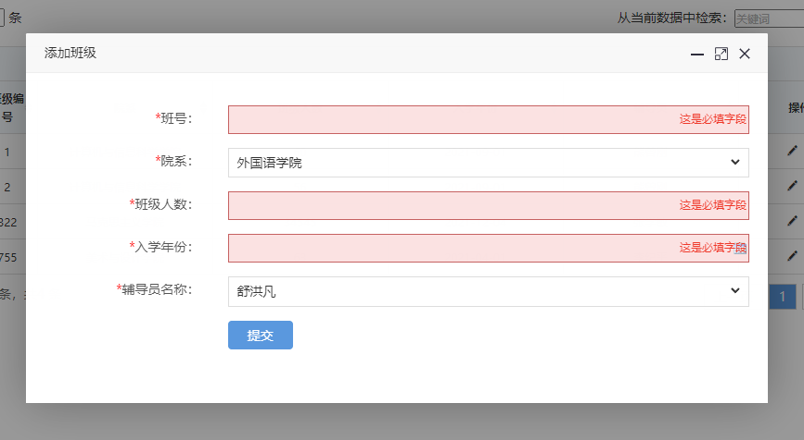

**图3.2.4.2 添加班级页面**

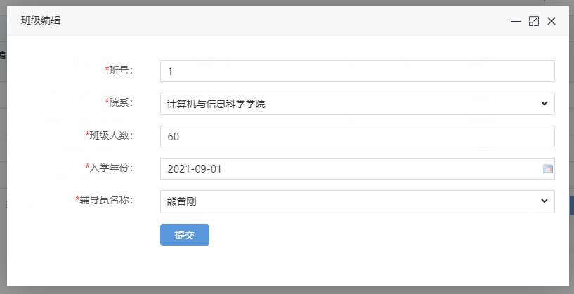

**图3.2.4.3 编辑班级页面**

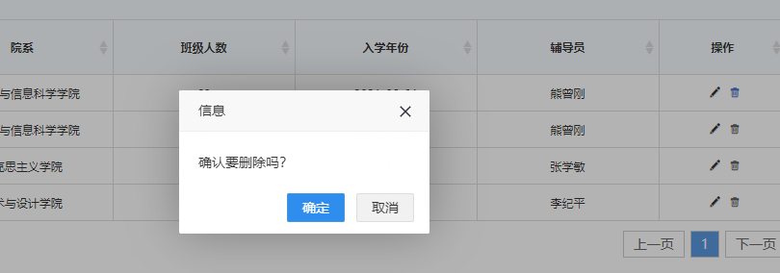

**图3.2.4.4 删除班级页面**

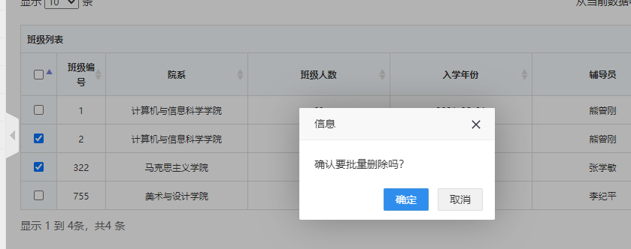

**图3.2.4.5 批量删除班级页面**

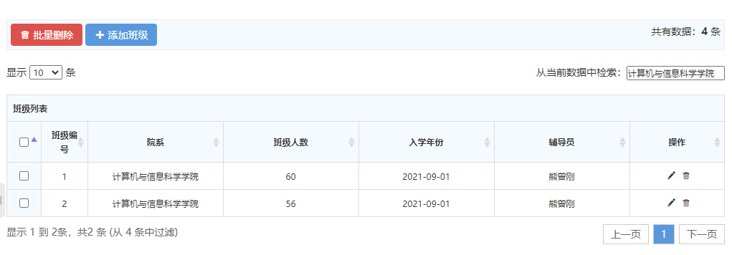

**图3.2.4.5 筛选班级页面**

Class.java 班级实体类

@Data  
@NoArgsConstructor  
@AllArgsConstructor  
@TableName*(*"class"*)*public class Class implements Serializable *{* @TableId  
 private Integer classNO; *//班号* private Integer facultyNO; *//院系* @TableField*(*exist = false*)* private String facultyName; *//院系名称* private Integer classSize; *// 班级人数* @DateTimeFormat*(*pattern = "yyyy-MM-dd"*)* private Date year; *// 入学年份* private Integer counsellorNO; *// 辅导员* @TableField*(*exist = false*)* private String counsellorName; *//辅导员名称  
}*

ClassMapper.java 班级mapper和Dao

@Repository  
public interface ClassMapper extends BaseMapper*<*Class*> {  
}*

ClassController.java 班级控制器

@Slf4j  
@Controller  
public class ClassController *{* @Autowired  
 private ClassMapper classMapper;  
  
 @Autowired  
 private FacultyController facultyController;  
  
 @Autowired  
 private TeacherController teacherController;  
  
 @ResponseBody  
 @GetMapping*(*"/class/isAvailableClassNO"*)* public HashMap*<*String, Object*>* isAvailableID*(*Class classes*){* Class aClass = classMapper.selectById*(*classes.getClassNO*())*;  
 HashMap*<*String, Object*>* map = new HashMap*<>()*;  
 if *(*aClass == null*){* map.put*(*"code","100"*)*;  
 map.put*(*"id",classes.getClassNO*())*;  
 *}* else *{* map.put*(*"code","500"*)*;  
 map.put*(*"id",classes.getClassNO*())*;  
 *}* return map;  
 *}* @ResponseBody  
 @GetMapping*(*"/class/classList"*)* public List*<*Class*>* toClassList*(){* return classMapper.selectList*(*null*)*;  
 *}* public Class getClassById*(*Integer id*){* return classMapper.selectById*(*id*)*;  
 *}* @GetMapping*(*"/class/classListPage"*)* public String toClassList*(*Model model*){* List*<*Class*>* classList = classMapper.selectList*(*null*)*;  
 for *(*Class classes : classList*) {* classes.setFacultyName*(*facultyController.getFacultyById*(*classes.getFacultyNO*())*.getFacultyName*())*;  
 classes.setCounsellorName*(*teacherController.getTeacherById*(*classes.getCounsellorNO*())*.getName*())*;  
 *}* model.addAttribute*(*"classList",classList*)*;  
 return "class/admin-list";  
 *}* @ResponseBody  
 @PostMapping*(*"/class/deleteClassById"*)* public HashMap*<*String, Object*>* deleteClassById*(*Class classes*){  
 log*.info*(*classes.toString*())*;  
  
 int count = classMapper.deleteById*(*classes.getClassNO*())*;  
 *log*.info*(*String.*valueOf(*count*))*;  
  
 HashMap*<*String, Object*>* map = new HashMap*<>()*;  
 if *(*count==1*){* map.put*(*"code","100"*)*;  
 map.put*(*"id",classes.getClassNO*())*;  
 *}* else *{* map.put*(*"code","500"*)*;  
 map.put*(*"id",classes.getClassNO*())*;  
 *}* return map;  
 *}* @ResponseBody  
 @PostMapping*(*"/class/deleteBatchIds"*)* public HashMap*<*String, Object*>* deleteBatchIds*(*String ids*){* System.*out*.println*(*ids*)*;  
  
 JSON parse = JSONUtil.*parse(*ids*)*;  
 int count = classMapper.deleteBatchIds*((*Collection*<*? extends Serializable*>)* parse*)*;  
 *log*.info*(*String.*valueOf(*count*))*;  
 HashMap*<*String, Object*>* map = new HashMap*<>()*;  
 if *(*count>=1*){* map.put*(*"code","100"*)*;  
 map.put*(*"ids",ids*)*;  
 *}* else *{* map.put*(*"code","500"*)*;  
 map.put*(*"ids",ids*)*;  
 *}* return map;  
 *}* @GetMapping*(*"/class/classAdd"*)* public String toUserAdd*(*Model model*){* List*<*Teacher*>* teachers = teacherController.teacherList*()*;  
 model.addAttribute*(*"teacherList",teachers*)*;  
 List*<*Faculty*>* facultyList = facultyController.toFacultyList*()*;  
 model.addAttribute*(*"facultyList",facultyList*)*;  
 return "class/admin-add";  
 *}* @ResponseBody  
 @PostMapping*(*"/class/classAdd"*)* public HashMap*<*String, Object*>* classAdd*(*Class classes*){  
 log*.info*(*classes.toString*())*;  
  
 int count = classMapper.insert*(*classes*)*;  
 *log*.info*(*String.*valueOf(*count*))*;  
  
 HashMap*<*String, Object*>* map = new HashMap*<>()*;  
 if *(*count==1*){* map.put*(*"code","100"*)*;  
 map.put*(*"id",classes.getClassNO*())*;  
 *}* else *{* map.put*(*"code","500"*)*;  
 map.put*(*"id",classes.getClassNO*())*;  
 *}* return map;  
 *}* @GetMapping*(*"/class/classUpdate/{id}"*)* public String toClassUpdate*(*@PathVariable*(*"id"*)* Integer id, Model model*){* List*<*Teacher*>* teachers = teacherController.teacherList*()*;  
 model.addAttribute*(*"teacherList",teachers*)*;  
 List*<*Faculty*>* facultyList = facultyController.toFacultyList*()*;  
 model.addAttribute*(*"facultyList",facultyList*)*;  
 Class t = classMapper.selectById*(*id*)*;  
 model.addAttribute*(*"class",t*)*;  
 return "class/admin-update";  
 *}* @ResponseBody  
 @PostMapping*(*"/class/classUpdate"*)* public HashMap*<*String, Object*>* classUpdate*(*Class classes*){  
 log*.info*(*classes.toString*())*;  
  
 int count = classMapper.updateById*(*classes*)*;  
 *log*.info*(*String.*valueOf(*count*))*;  
  
 HashMap*<*String, Object*>* map = new HashMap*<>()*;  
 if *(*count==1*){* map.put*(*"code","100"*)*;  
 map.put*(*"id",classes.getClassNO*())*;  
 *}* else *{* map.put*(*"code","500"*)*;  
 map.put*(*"id",classes.getClassNO*())*;  
 *}* return map;  
 *}  
}*

### 3.2.5 院系模块

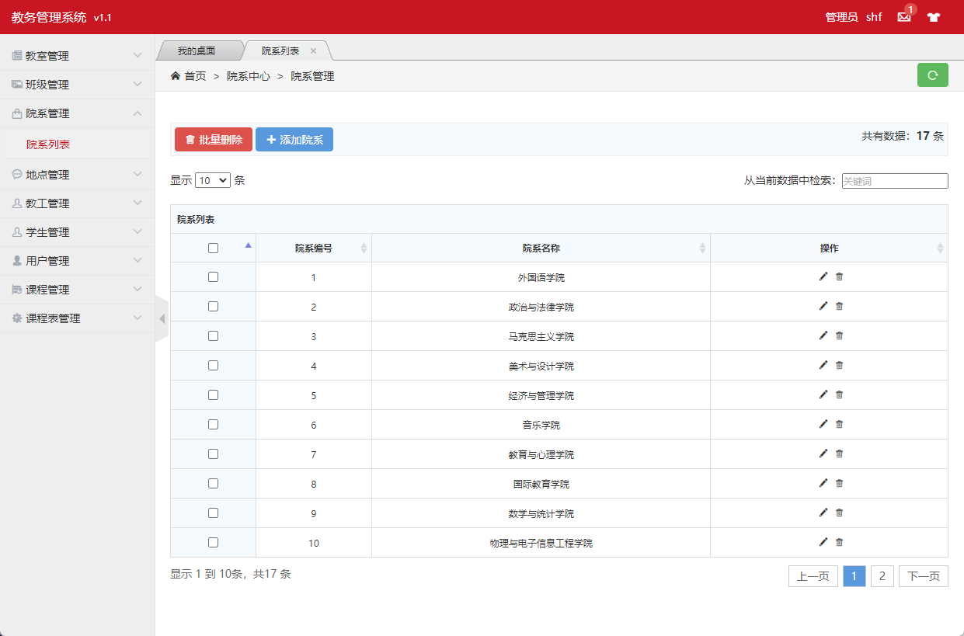

**图3.2.5.1 院系页面**

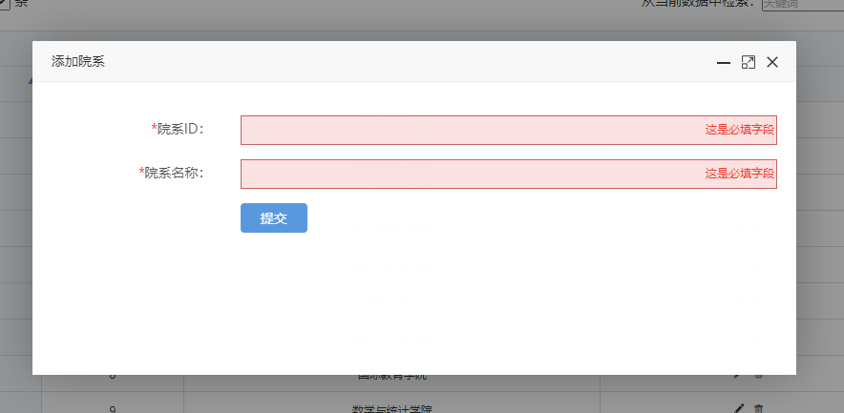

**图3.2.5.2 添加院系页面**

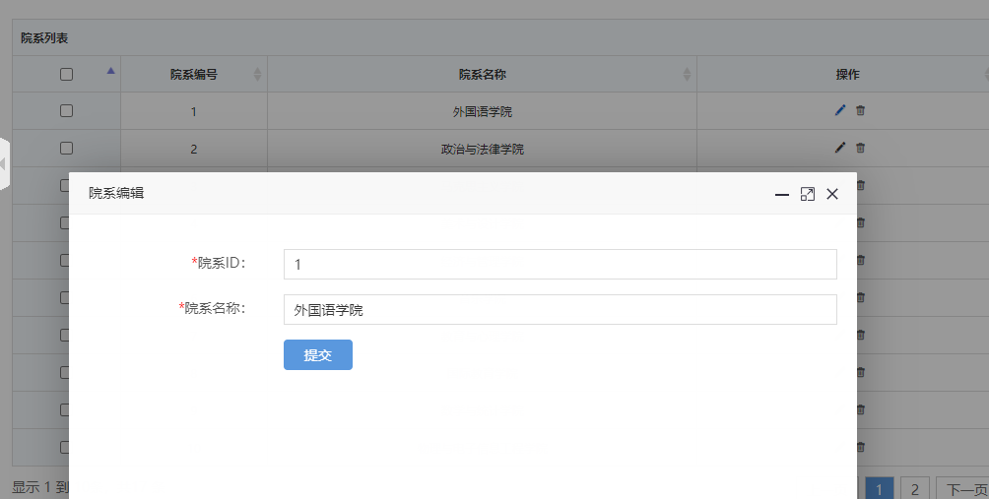

**图3.2.5.3 编辑院系页面**

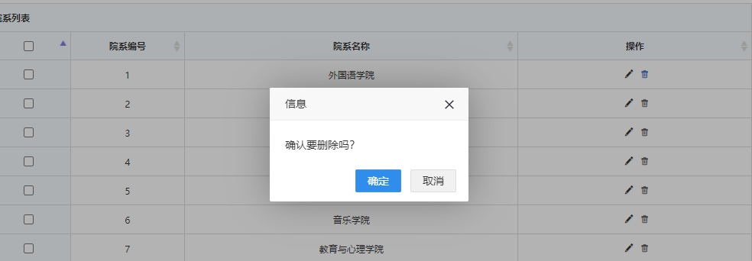

**图3.2.5.4 删除院系页面**

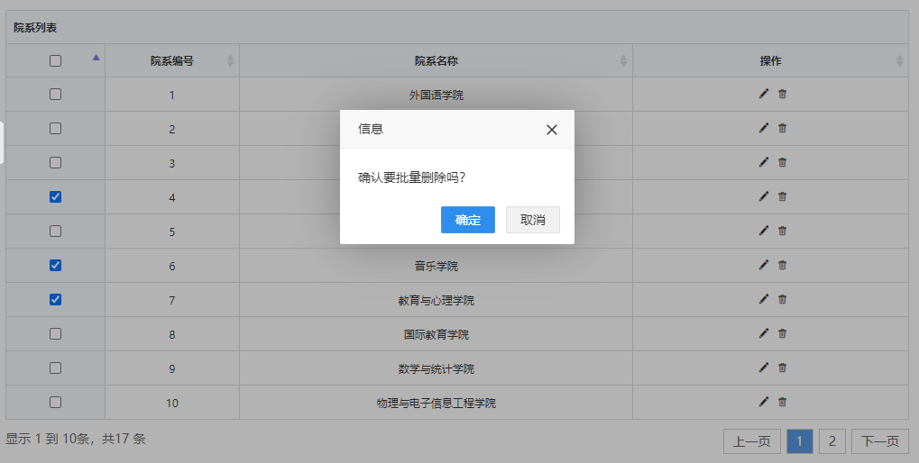

**图3.2.5.5 批量删除院系页面**

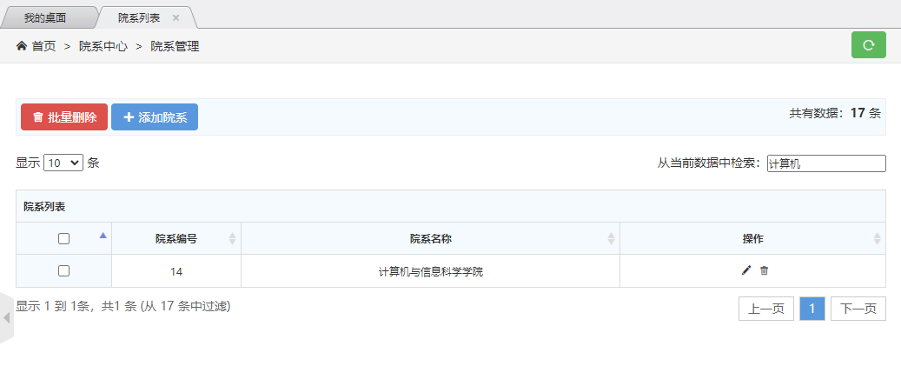

**图3.2.5.6 根据条件查询院系页面**

Faculty.java 院系实体类

@Data  
@NoArgsConstructor  
@AllArgsConstructor  
@TableName*(*"faculty"*)*public class Faculty implements Serializable *{* @TableId  
 private Integer facultyNO; *//#院系ID* private String facultyName; *//#院系名称  
}*

FacultyMapper.java 院系mapper和Dao

@Repository  
public interface FacultyMapper extends BaseMapper*<*Faculty*> {  
}*

FacultyController.java 院系控制器

@Slf4j  
@Controller  
public class FacultyController *{* @Autowired  
 private FacultyMapper facultyMapper;  
  
 @ResponseBody  
 @GetMapping*(*"/faculty/isAvailableFacultyNO"*)* public HashMap*<*String, Object*>* isAvailableFacultyNO*(*Faculty faculty*){* Faculty room = facultyMapper.selectById*(*faculty.getFacultyNO*())*;  
 HashMap*<*String, Object*>* map = new HashMap*<>()*;  
 if *(*room == null*){* map.put*(*"code","100"*)*;  
 map.put*(*"id",faculty.getFacultyNO*())*;  
 *}* else *{* map.put*(*"code","500"*)*;  
 map.put*(*"id",faculty.getFacultyNO*())*;  
 *}* return map;  
 *}* @ResponseBody  
 @GetMapping*(*"/faculty/facultyList"*)* public List*<*Faculty*>* toFacultyList*(){* return facultyMapper.selectList*(*null*)*;  
 *}* public Faculty getFacultyById*(*Integer id*){* return facultyMapper.selectById*(*id*)*;  
 *}* @GetMapping*(*"/faculty/facultyListPage"*)* public String toFacultyList*(*Model model*){* List*<*Faculty*>* facultyList = facultyMapper.selectList*(*null*)*;  
 model.addAttribute*(*"facultyList",facultyList*)*;  
 return "faculty/admin-list";  
 *}* @ResponseBody  
 @PostMapping*(*"/faculty/deleteFacultyById"*)* public HashMap*<*String, Object*>* deleteFacultyById*(*Faculty faculty*){  
 log*.info*(*faculty.toString*())*;  
  
 int count = facultyMapper.deleteById*(*faculty.getFacultyNO*())*;  
 *log*.info*(*String.*valueOf(*count*))*;  
  
 HashMap*<*String, Object*>* map = new HashMap*<>()*;  
 if *(*count==1*){* map.put*(*"code","100"*)*;  
 map.put*(*"id",faculty.getFacultyNO*())*;  
 *}* else *{* map.put*(*"code","500"*)*;  
 map.put*(*"id",faculty.getFacultyNO*())*;  
 *}* return map;  
 *}* @ResponseBody  
 @PostMapping*(*"/faculty/deleteBatchIds"*)* public HashMap*<*String, Object*>* deleteBatchIds*(*String ids*){* System.*out*.println*(*ids*)*;  
  
 JSON parse = JSONUtil.*parse(*ids*)*;  
 int count = facultyMapper.deleteBatchIds*((*Collection*<*? extends Serializable*>)* parse*)*;  
 *log*.info*(*String.*valueOf(*count*))*;  
 HashMap*<*String, Object*>* map = new HashMap*<>()*;  
 if *(*count>=1*){* map.put*(*"code","100"*)*;  
 map.put*(*"ids",ids*)*;  
 *}* else *{* map.put*(*"code","500"*)*;  
 map.put*(*"ids",ids*)*;  
 *}* return map;  
 *}* @GetMapping*(*"/faculty/facultyAdd"*)* public String toUserAdd*(){* return "faculty/admin-add";  
 *}* @ResponseBody  
 @PostMapping*(*"/faculty/facultyAdd"*)* public HashMap*<*String, Object*>* facultyAdd*(*Faculty faculty*){  
 log*.info*(*faculty.toString*())*;  
  
 int count = facultyMapper.insert*(*faculty*)*;  
 *log*.info*(*String.*valueOf(*count*))*;  
  
 HashMap*<*String, Object*>* map = new HashMap*<>()*;  
 if *(*count==1*){* map.put*(*"code","100"*)*;  
 map.put*(*"id",faculty.getFacultyNO*())*;  
 *}* else *{* map.put*(*"code","500"*)*;  
 map.put*(*"id",faculty.getFacultyNO*())*;  
 *}* return map;  
 *}* @GetMapping*(*"/faculty/facultyUpdate/{id}"*)* public String toFacultyUpdate*(*@PathVariable*(*"id"*)* Integer id, Model model*){* Faculty t = facultyMapper.selectById*(*id*)*;  
 model.addAttribute*(*"faculty",t*)*;  
 return "faculty/admin-update";  
 *}* @ResponseBody  
 @PostMapping*(*"/faculty/facultyUpdate"*)* public HashMap*<*String, Object*>* facultyUpdate*(*Faculty faculty*){  
 log*.info*(*faculty.toString*())*;  
  
 int count = facultyMapper.updateById*(*faculty*)*;  
 *log*.info*(*String.*valueOf(*count*))*;  
  
 HashMap*<*String, Object*>* map = new HashMap*<>()*;  
 if *(*count==1*){* map.put*(*"code","100"*)*;  
 map.put*(*"id",faculty.getFacultyNO*())*;  
 *}* else *{* map.put*(*"code","500"*)*;  
 map.put*(*"id",faculty.getFacultyNO*())*;  
 *}* return map;  
 *}  
}*

### 3.2.6 地点模块

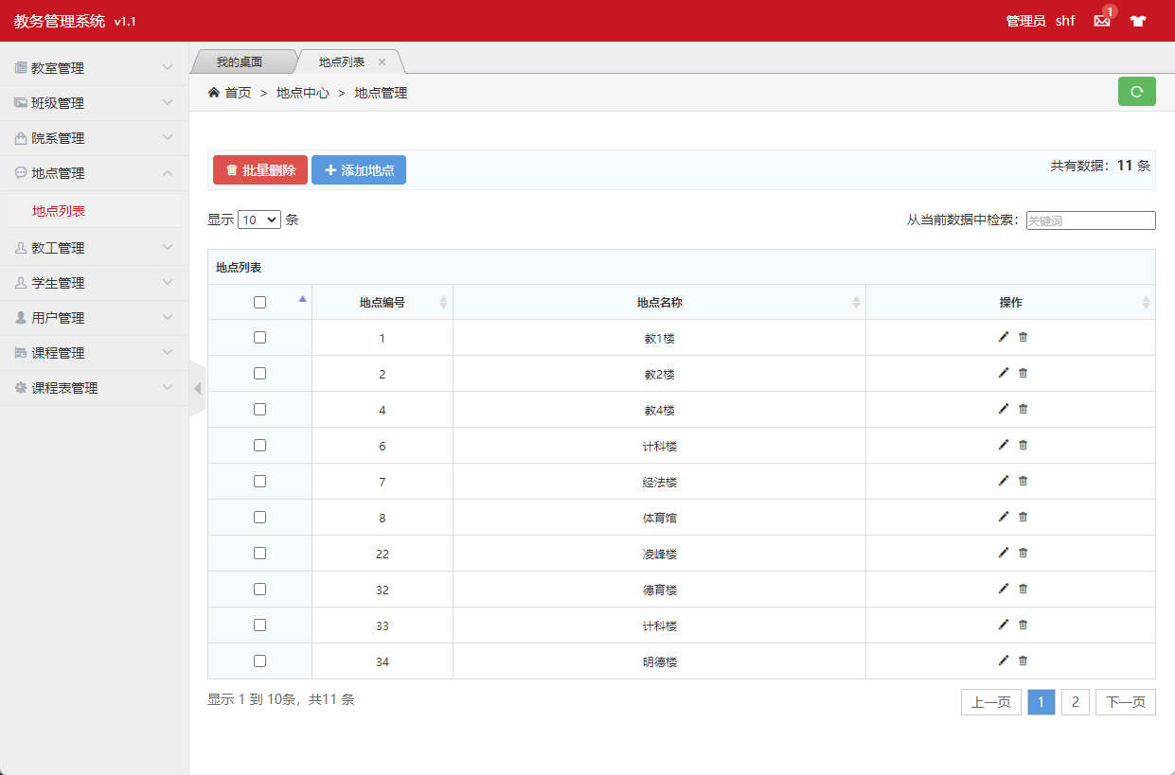

**图3.2.6.1 地点列表页面**

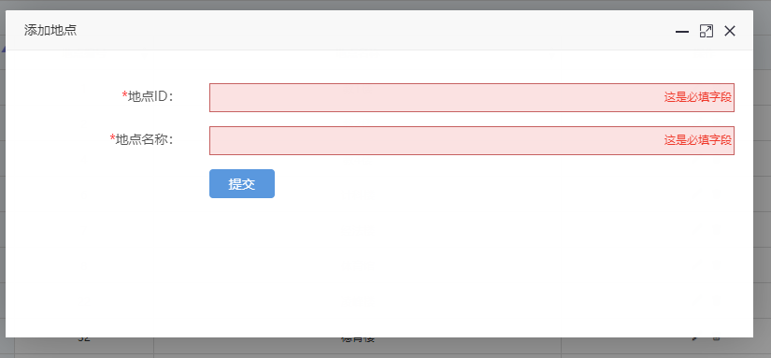

**图3.2.6.2 添加地点页面**

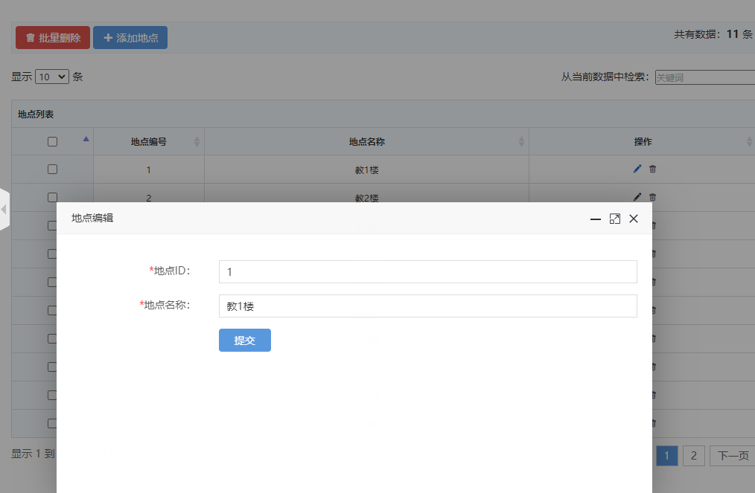

**图3.2.6.3 修改地点页面**

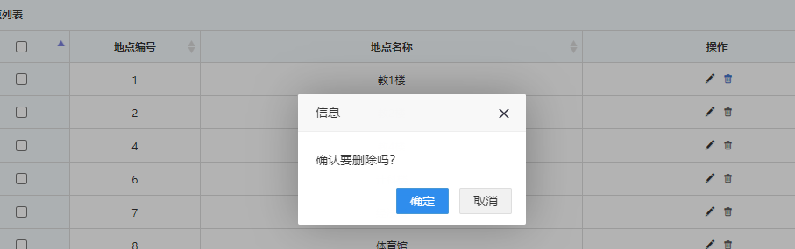

**图3.2.6.4 删除地点页面**

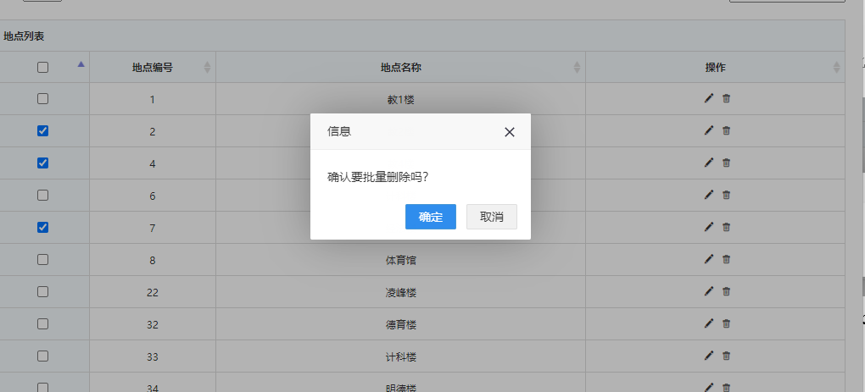

**图3.2.6.4 批量删除地点页面**

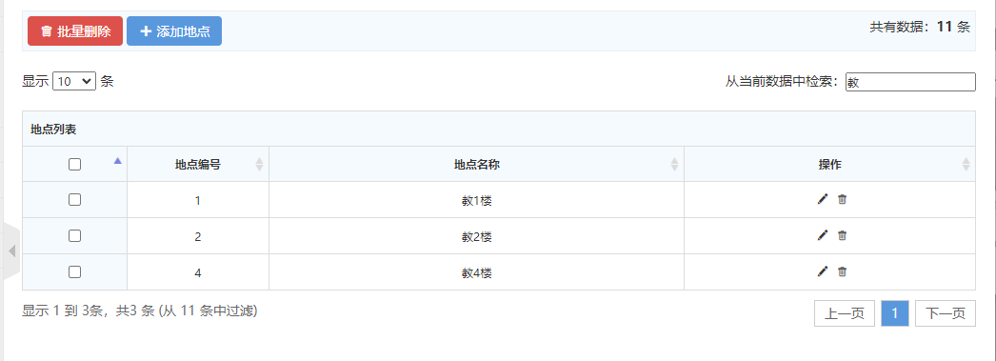

**图3.2.6.5 筛选地点页面**

Location.java 地点实体类

@Data  
@NoArgsConstructor  
@AllArgsConstructor  
@TableName*(*"location"*)*public class Location implements Serializable *{* @TableId  
 private Integer locationNo; *// 地点ID* private String locationName; *// 地点名称  
}*

LocationMapper.java 地点mapper和Dao

@Repository  
public interface LocationMapper extends BaseMapper*<*Location*> {  
}*

LocationController.java 地点控制器

@Slf4j  
@Controller  
public class LocationController *{* @Autowired  
 private LocationMapper locationMapper;  
  
 @ResponseBody  
 @GetMapping*(*"/location/isAvailableLocationNO"*)* public HashMap*<*String, Object*>* isAvailableLocationNO*(*Location location*){* Location room = locationMapper.selectById*(*location.getLocationNo*())*;  
 HashMap*<*String, Object*>* map = new HashMap*<>()*;  
 if *(*room == null*){* map.put*(*"code","100"*)*;  
 map.put*(*"id",location.getLocationNo*())*;  
 *}* else *{* map.put*(*"code","500"*)*;  
 map.put*(*"id",location.getLocationNo*())*;  
 *}* return map;  
 *}* public Location getLocationById*(*Integer id*){* return locationMapper.selectById*(*id*)*;  
 *}* public List*<*Location*>* locationList*(){* return locationMapper.selectList*(*null*)*;  
 *}* @GetMapping*(*"/location/locationListPage"*)* public String toLocationList*(*Model model*){* List*<*Location*>* locationList = locationMapper.selectList*(*null*)*;  
 model.addAttribute*(*"locationList",locationList*)*;  
 return "location/admin-list";  
 *}* @ResponseBody  
 @PostMapping*(*"/location/deleteLocationById"*)* public HashMap*<*String, Object*>* deleteLocationById*(*Location location*){  
 log*.info*(*location.toString*())*;  
  
 int count = locationMapper.deleteById*(*location.getLocationNo*())*;  
 *log*.info*(*String.*valueOf(*count*))*;  
  
 HashMap*<*String, Object*>* map = new HashMap*<>()*;  
 if *(*count==1*){* map.put*(*"code","100"*)*;  
 map.put*(*"id",location.getLocationNo*())*;  
 *}* else *{* map.put*(*"code","500"*)*;  
 map.put*(*"id",location.getLocationNo*())*;  
 *}* return map;  
 *}* @ResponseBody  
 @PostMapping*(*"/location/deleteBatchIds"*)* public HashMap*<*String, Object*>* deleteBatchIds*(*String ids*){* System.*out*.println*(*ids*)*;  
  
 JSON parse = JSONUtil.*parse(*ids*)*;  
 int count = locationMapper.deleteBatchIds*((*Collection*<*? extends Serializable*>)* parse*)*;  
 *log*.info*(*String.*valueOf(*count*))*;  
 HashMap*<*String, Object*>* map = new HashMap*<>()*;  
 if *(*count>=1*){* map.put*(*"code","100"*)*;  
 map.put*(*"ids",ids*)*;  
 *}* else *{* map.put*(*"code","500"*)*;  
 map.put*(*"ids",ids*)*;  
 *}* return map;  
 *}* @GetMapping*(*"/location/locationAdd"*)* public String toUserAdd*(){* return "location/admin-add";  
 *}* @ResponseBody  
 @PostMapping*(*"/location/locationAdd"*)* public HashMap*<*String, Object*>* locationAdd*(*Location location*){  
 log*.info*(*location.toString*())*;  
  
 int count = locationMapper.insert*(*location*)*;  
 *log*.info*(*String.*valueOf(*count*))*;  
  
 HashMap*<*String, Object*>* map = new HashMap*<>()*;  
 if *(*count==1*){* map.put*(*"code","100"*)*;  
 map.put*(*"id",location.getLocationNo*())*;  
 *}* else *{* map.put*(*"code","500"*)*;  
 map.put*(*"id",location.getLocationNo*())*;  
 *}* return map;  
 *}* @GetMapping*(*"/location/locationUpdate/{id}"*)* public String toLocationUpdate*(*@PathVariable*(*"id"*)* Integer id,Model model*){* Location t = locationMapper.selectById*(*id*)*;  
 model.addAttribute*(*"location",t*)*;  
 return "location/admin-update";  
 *}* @ResponseBody  
 @PostMapping*(*"/location/locationUpdate"*)* public HashMap*<*String, Object*>* locationUpdate*(*Location location*){  
 log*.info*(*location.toString*())*;  
  
 int count = locationMapper.updateById*(*location*)*;  
 *log*.info*(*String.*valueOf(*count*))*;  
  
 HashMap*<*String, Object*>* map = new HashMap*<>()*;  
 if *(*count==1*){* map.put*(*"code","100"*)*;  
 map.put*(*"id",location.getLocationNo*())*;  
 *}* else *{* map.put*(*"code","500"*)*;  
 map.put*(*"id",location.getLocationNo*())*;  
 *}* return map;  
 *}  
  
}*

### 3.2.7 教工模块

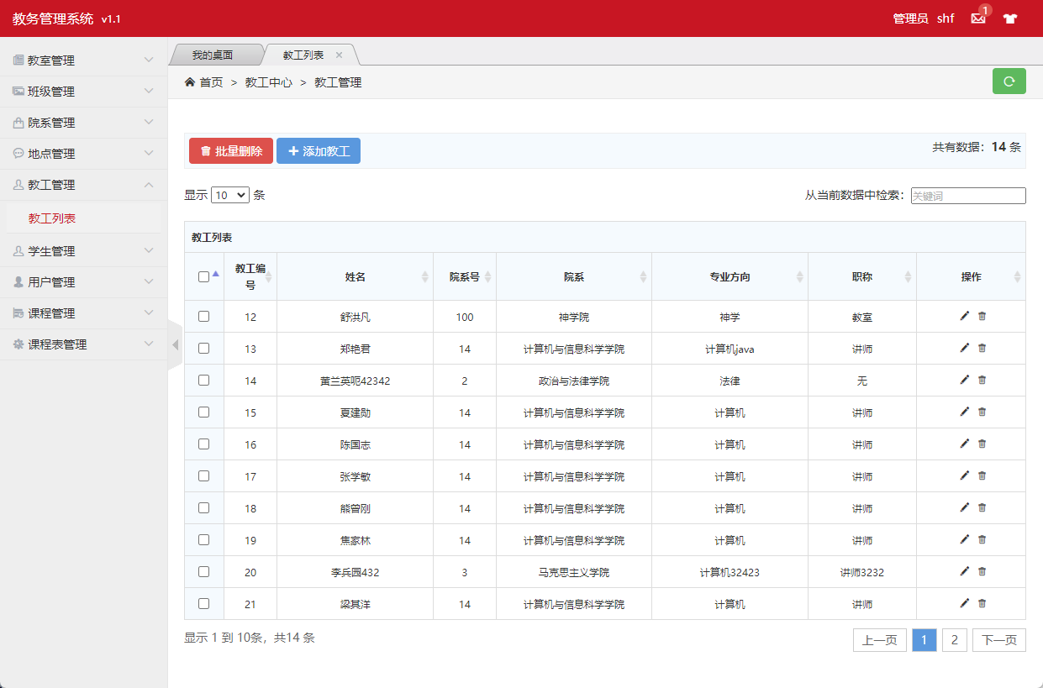

**图3.2.7.1 教工页面**

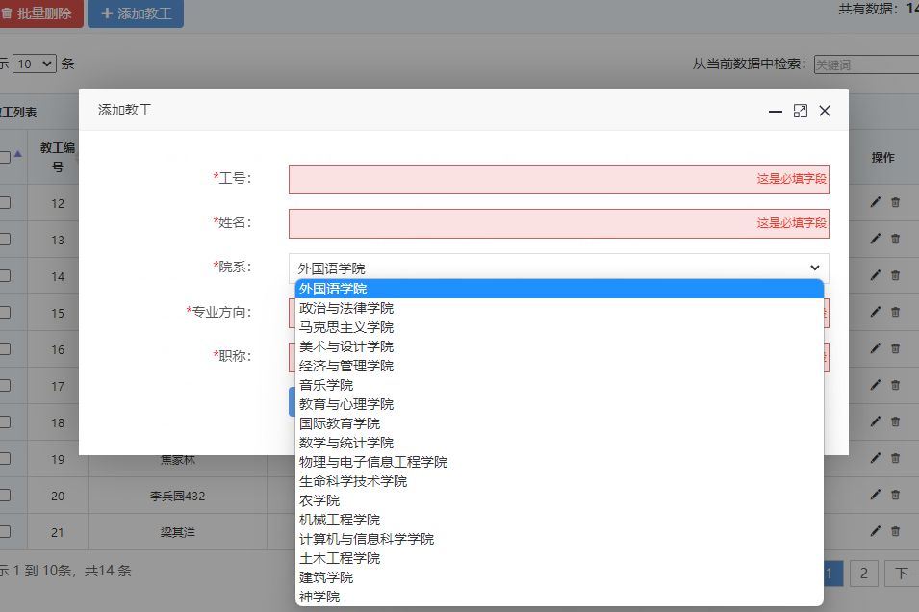

**图3.2.7.2 添加教工页面**

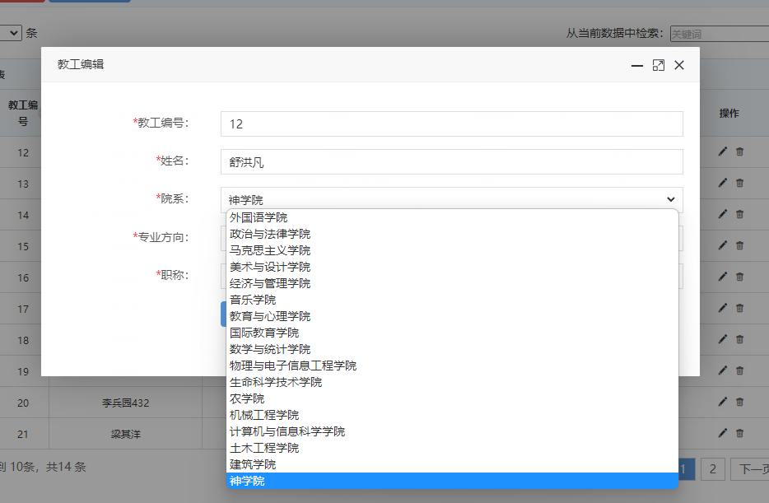

**图3.2.7.3 修改教工页面**

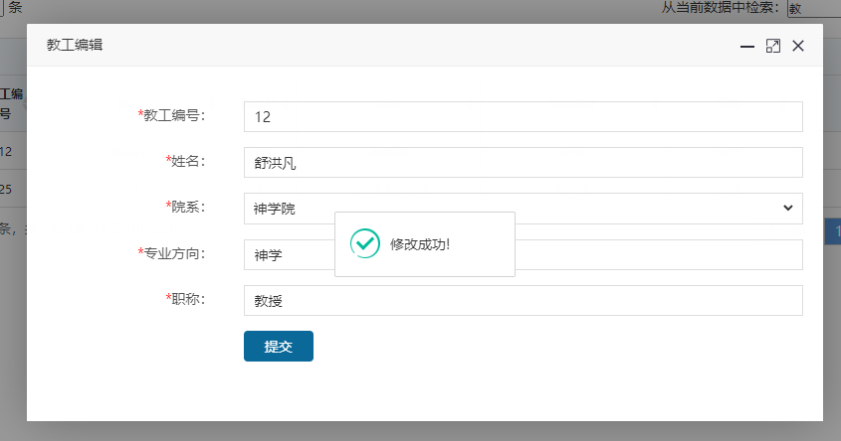

**图3.2.7.4 修改教工成功页面**

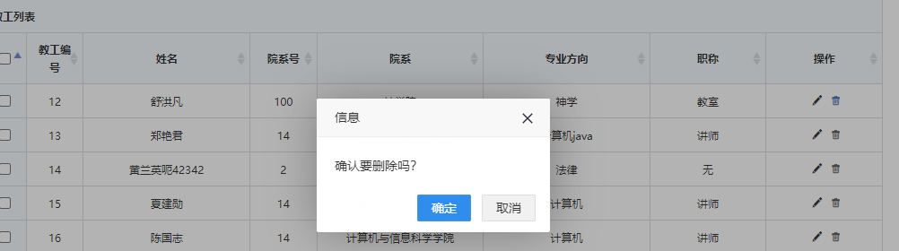

**图3.2.7.5 删除教工页面**

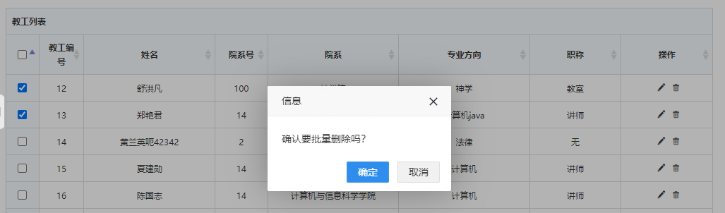

**图3.2.7.6 批量删除教工页面**

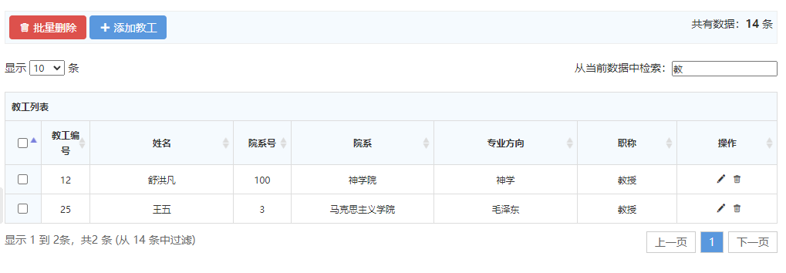

**图3.2.7.7 查询教工页面**

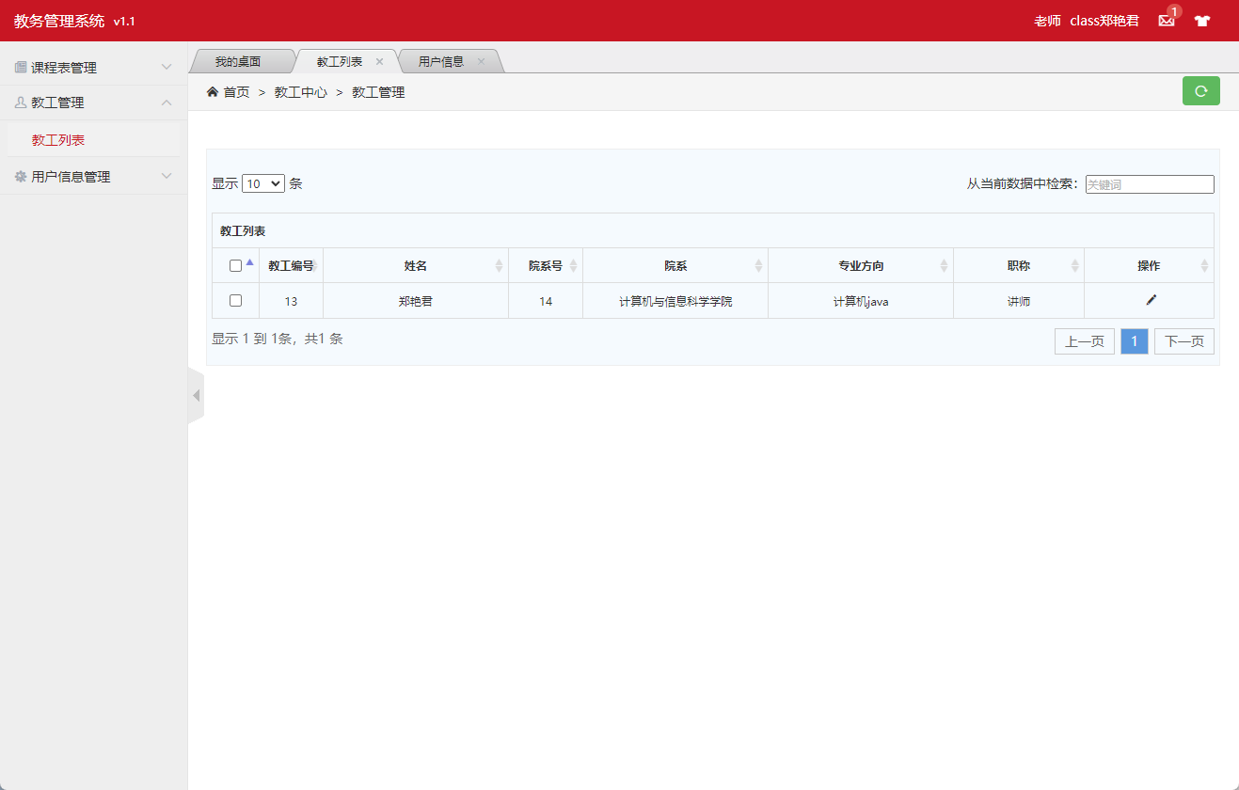

**图3.2.7.8 教工用户教工列表页面**

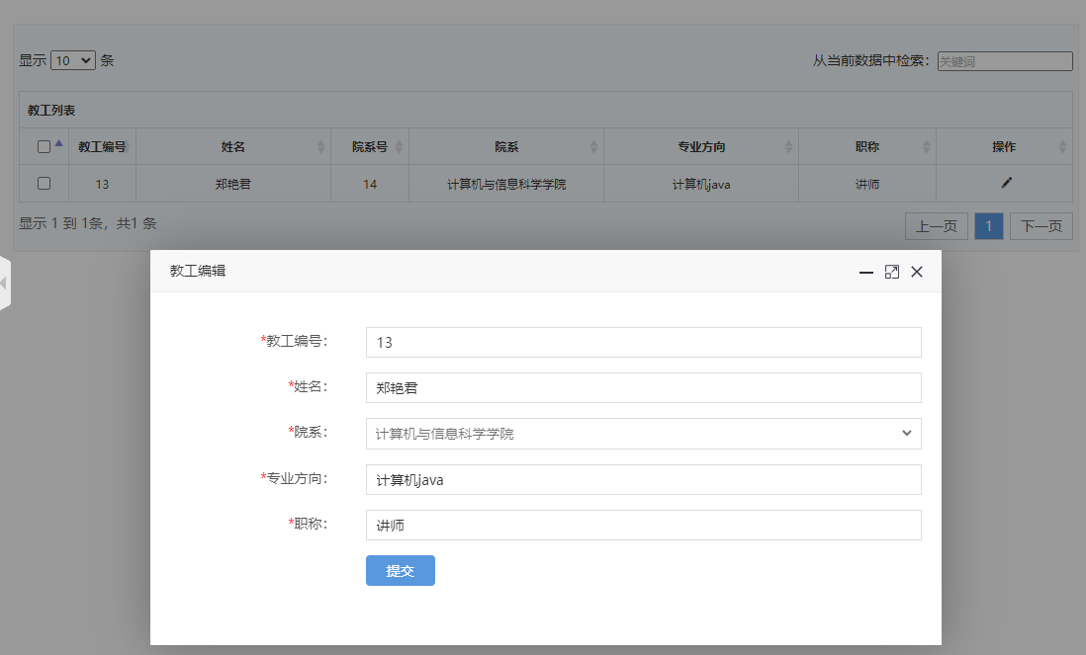

**图3.2.7.9 教工用户修改教工列表页面**

Teacher.java 教工实体类

@Data  
@NoArgsConstructor  
@AllArgsConstructor  
@TableName*(*"teacher"*)*public class Teacher implements Serializable *{* @TableId  
 private Integer teacherID; *// 教工编号* private String name; *// 姓名* private Integer facultyNO; *// 院系* @TableField*(*exist = false*)* private String facultyName; *//#院系名称* private String speciality; *// 专业方向* private String title; *// 职称  
}*

TeacherMapper.java 教工mapper和Dao

@Repository  
public interface TeacherMapper extends BaseMapper*<*Teacher*> {  
}*

TeacherController.java 教工控制器

@Slf4j  
@Controller  
public class TeacherController *{* @Autowired  
 private TeacherMapper teacherMapper;  
  
 @Autowired  
 private FacultyController facultyController;  
  
 @ResponseBody  
 @GetMapping*(*"/teacher/isAvailableTeacherNO"*)* public HashMap*<*String, Object*>* isAvailableTeacherNO*(*Teacher teacher*){* Teacher room = teacherMapper.selectById*(*teacher.getTeacherID*())*;  
 HashMap*<*String, Object*>* map = new HashMap*<>()*;  
 if *(*room == null*){* map.put*(*"code","100"*)*;  
 map.put*(*"id",teacher.getTeacherID*())*;  
 *}* else *{* map.put*(*"code","500"*)*;  
 map.put*(*"id",teacher.getTeacherID*())*;  
 *}* return map;  
 *}* public Teacher getTeacherById*(*Integer id*){* return teacherMapper.selectById*(*id*)*;  
 *}* public List*<*Teacher*>* teacherList*(){* return teacherMapper.selectList*(*null*)*;  
 *}* @GetMapping*(*"/teacher/teacherPage"*)* public String teacherPage*(*Teacher teacher,Model model*){* ArrayList*<*Teacher*>* teachers = new ArrayList*<>()*;  
 Teacher s = teacherMapper.selectById*(*teacher.getTeacherID*())*;  
 s.setFacultyName*(*facultyController.getFacultyById*(*s.getFacultyNO*())*.getFacultyName*())*;  
 teachers.add*(*s*)*;  
 model.addAttribute*(*"teacherList",teachers*)*;  
 return "teacher/admin-list-public";  
 *}* @GetMapping*(*"/teacher/teacherListPage"*)* public String toTeacherList*(*Model model*){* List*<*Teacher*>* teacherList = teacherMapper.selectList*(*null*)*;  
 for *(*Teacher teacher : teacherList*) {* teacher.setFacultyName*(*facultyController.getFacultyById*(*teacher.getFacultyNO*())*.getFacultyName*())*;  
 *}* model.addAttribute*(*"teacherList",teacherList*)*;  
 return "teacher/admin-list";  
 *}* @ResponseBody  
 @PostMapping*(*"/teacher/deleteTeacherById"*)* public HashMap*<*String, Object*>* deleteTeacherById*(*Teacher teacher*){  
 log*.info*(*teacher.toString*())*;  
  
 int count = teacherMapper.deleteById*(*teacher.getTeacherID*())*;  
 *log*.info*(*String.*valueOf(*count*))*;  
  
 HashMap*<*String, Object*>* map = new HashMap*<>()*;  
 if *(*count==1*){* map.put*(*"code","100"*)*;  
 map.put*(*"id",teacher.getTeacherID*())*;  
 *}* else *{* map.put*(*"code","500"*)*;  
 map.put*(*"id",teacher.getTeacherID*())*;  
 *}* return map;  
 *}* @ResponseBody  
 @PostMapping*(*"/teacher/deleteBatchIds"*)* public HashMap*<*String, Object*>* deleteBatchIds*(*String ids*){* System.*out*.println*(*ids*)*;  
  
 JSON parse = JSONUtil.*parse(*ids*)*;  
 int count = teacherMapper.deleteBatchIds*((*Collection*<*? extends Serializable*>)* parse*)*;  
 *log*.info*(*String.*valueOf(*count*))*;  
 HashMap*<*String, Object*>* map = new HashMap*<>()*;  
 if *(*count>=1*){* map.put*(*"code","100"*)*;  
 map.put*(*"ids",ids*)*;  
 *}* else *{* map.put*(*"code","500"*)*;  
 map.put*(*"ids",ids*)*;  
 *}* return map;  
 *}* @GetMapping*(*"/teacher/teacherAdd"*)* public String totTeacherAdd*(*Model model*){* List*<*Faculty*>* facultyList = facultyController.toFacultyList*()*;  
 model.addAttribute*(*"facultyList",facultyList*)*;  
 return "teacher/admin-add";  
 *}* @ResponseBody  
 @PostMapping*(*"/teacher/teacherAdd"*)* public HashMap*<*String, Object*>* teacherAdd*(*Teacher teacher*){  
 log*.info*(*teacher.toString*())*;  
  
 int count = teacherMapper.insert*(*teacher*)*;  
 *log*.info*(*String.*valueOf(*count*))*;  
  
 HashMap*<*String, Object*>* map = new HashMap*<>()*;  
 if *(*count==1*){* map.put*(*"code","100"*)*;  
 map.put*(*"id",teacher.getTeacherID*())*;  
 *}* else *{* map.put*(*"code","500"*)*;  
 map.put*(*"id",teacher.getTeacherID*())*;  
 *}* return map;  
 *}* @GetMapping*(*"/teacher/teacherUpdate/{id}"*)* public String toTeacherUpdate*(*@PathVariable*(*"id"*)* Integer id,Model model*){* List*<*Faculty*>* facultyList = facultyController.toFacultyList*()*;  
 model.addAttribute*(*"facultyList",facultyList*)*;  
 Teacher t = teacherMapper.selectById*(*id*)*;  
 model.addAttribute*(*"teacher",t*)*;  
 return "teacher/admin-update";  
 *}* @ResponseBody  
 @PostMapping*(*"/teacher/teacherUpdate"*)* public HashMap*<*String, Object*>* teacherUpdate*(*Teacher teacher*){  
 log*.info*(*teacher.toString*())*;  
  
 int count = teacherMapper.updateById*(*teacher*)*;  
 *log*.info*(*String.*valueOf(*count*))*;  
  
 HashMap*<*String, Object*>* map = new HashMap*<>()*;  
 if *(*count==1*){* map.put*(*"code","100"*)*;  
 map.put*(*"id",teacher.getTeacherID*())*;  
 *}* else *{* map.put*(*"code","500"*)*;  
 map.put*(*"id",teacher.getTeacherID*())*;  
 *}* return map;  
 *}  
  
}*

### 3.2.8 用户模块

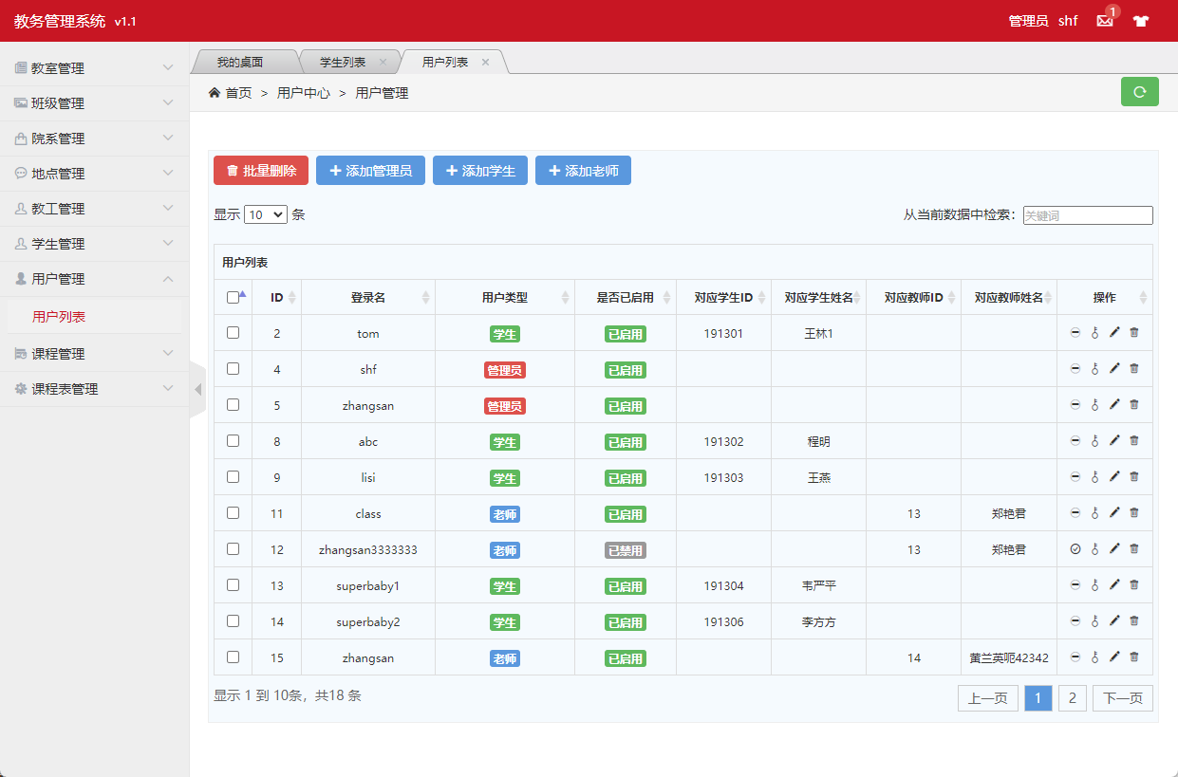

**图3.2.8.1 用户页面**

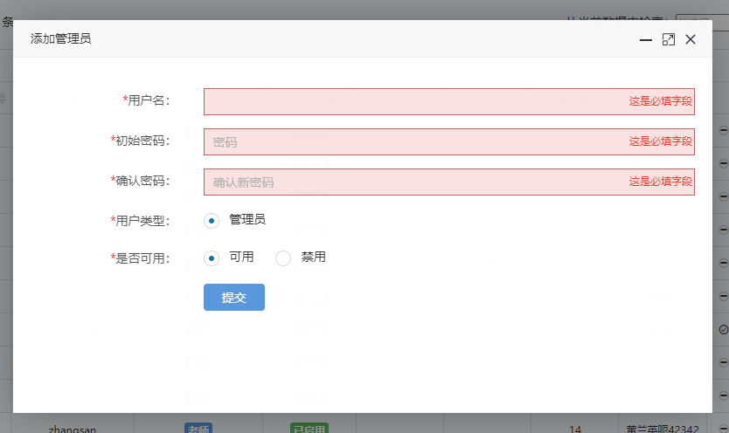

**图3.2.8.2 添加管理员用户页面**

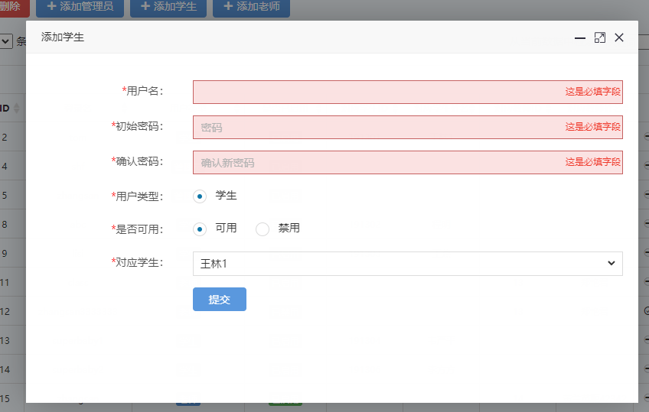

**图3.2.8.3 添加学生用户页面**

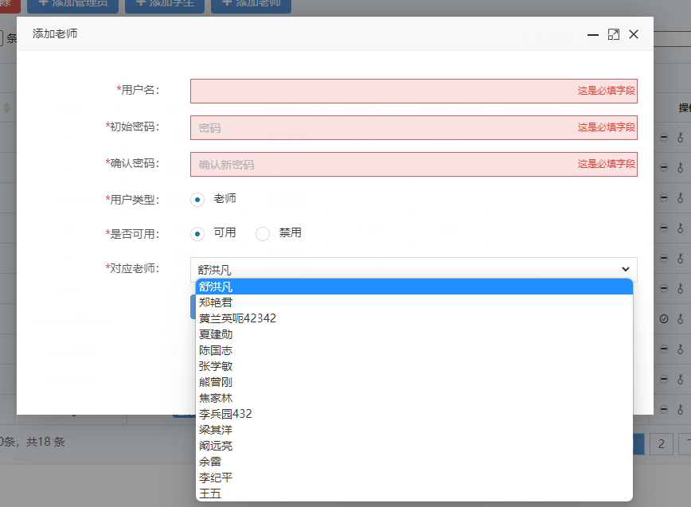

**图3.2.8.4 添加老师用户页面**

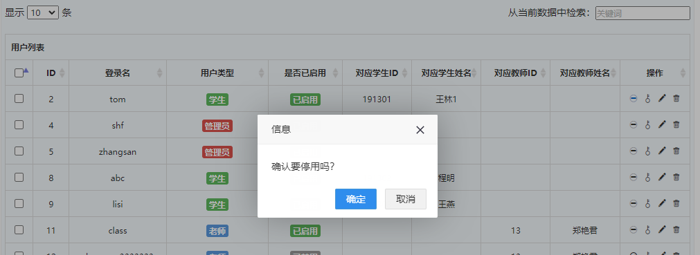

**图3.2.8.5 停用用户页面**

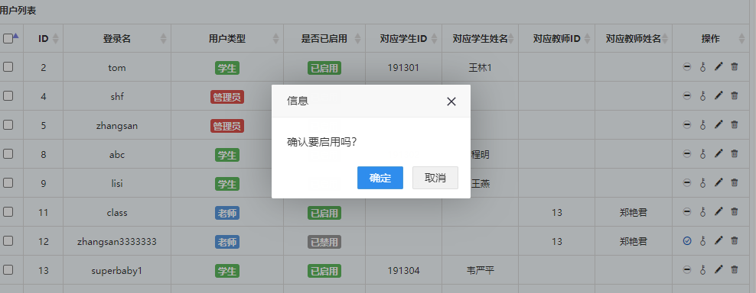

**图3.2.8.6 启用用户页面**

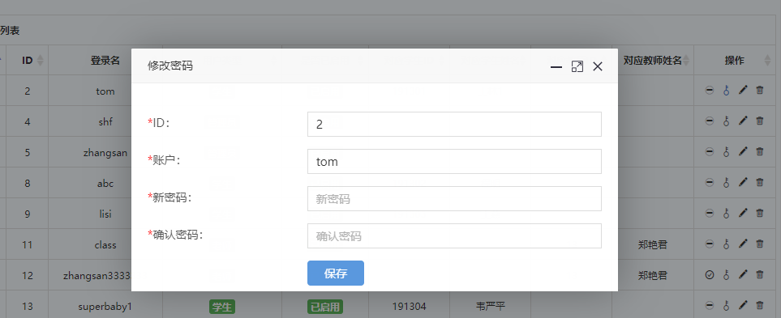

**图3.2.8.6 修改用户密码页面**

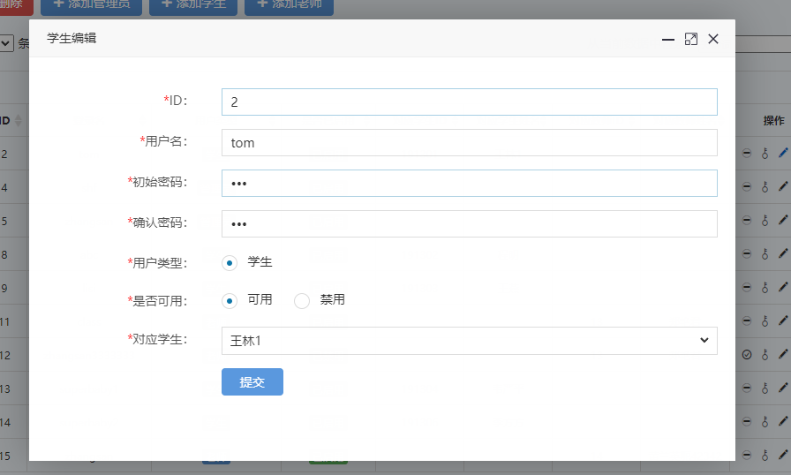

**图3.2.8.7 修改学生用户页面**

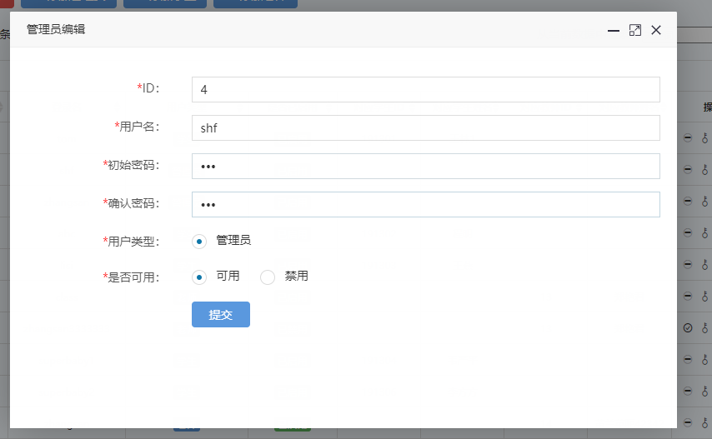

**图3.2.8.7 修改管理员用户页面**

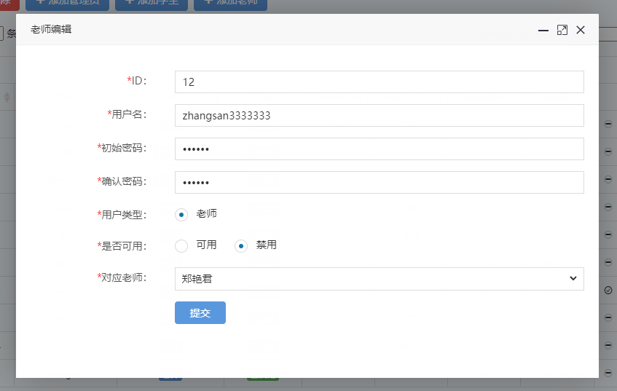

**图3.2.8.7 修改老师用户页面**

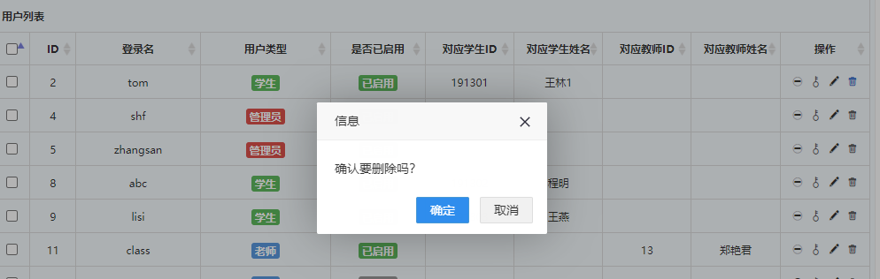

**图3.2.8.7 删除用户页面**

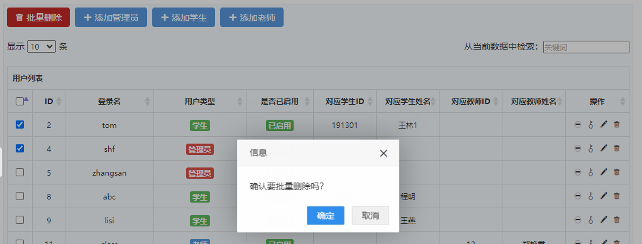

**图3.2.8.8 批量删除用户页面**

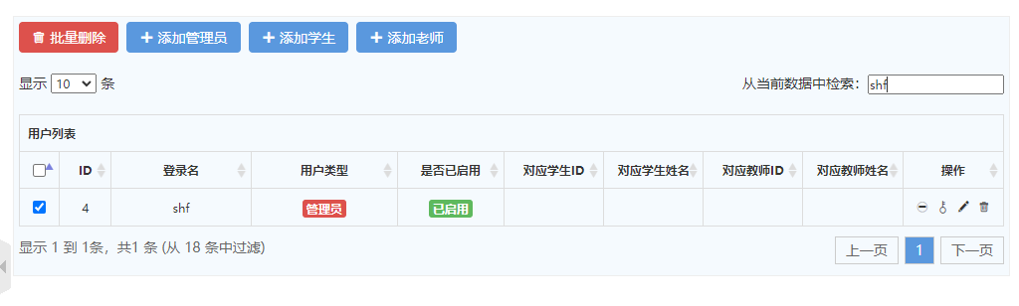

**图3.2.8.8 检索用户页面**

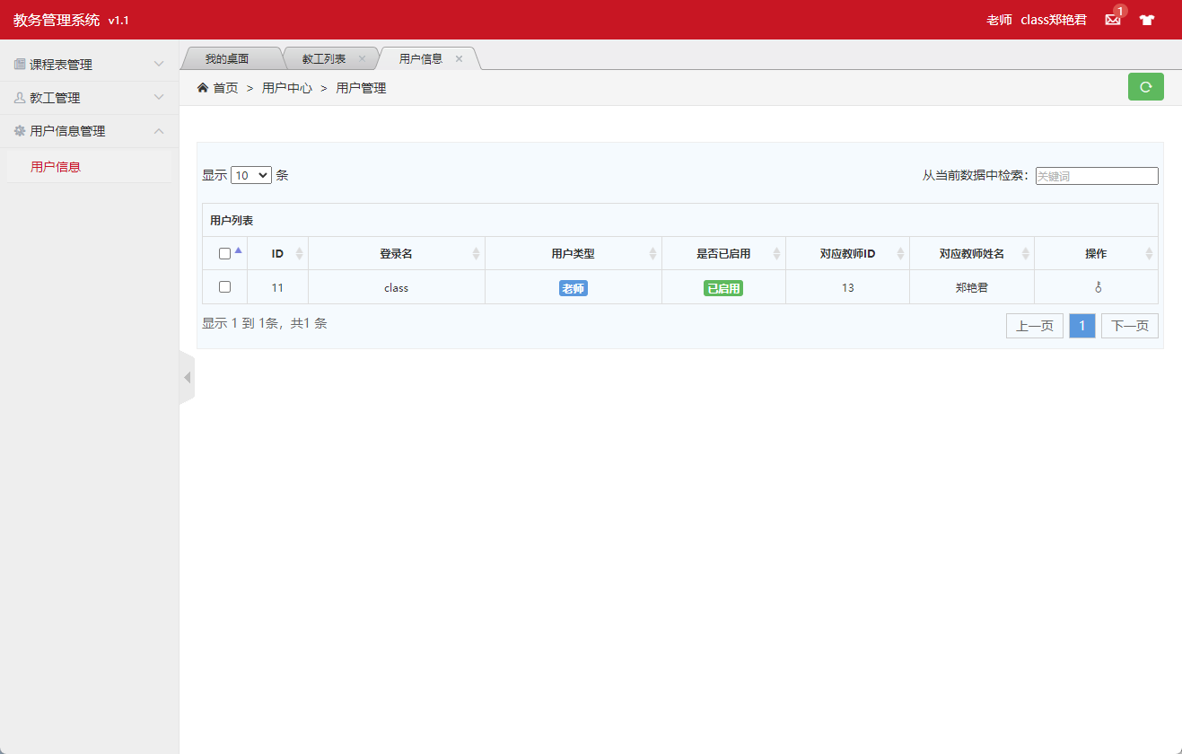

**图3.2.8.9 教师用户页面**

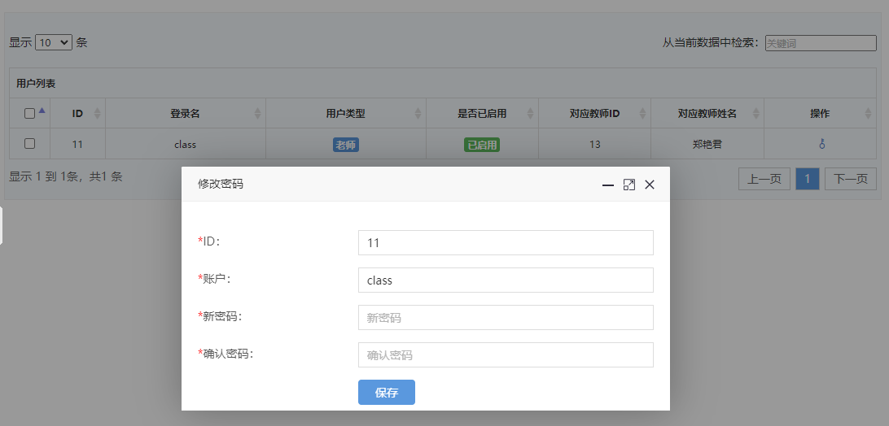

**图3.2.8.10 教师用户修改密码页面**

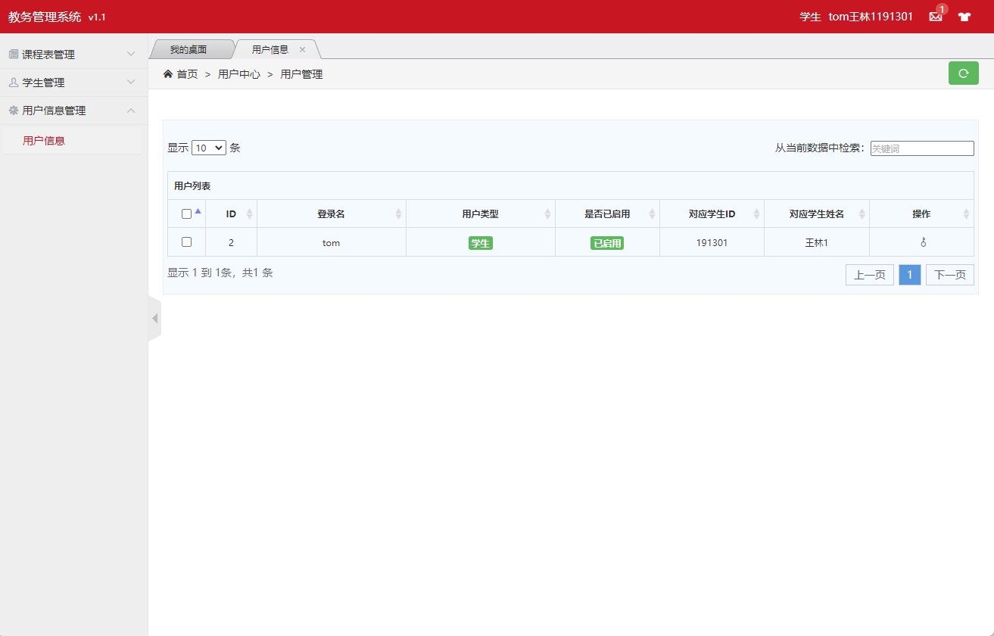

**图3.2.8.11 学生用户页面**

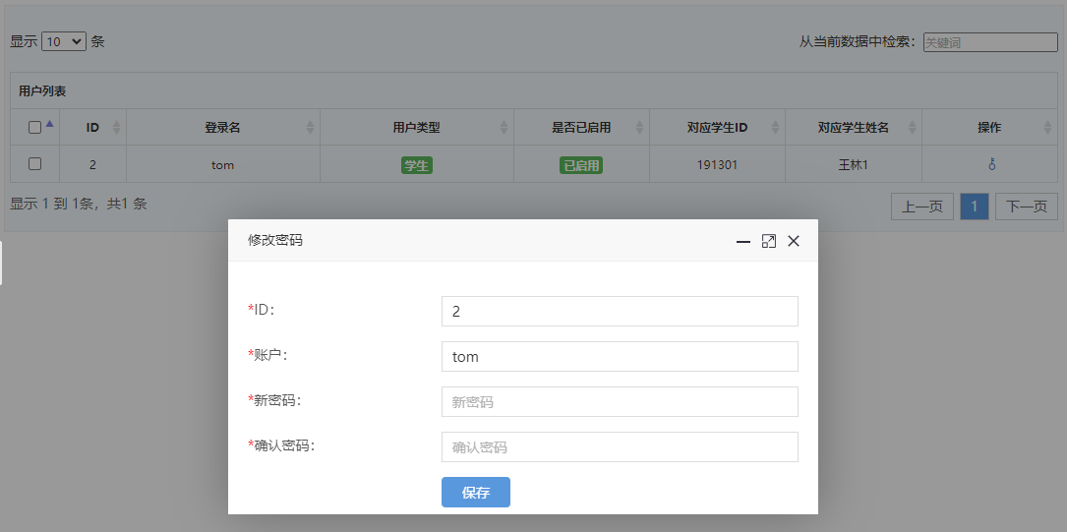

**图3.2.8.12 学生用户修改密码页面**

User.java 用户实体类

@Data  
@NoArgsConstructor  
@AllArgsConstructor  
@TableName*(*"user"*)*public class User implements Serializable *{* @TableId*(*type = IdType.*AUTO)* private Integer id; *//#ID* private String username; *//#用户名* private String password; *//#密码* private Integer type; *//#用户类型 0学生 1教师 2管理员* private Integer disabled; *//#是否可用* private Integer contrastStudentID; *// 对应学生ID* private Integer contrastTeacherID; *// 对应老师ID* @TableField*(*exist = false*)* private String contrastStudentName; *//对应学生姓名* @TableField*(*exist = false*)* private String contrastTeacherName; *//对应老师姓名* @TableField*(*exist = false*)* private Integer classNO; *//对应学生班级* @TableField*(*exist = false*)* private String captcha; *//验证码  
}*

UserMapper.java 用户mapper和Dao

@Repository  
public interface UserMapper extends BaseMapper*<*User*> {  
}*

UserController.java 用户控制类类

@Slf4j  
@Controller  
public class UserController *{* @Autowired  
 private UserMapper userMapper;  
  
 @Autowired  
 private StudentController studentController;  
  
 @Autowired  
 private TeacherController teacherController;  
  
 @ResponseBody  
 @GetMapping*(*"/user/isAvailableUserName"*)* public HashMap*<*String, Object*>* isAvailableUserName*(*User useres*){* User aUser = userMapper.selectOne*(*new QueryWrapper*<*User*>()*.eq*(*"username",useres.getUsername*()))*;  
 HashMap*<*String, Object*>* map = new HashMap*<>()*;  
 if *(*aUser == null*){* map.put*(*"code","100"*)*;  
 map.put*(*"id",useres.getUsername*())*;  
 *}* else *{* map.put*(*"code","500"*)*;  
 map.put*(*"id",useres.getUsername*())*;  
 *}* return map;  
 *}* @GetMapping*(*"/user/userListPage"*)* public String toUserList*(*Model model*){* List*<*User*>* userList = userMapper.selectList*(*null*)*;  
 for *(*User user : userList*) {* if *(*user.getContrastStudentID*()*!=null*){* user.setContrastStudentName*(*studentController.getStudentById*(*user.getContrastStudentID*())*.getName*())*;  
 *}* if *(*user.getContrastTeacherID*()*!=null*){* user.setContrastTeacherName*(*teacherController.getTeacherById*(*user.getContrastTeacherID*())*.getName*())*;  
 *}  
 }* model.addAttribute*(*"userList",userList*)*;  
 return "user/admin-list";  
 *}* @GetMapping*(*"/user/userPage"*)* public String userPage*(*User user,Model model*){* User u = userMapper.selectOne*(*new QueryWrapper*<*User*>()*.eq*(*"username",user.getUsername*()))*;  
 if *(*u.getContrastTeacherID*()*!=null*){* Teacher teacherById = teacherController.getTeacherById*(*u.getContrastTeacherID*())*;  
 u.setContrastTeacherName*(*teacherById.getName*())*;  
 *}* if *(*u.getContrastStudentID*()*!=null*){* Student studentById = studentController.getStudentById*(*u.getContrastStudentID*())*;  
 u.setContrastStudentName*(*studentById.getName*())*;  
 *}* ArrayList*<*User*>* users = new ArrayList*<>()*;  
 users.add*(*u*)*;  
 model.addAttribute*(*"userList",users*)*;  
 return "user/admin-list-public";  
 *}* @GetMapping*(*"/user/userListPaging/{num}/{size}"*)* @ResponseBody  
 public Page*<*User*>* pagelist*(*@PathVariable*(*"num"*)* int num, @PathVariable*(*"size"*)* int size*){* QueryWrapper*<*User*>* wrapper = new QueryWrapper*<>()*;  
 Page*<*User*>* page = new Page*<>(*num,size*)*;  
 System.*out*.println*(*page*)*;  
 return userMapper.selectPage*(*page,wrapper*)*;  
 *}* @ResponseBody  
 @PostMapping*(*"/user/stopUserById"*)* public HashMap*<*String, Object*>* stopUserById*(*User user*){  
 log*.info*(*user.toString*())*;  
  
 User u = new User*()*;  
 u.setId*(*user.getId*())*;  
 u.setDisabled*(*1*)*;  
 int count = userMapper.updateById*(*u*)*;  
 *log*.info*(*String.*valueOf(*count*))*;  
  
 HashMap*<*String, Object*>* map = new HashMap*<>()*;  
 if *(*count==1*){* map.put*(*"code","100"*)*;  
 map.put*(*"id",user.getId*())*;  
 *}* else *{* map.put*(*"code","500"*)*;  
 map.put*(*"id",user.getId*())*;  
 *}* return map;  
 *}* @ResponseBody  
 @PostMapping*(*"/user/startUserById"*)* public HashMap*<*String, Object*>* startUserById*(*User user*){  
 log*.info*(*user.toString*())*;  
  
 User u = new User*()*;  
 u.setId*(*user.getId*())*;  
 u.setDisabled*(*0*)*;  
 int count = userMapper.updateById*(*u*)*;  
 *log*.info*(*String.*valueOf(*count*))*;  
  
 HashMap*<*String, Object*>* map = new HashMap*<>()*;  
 if *(*count==1*){* map.put*(*"code","100"*)*;  
 map.put*(*"id",user.getId*())*;  
 *}* else *{* map.put*(*"code","500"*)*;  
 map.put*(*"id",user.getId*())*;  
 *}* return map;  
 *}* @ResponseBody  
 @PostMapping*(*"/user/deleteUserById"*)* public HashMap*<*String, Object*>* deleteUserById*(*User user*){  
 log*.info*(*user.toString*())*;  
  
 int count = userMapper.deleteById*(*user.getId*())*;  
 *log*.info*(*String.*valueOf(*count*))*;  
  
 HashMap*<*String, Object*>* map = new HashMap*<>()*;  
 if *(*count==1*){* map.put*(*"code","100"*)*;  
 map.put*(*"id",user.getId*())*;  
 *}* else *{* map.put*(*"code","500"*)*;  
 map.put*(*"id",user.getId*())*;  
 *}* return map;  
 *}* @ResponseBody  
 @PostMapping*(*"/user/deleteBatchIds"*)* public HashMap*<*String, Object*>* deleteBatchIds*(*String ids*){* System.*out*.println*(*ids*)*;  
  
 JSON parse = JSONUtil.*parse(*ids*)*;  
 int count = userMapper.deleteBatchIds*((*Collection*<*? extends Serializable*>)* parse*)*;  
 *log*.info*(*String.*valueOf(*count*))*;  
 HashMap*<*String, Object*>* map = new HashMap*<>()*;  
 if *(*count>=1*){* map.put*(*"code","100"*)*;  
 map.put*(*"ids",ids*)*;  
 *}* else *{* map.put*(*"code","500"*)*;  
 map.put*(*"ids",ids*)*;  
 *}* return map;  
 *}* @GetMapping*(*"/user/userAdd"*)* public String toUserAdd*(*Model model*){* List*<*Teacher*>* teachers = teacherController.teacherList*()*;  
 model.addAttribute*(*"teacherList",teachers*)*;  
 List*<*Student*>* studentList = studentController.getStudentList*()*;  
 model.addAttribute*(*"studentList",studentList*)*;  
 return "user/admin-add";  
 *}* @GetMapping*(*"/user/userAddStudent"*)* public String toUserAddStudent*(*Model model*){* List*<*Student*>* studentList = studentController.getStudentList*()*;  
 model.addAttribute*(*"studentList",studentList*)*;  
 return "user/admin-add-student";  
 *}* @GetMapping*(*"/user/userAddTeacher"*)* public String toUserAddTeacher*(*Model model*){* List*<*Teacher*>* teachers = teacherController.teacherList*()*;  
 model.addAttribute*(*"teacherList",teachers*)*;  
 return "user/admin-add-teacher";  
 *}* @ResponseBody  
 @PostMapping*(*"/user/userAdd"*)* public HashMap*<*String, Object*>* userAdd*(*User user*){  
 log*.info*(*user.toString*())*;  
  
 int count = userMapper.insert*(*user*)*;  
 *log*.info*(*String.*valueOf(*count*))*;  
  
 HashMap*<*String, Object*>* map = new HashMap*<>()*;  
 if *(*count==1*){* map.put*(*"code","100"*)*;  
 map.put*(*"id",user.getId*())*;  
 *}* else *{* map.put*(*"code","500"*)*;  
 map.put*(*"id",user.getId*())*;  
 *}* return map;  
 *}* @GetMapping*(*"/user/userUpdateStudent/{id}"*)* public String userUpdateStudent*(*@PathVariable*(*"id"*)* Integer id,Model model*){* User u = userMapper.selectById*(*id*)*;  
 model.addAttribute*(*"user",u*)*;  
 List*<*Student*>* studentList = studentController.getStudentList*()*;  
 model.addAttribute*(*"studentList",studentList*)*;  
 return "user/admin-update-student";  
 *}* @GetMapping*(*"/user/userUpdateTeacher/{id}"*)* public String userUpdateTeacher*(*@PathVariable*(*"id"*)* Integer id,Model model*){* User u = userMapper.selectById*(*id*)*;  
 model.addAttribute*(*"user",u*)*;  
 List*<*Teacher*>* teacherList = teacherController.teacherList*()*;  
 model.addAttribute*(*"teacherList",teacherList*)*;  
 return "user/admin-update-teacher";  
 *}* @GetMapping*(*"/user/userUpdate/{id}"*)* public String toUserUpdate*(*@PathVariable*(*"id"*)* Integer id,Model model*){* User u = userMapper.selectById*(*id*)*;  
 model.addAttribute*(*"user",u*)*;  
 return "user/admin-update";  
 *}* @GetMapping*(*"/user/userUpdatePassword/{id}"*)* public String toUserUpdatePassword*(*@PathVariable*(*"id"*)* Integer id,Model model*){* User u = userMapper.selectById*(*id*)*;  
 model.addAttribute*(*"user",u*)*;  
 return "user/change-password";  
 *}* @ResponseBody  
 @PostMapping*(*"/user/userUpdate"*)* public HashMap*<*String, Object*>* userUpdate*(*User user*){  
 log*.info*(*user.toString*())*;  
  
 int count = userMapper.updateById*(*user*)*;  
 *log*.info*(*String.*valueOf(*count*))*;  
  
 HashMap*<*String, Object*>* map = new HashMap*<>()*;  
 if *(*count==1*){* map.put*(*"code","100"*)*;  
 map.put*(*"id",user.getId*())*;  
 *}* else *{* map.put*(*"code","500"*)*;  
 map.put*(*"id",user.getId*())*;  
 *}* return map;  
 *}* @ResponseBody  
 @PostMapping*(*"/user/userUpdatePassword"*)* public HashMap*<*String, Object*>* userUpdatePassword*(*User user*){  
 log*.info*(*user.toString*())*;  
  
 int count = userMapper.update*(*user,new UpdateWrapper*<*User*>()* .set*(*"password",user.getPassword*())* .eq*(*"id",user.getId*()))*;  
 *log*.info*(*String.*valueOf(*count*))*;  
  
 HashMap*<*String, Object*>* map = new HashMap*<>()*;  
 if *(*count==1*){* map.put*(*"code","100"*)*;  
 map.put*(*"id",user.getId*())*;  
 *}* else *{* map.put*(*"code","500"*)*;  
 map.put*(*"id",user.getId*())*;  
 *}* return map;  
 *}  
  
}*

### 3.2.9 课程模块

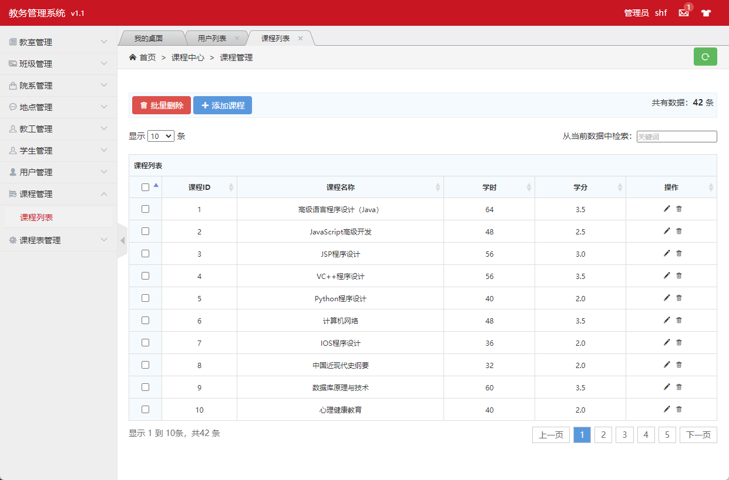

**图3.2.9.1 课程页面**

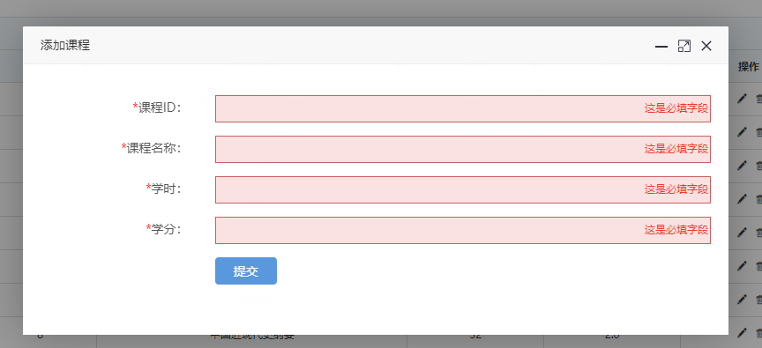

**图3.2.9.2 添加课程页面**

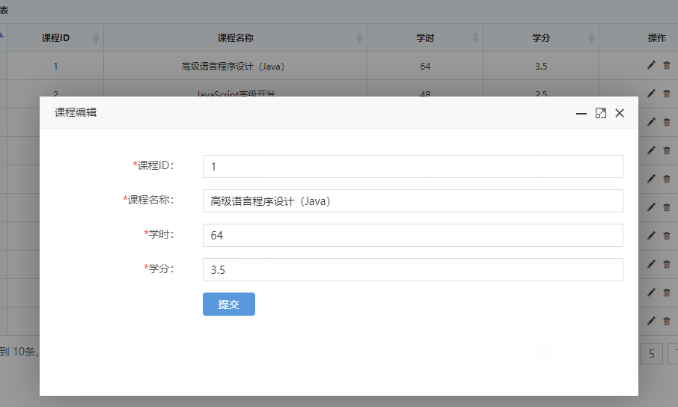

**图3.2.9.3 编辑课程页面**

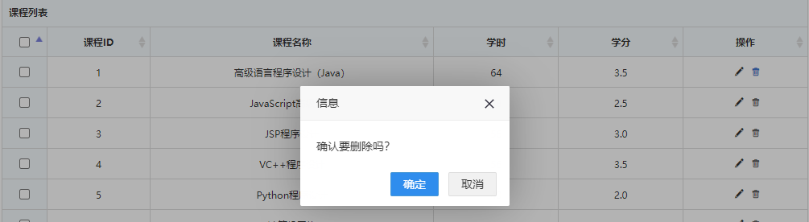

**图3.2.9.4 删除课程页面**

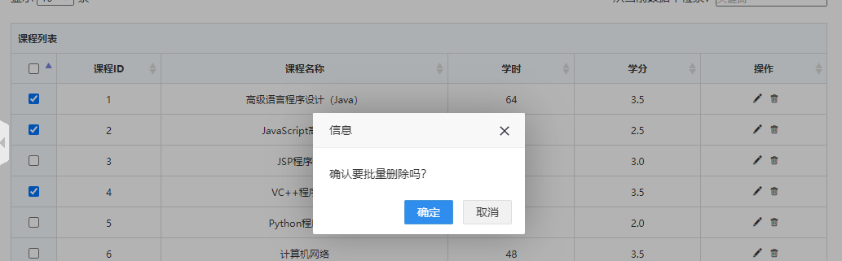

**图3.2.9.5 批量删除课程页面**

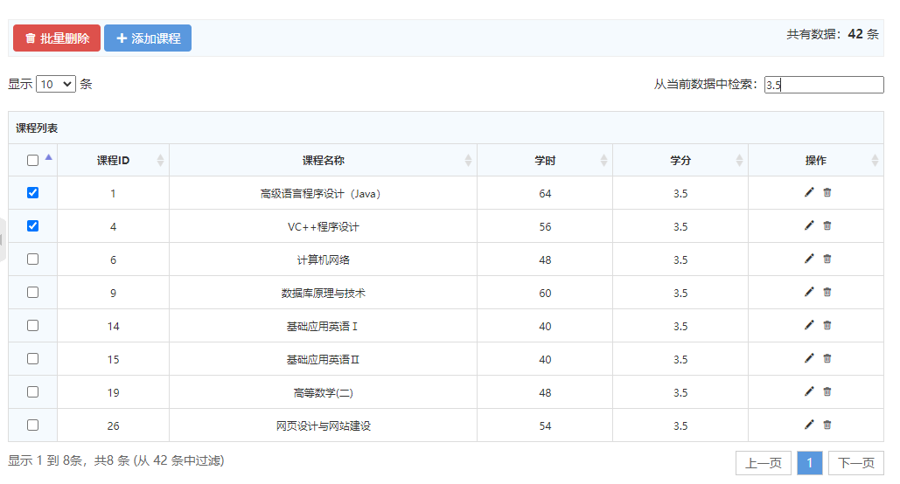

**图3.2.9.6 筛选课程页面**

Course.java 课程实体类

@Data  
@NoArgsConstructor  
@AllArgsConstructor  
@TableName*(*"course"*)*public class Course implements Serializable *{* @TableId  
 private Integer courseID; *//#课程ID* private String courseName; *//#课程名* private Integer hour; *//# 学时* private Double credit;*//# 学分  
}*

CourseMapper.java 课程mapper和DAO

@Repository  
public interface CourseMapper extends BaseMapper*<*Course*> {  
}*

CourseController.java 课程控制器

@Slf4j  
@Controller  
public class CourseController *{* @Autowired  
 private CourseMapper courseMapper;  
  
 @ResponseBody  
 @GetMapping*(*"/course/isAvailableCourseNO"*)* public HashMap*<*String, Object*>* isAvailableCourseNO*(*Course course*){* Course room = courseMapper.selectById*(*course.getCourseID*())*;  
 HashMap*<*String, Object*>* map = new HashMap*<>()*;  
 if *(*room == null*){* map.put*(*"code","100"*)*;  
 map.put*(*"id",course.getCourseID*())*;  
 *}* else *{* map.put*(*"code","500"*)*;  
 map.put*(*"id",course.getCourseID*())*;  
 *}* return map;  
 *}* @ResponseBody  
 @GetMapping*(*"/course/courseList"*)* public List*<*Course*>* toCourseList*(){* return courseMapper.selectList*(*null*)*;  
 *}* public Course getCourseById*(*Integer id*){* return courseMapper.selectById*(*id*)*;  
 *}* @GetMapping*(*"/course/courseListPage"*)* public String toCourseList*(*Model model*){* List*<*Course*>* courseList = courseMapper.selectList*(*null*)*;  
 model.addAttribute*(*"courseList",courseList*)*;  
 return "course/admin-list";  
 *}* @ResponseBody  
 @PostMapping*(*"/course/deleteCourseById"*)* public HashMap*<*String, Object*>* deleteCourseById*(*Course course*){  
 log*.info*(*course.toString*())*;  
  
 int count = courseMapper.deleteById*(*course.getCourseID*())*;  
 *log*.info*(*String.*valueOf(*count*))*;  
  
 HashMap*<*String, Object*>* map = new HashMap*<>()*;  
 if *(*count==1*){* map.put*(*"code","100"*)*;  
 map.put*(*"id",course.getCourseID*())*;  
 *}* else *{* map.put*(*"code","500"*)*;  
 map.put*(*"id",course.getCourseID*())*;  
 *}* return map;  
 *}* @ResponseBody  
 @PostMapping*(*"/course/deleteBatchIds"*)* public HashMap*<*String, Object*>* deleteBatchIds*(*String ids*){* System.*out*.println*(*ids*)*;  
  
 JSON parse = JSONUtil.*parse(*ids*)*;  
 int count = courseMapper.deleteBatchIds*((*Collection*<*? extends Serializable*>)* parse*)*;  
 *log*.info*(*String.*valueOf(*count*))*;  
 HashMap*<*String, Object*>* map = new HashMap*<>()*;  
 if *(*count>=1*){* map.put*(*"code","100"*)*;  
 map.put*(*"ids",ids*)*;  
 *}* else *{* map.put*(*"code","500"*)*;  
 map.put*(*"ids",ids*)*;  
 *}* return map;  
 *}* @GetMapping*(*"/course/courseAdd"*)* public String toUserAdd*(){* return "course/admin-add";  
 *}* @ResponseBody  
 @PostMapping*(*"/course/courseAdd"*)* public HashMap*<*String, Object*>* courseAdd*(*Course course*){  
 log*.info*(*course.toString*())*;  
  
 int count = courseMapper.insert*(*course*)*;  
 *log*.info*(*String.*valueOf(*count*))*;  
  
 HashMap*<*String, Object*>* map = new HashMap*<>()*;  
 if *(*count==1*){* map.put*(*"code","100"*)*;  
 map.put*(*"id",course.getCourseID*())*;  
 *}* else *{* map.put*(*"code","500"*)*;  
 map.put*(*"id",course.getCourseID*())*;  
 *}* return map;  
 *}* @GetMapping*(*"/course/courseUpdate/{id}"*)* public String toCourseUpdate*(*@PathVariable*(*"id"*)* Integer id, Model model*){* Course c = courseMapper.selectById*(*id*)*;  
 model.addAttribute*(*"course",c*)*;  
 return "course/admin-update";  
 *}* @ResponseBody  
 @PostMapping*(*"/course/courseUpdate"*)* public HashMap*<*String, Object*>* courseUpdate*(*Course course*){  
 log*.info*(*course.toString*())*;  
  
 int count = courseMapper.updateById*(*course*)*;  
 *log*.info*(*String.*valueOf(*count*))*;  
  
 HashMap*<*String, Object*>* map = new HashMap*<>()*;  
 if *(*count==1*){* map.put*(*"code","100"*)*;  
 map.put*(*"id",course.getCourseID*())*;  
 *}* else *{* map.put*(*"code","500"*)*;  
 map.put*(*"id",course.getCourseID*())*;  
 *}* return map;  
 *}  
}*

### 3.2.10 课程表模块

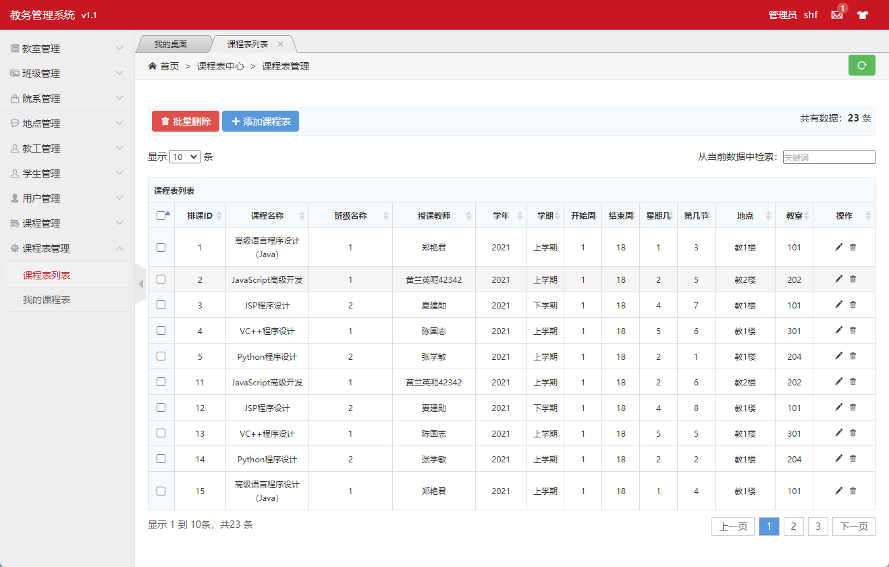

**图3.2.10.1课程表列表页面**

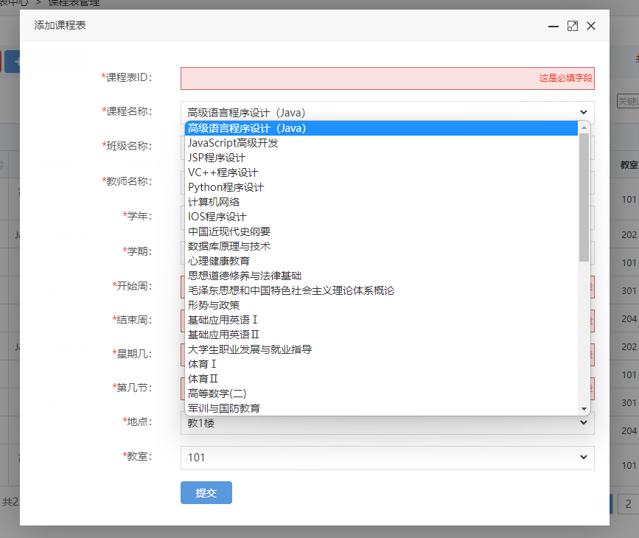

**图3.2.10.2添加课程表页面1**

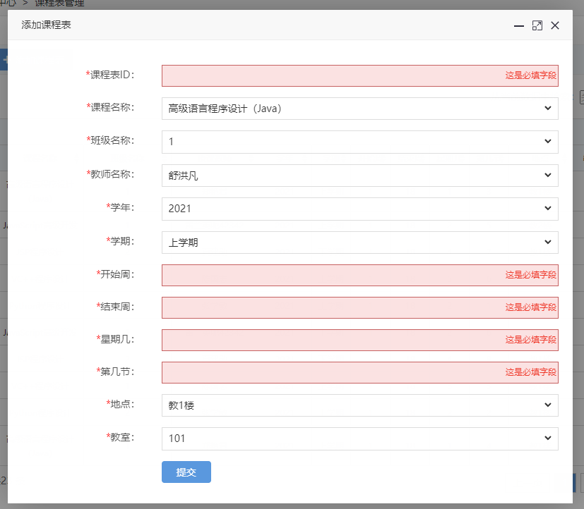

**图3.2.10.3添加课程表页面2**

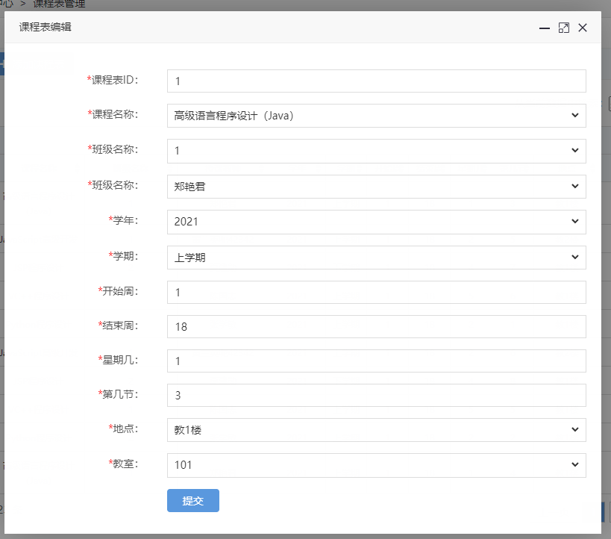

**图3.2.10.4修改课程表页面**

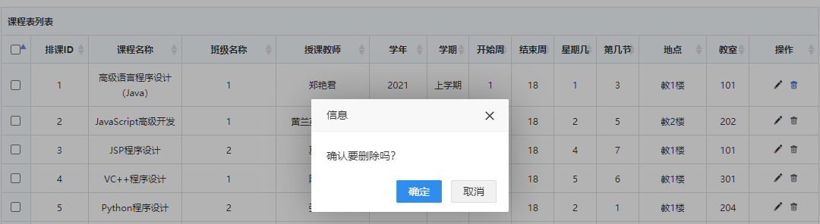

**图3.2.10.5删除课程表页面**

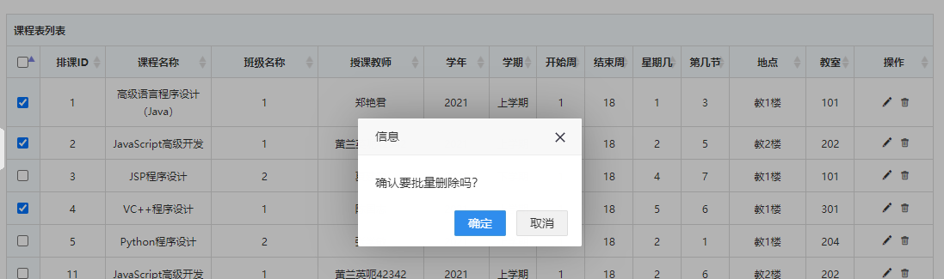

**图3.2.10.5批量删除课程表页面**

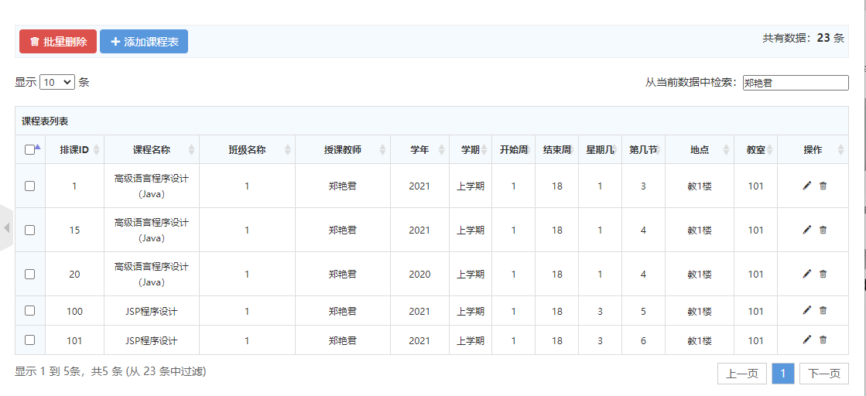

**图3.2.10.6筛选课程表页面**

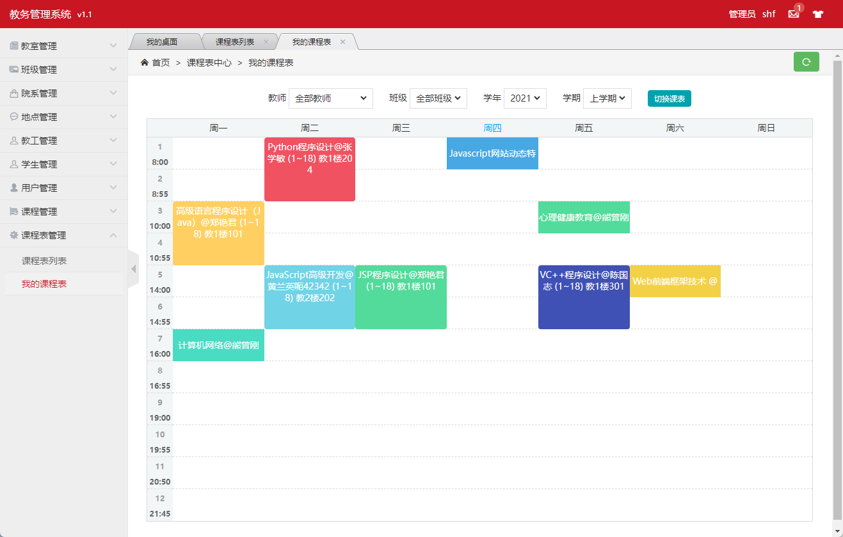

**图3.2.10.7 我的课程表页面**

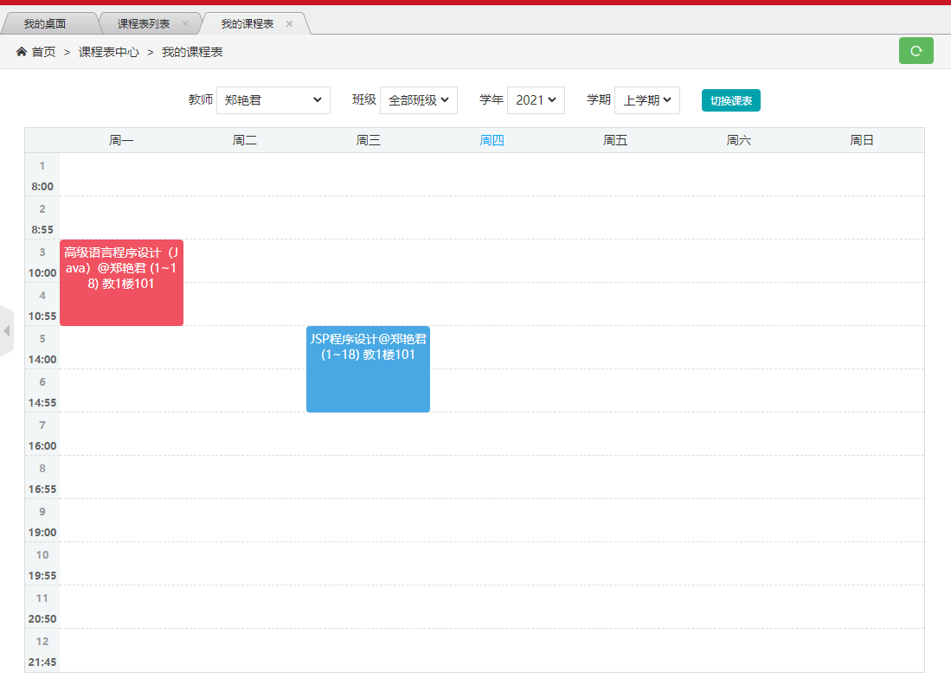

**图3.2.10.8 筛选课程表页面1**

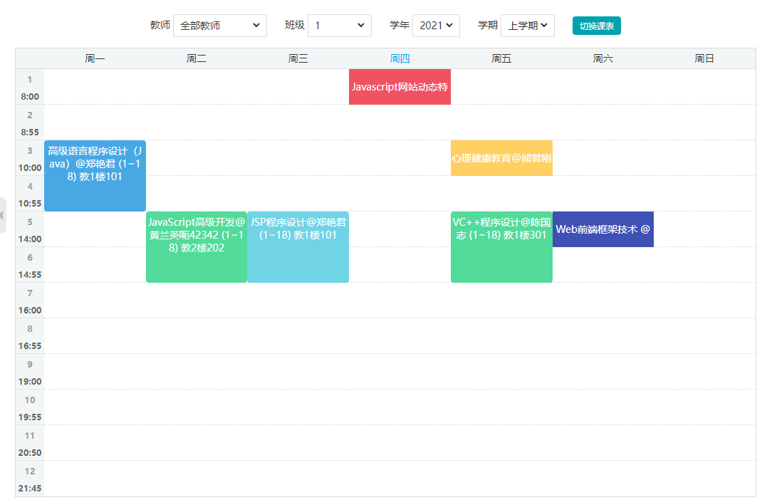

**图3.2.10.9 筛选课程表页面2**

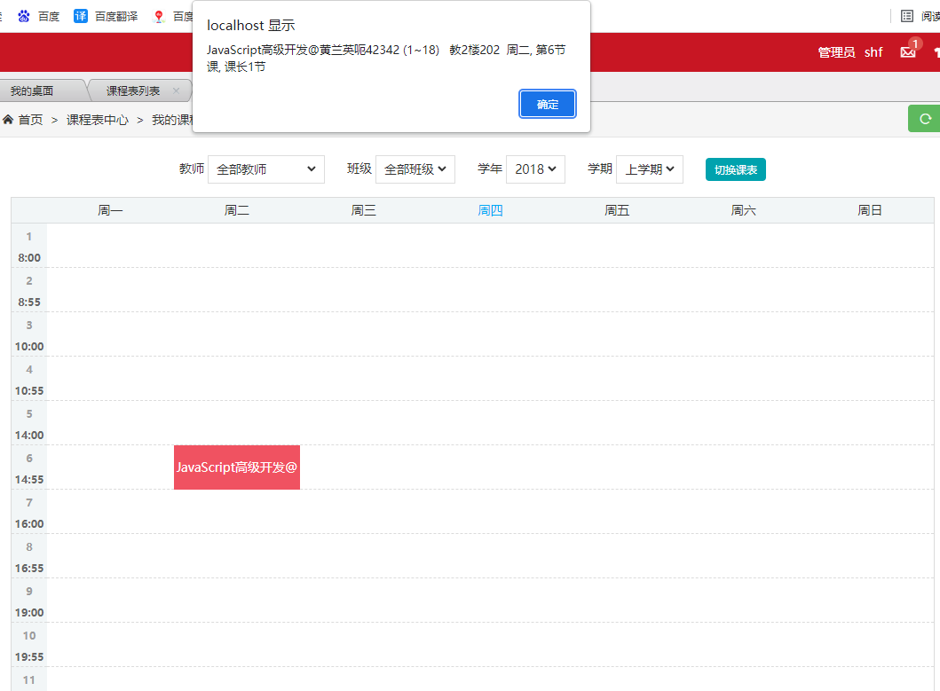

**图3.2.10.10 筛选课程表页面3**

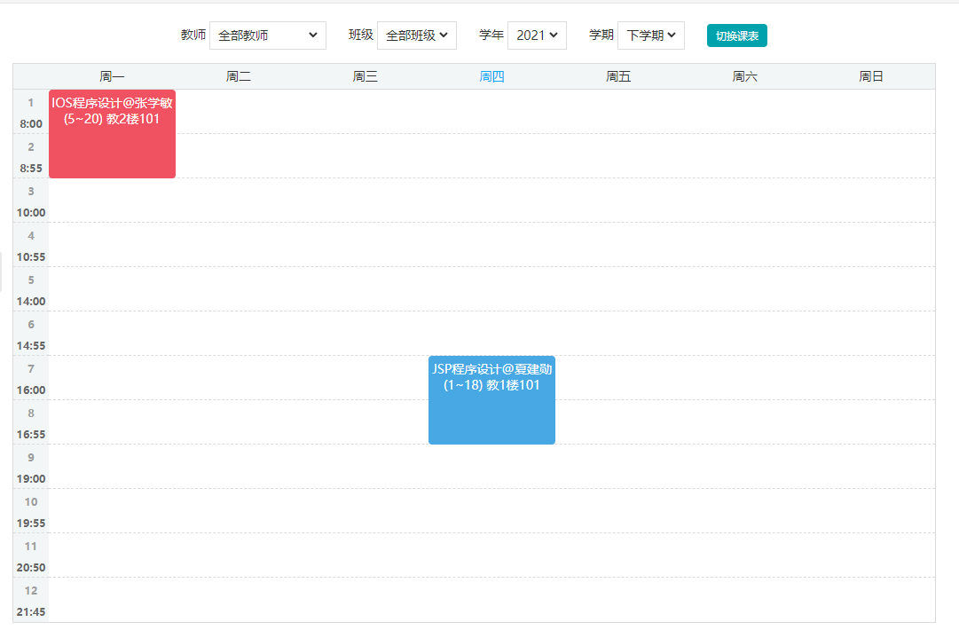

**图3.2.10.11 筛选课程表页面4**

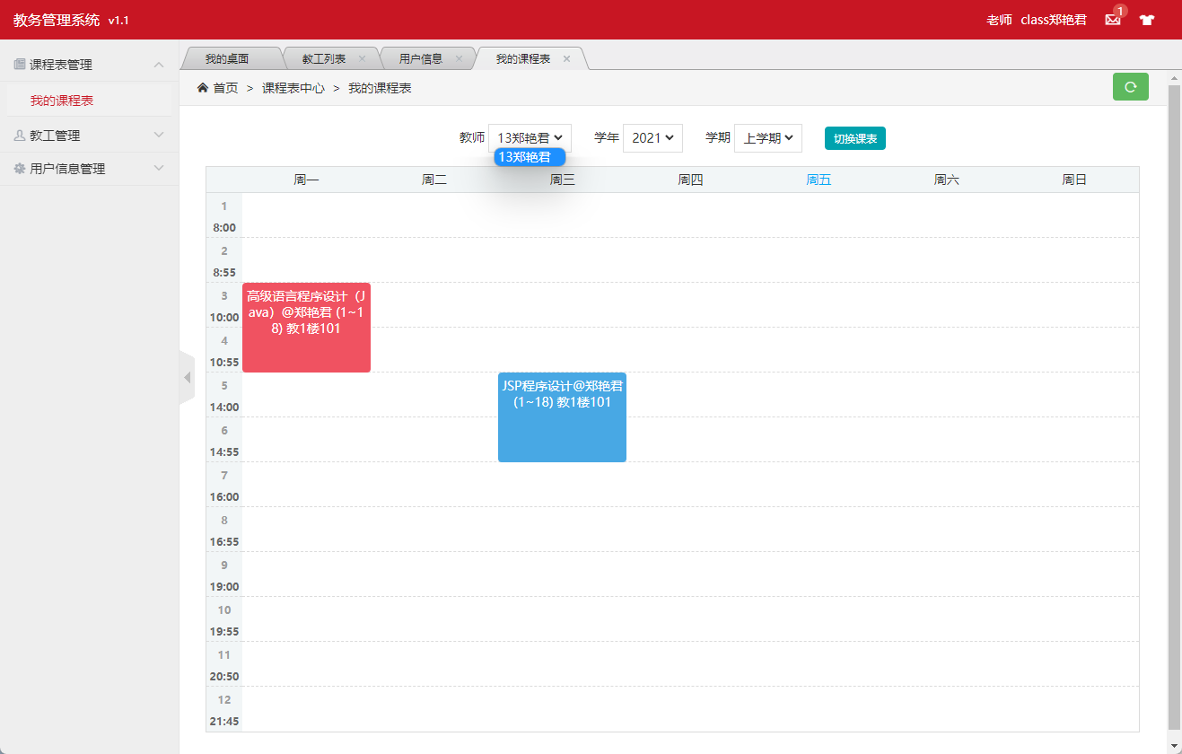

**图3.2.10.12 教工用户课程表页面**

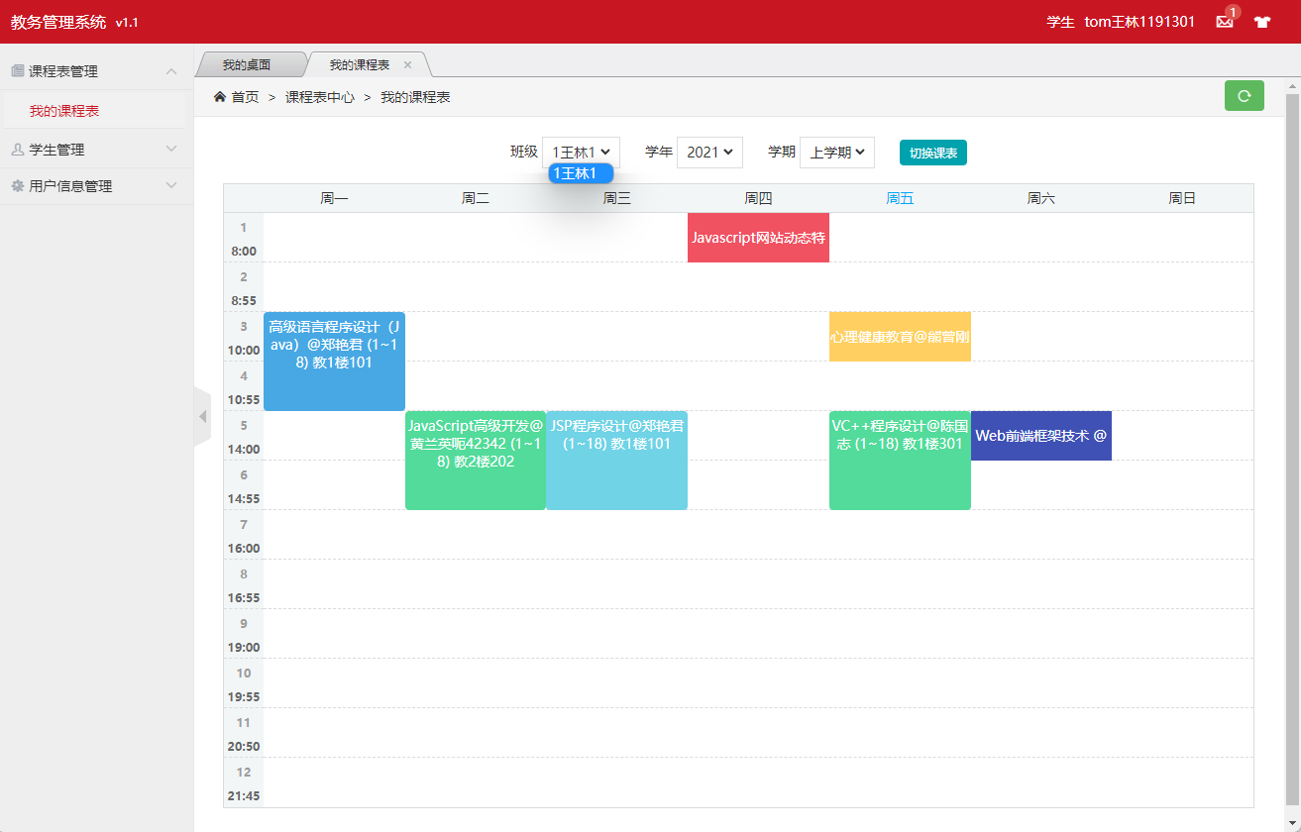

**图3.2.10.12 学生用户课程表页面**

Curriculum.java 课程表实体类

@Data  
@NoArgsConstructor  
@AllArgsConstructor  
@TableName*(*"curriculum"*)*public class Curriculum implements Serializable *{ // 课程* @TableId  
 private Integer ID; *// 排课ID* private Integer courseNO; *// 课程号* @TableField*(*exist = false*)* private String courseName; *//#课程名* private Integer classNO; *// 班级号* private Integer teacherID; *// 授课教师编号* @TableField*(*exist = false*)* private String name; *// 姓名* private Integer schoolYear; *// 学年* private Integer term; *// 学期* private Integer startWeek; *// 第几周开始* private Integer endWeek; *// 第几周结束* private Integer weekday; *// 星期几* private Integer section; *// 第几节* private Integer locationNo; *// 地点* @TableField*(*exist = false*)* private String locationName; *// 地点名称* private Integer classRoomNO; *// 教室  
}*

CurriculumMapper.java 课表Mapper和DAO

@Repository  
public interface CurriculumMapper extends BaseMapper*<*Curriculum*> {  
}*

CurriculumController.java 课程表控制器

@Slf4j  
@Controller  
public class CurriculumController *{* @Autowired  
 private CurriculumMapper curriculumMapper;  
  
 @Autowired  
 private CourseController courseController;  
  
 @Autowired  
 private ClassController classController;  
  
 @Autowired  
 private TeacherController teacherController;  
  
 @Autowired  
 private LocationController locationController;  
  
 @Autowired  
 private ClassRoomController classRoomController;  
  
 @ResponseBody  
 @GetMapping*(*"/curriculum/curriculumList"*)* public List*<*Curriculum*>* toCurriculumList*(){* return curriculumMapper.selectList*(*null*)*;  
 *}* public Curriculum getCurriculumById*(*Integer id*){* return curriculumMapper.selectById*(*id*)*;  
 *}* @GetMapping*(*"/curriculum/curriculumListPage"*)* public String toCurriculumList*(*Model model*){* List*<*Curriculum*>* curriculumList = curriculumMapper.selectList*(*null*)*;  
 for *(*Curriculum curriculum : curriculumList*) {* curriculum.setCourseName*(*courseController.getCourseById*(*curriculum.getCourseNO*())*.getCourseName*())*;  
 curriculum.setName*(*teacherController.getTeacherById*(*curriculum.getTeacherID*())*.getName*())*;  
 curriculum.setLocationName*(*locationController.getLocationById*(*curriculum.getLocationNo*())*.getLocationName*())*;  
 *}* model.addAttribute*(*"curriculumList",curriculumList*)*;  
 return "curriculum/admin-list";  
 *}* @ResponseBody  
 @PostMapping*(*"/curriculum/deleteCurriculumById"*)* public HashMap*<*String, Object*>* deleteCurriculumById*(*Curriculum curriculum*){  
 log*.info*(*curriculum.toString*())*;  
  
 int count = curriculumMapper.deleteById*(*curriculum.getID*())*;  
 *log*.info*(*String.*valueOf(*count*))*;  
  
 HashMap*<*String, Object*>* map = new HashMap*<>()*;  
 if *(*count==1*){* map.put*(*"code","100"*)*;  
 map.put*(*"id",curriculum.getID*())*;  
 *}* else *{* map.put*(*"code","500"*)*;  
 map.put*(*"id",curriculum.getID*())*;  
 *}* return map;  
 *}* @ResponseBody  
 @PostMapping*(*"/curriculum/deleteBatchIds"*)* public HashMap*<*String, Object*>* deleteBatchIds*(*String ids*){* System.*out*.println*(*ids*)*;  
  
 JSON parse = JSONUtil.*parse(*ids*)*;  
 int count = curriculumMapper.deleteBatchIds*((*Collection*<*? extends Serializable*>)* parse*)*;  
 *log*.info*(*String.*valueOf(*count*))*;  
 HashMap*<*String, Object*>* map = new HashMap*<>()*;  
 if *(*count>=1*){* map.put*(*"code","100"*)*;  
 map.put*(*"ids",ids*)*;  
 *}* else *{* map.put*(*"code","500"*)*;  
 map.put*(*"ids",ids*)*;  
 *}* return map;  
 *}* @GetMapping*(*"/curriculum/curriculumAdd"*)* public String toUserAdd*(*Model model*){* List*<*Course*>* courses = courseController.toCourseList*()*;  
 model.addAttribute*(*"courseList",courses*)*;  
 List*<*Class*>* classes = classController.toClassList*()*;  
 model.addAttribute*(*"classList",classes*)*;  
 List*<*Teacher*>* teachers = teacherController.teacherList*()*;  
 model.addAttribute*(*"teacherList",teachers*)*;  
 List*<*Location*>* locations = locationController.locationList*()*;  
 model.addAttribute*(*"locationList",locations*)*;  
 List*<*ClassRoom*>* classRooms = classRoomController.toClassRoomList*()*;  
 model.addAttribute*(*"classRoomList",classRooms*)*;  
 return "curriculum/admin-add";  
 *}* @ResponseBody  
 @PostMapping*(*"/curriculum/curriculumAdd"*)* public HashMap*<*String, Object*>* curriculumAdd*(*Curriculum curriculum*){  
 log*.info*(*curriculum.toString*())*;  
  
 int count = curriculumMapper.insert*(*curriculum*)*;  
 *log*.info*(*String.*valueOf(*count*))*;  
  
 HashMap*<*String, Object*>* map = new HashMap*<>()*;  
 if *(*count==1*){* map.put*(*"code","100"*)*;  
 map.put*(*"id",curriculum.getID*())*;  
 *}* else *{* map.put*(*"code","500"*)*;  
 map.put*(*"id",curriculum.getID*())*;  
 *}* return map;  
 *}* @GetMapping*(*"/curriculum/curriculumUpdate/{id}"*)* public String toCurriculumUpdate*(*@PathVariable*(*"id"*)* Integer id, Model model*){* List*<*Course*>* courses = courseController.toCourseList*()*;  
 model.addAttribute*(*"courseList",courses*)*;  
 List*<*Class*>* classes = classController.toClassList*()*;  
 model.addAttribute*(*"classList",classes*)*;  
 List*<*Teacher*>* teachers = teacherController.teacherList*()*;  
 model.addAttribute*(*"teacherList",teachers*)*;  
 List*<*Location*>* locations = locationController.locationList*()*;  
 model.addAttribute*(*"locationList",locations*)*;  
 List*<*ClassRoom*>* classRooms = classRoomController.toClassRoomList*()*;  
 model.addAttribute*(*"classRoomList",classRooms*)*;  
 Curriculum t = curriculumMapper.selectById*(*id*)*;  
 model.addAttribute*(*"curriculum",t*)*;  
 return "curriculum/admin-update";  
 *}* @ResponseBody  
 @PostMapping*(*"/curriculum/curriculumUpdate"*)* public HashMap*<*String, Object*>* curriculumUpdate*(*Curriculum curriculum*){  
 log*.info*(*curriculum.toString*())*;  
  
 int count = curriculumMapper.updateById*(*curriculum*)*;  
 *log*.info*(*String.*valueOf(*count*))*;  
  
 HashMap*<*String, Object*>* map = new HashMap*<>()*;  
 if *(*count==1*){* map.put*(*"code","100"*)*;  
 map.put*(*"id",curriculum.getID*())*;  
 *}* else *{* map.put*(*"code","500"*)*;  
 map.put*(*"id",curriculum.getID*())*;  
 *}* return map;  
 *}* @ResponseBody  
 @GetMapping*(*"/curriculum/isAvailableID"*)* public HashMap*<*String, Object*>* isAvailableID*(*Curriculum curriculum*){* Curriculum byId = curriculumMapper.selectById*(*curriculum.getID*())*;  
 HashMap*<*String, Object*>* map = new HashMap*<>()*;  
 if *(*byId == null*){* map.put*(*"code","100"*)*;  
 map.put*(*"id",curriculum.getID*())*;  
 *}* else *{* map.put*(*"code","500"*)*;  
 map.put*(*"id",curriculum.getID*())*;  
 *}* return map;  
 *}* @GetMapping*(*"/curriculum/myCurriculumPage"*)* public String myCurriculumPage*(*Model model*){* List*<*Curriculum*>* distinct_teacherID = curriculumMapper.selectList*(* new QueryWrapper*<*Curriculum*>()* .select*(*"distinct teacherID"*)* .orderByAsc*(*"teacherID"*)  
 )*;  
 for *(*Curriculum curriculum : distinct_teacherID*) {* curriculum.setName*(*teacherController.getTeacherById*(*curriculum.getTeacherID*())*.getName*())*;  
 *}* model.addAttribute*(*"distinctTeacherID",distinct_teacherID*)*;  
 List*<*Curriculum*>* distinct_schoolYear = curriculumMapper.selectList*(* new QueryWrapper*<*Curriculum*>()* .select*(*"distinct schoolYear"*)* .orderByAsc*(*"schoolYear"*)  
 )*;  
 model.addAttribute*(*"distinctSchoolYear",distinct_schoolYear*)*;  
 List*<*Curriculum*>* distinct_classNO = curriculumMapper.selectList*(* new QueryWrapper*<*Curriculum*>()* .select*(*"distinct classNO"*)* .orderByAsc*(*"classNO"*)  
 )*;  
 model.addAttribute*(*"distinctClassNO",distinct_classNO*)*;  
 return "curriculum/curriculum";  
 *}* @ResponseBody  
 @GetMapping*(*"/curriculum/myCurriculum"*)* public HashMap*<*String, Object*>* myCurriculum*(*Curriculum curriculum*){  
 log*.info*(*String.*valueOf(*curriculum*))*;  
 List*<*Curriculum*>* curriculumList = null;  
 if *(*curriculum.getClassNO*()*==404 && curriculum.getTeacherID*()*==404*){* curriculumList = curriculumMapper.selectList*(* new QueryWrapper*<*Curriculum*>()* .eq*(*"schoolYear",curriculum.getSchoolYear*())* .eq*(*"term",curriculum.getTerm*())  
 )*;  
 *}* else if *(*curriculum.getClassNO*()*==404*){* curriculumList = curriculumMapper.selectList*(* new QueryWrapper*<*Curriculum*>()* .eq*(*"teacherID",curriculum.getTeacherID*())* .eq*(*"schoolYear",curriculum.getSchoolYear*())* .eq*(*"term",curriculum.getTerm*())  
 )*;  
 *}* else if*(*curriculum.getTeacherID*()*==404*){* curriculumList = curriculumMapper.selectList*(* new QueryWrapper*<*Curriculum*>()* .eq*(*"schoolYear",curriculum.getSchoolYear*())* .eq*(*"term",curriculum.getTerm*())* .eq*(*"classNO",curriculum.getClassNO*())  
 )*;  
 *}* else *{* curriculumList = curriculumMapper.selectList*(* new QueryWrapper*<*Curriculum*>()* .eq*(*"teacherID",curriculum.getTeacherID*())* .eq*(*"schoolYear",curriculum.getSchoolYear*())* .eq*(*"term",curriculum.getTerm*())* .eq*(*"classNO",curriculum.getClassNO*())  
 )*;  
 *}* HashMap*<*String, Object*>* map = new HashMap*<>()*;  
 if *(*curriculumList.size*()* > 0*){* map.put*(*"code","100"*)*;  
 for *(*Curriculum c : curriculumList*) {* c.setCourseName*(*courseController.getCourseById*(*c.getCourseNO*())*.getCourseName*())*;  
 c.setName*(*teacherController.getTeacherById*(*c.getTeacherID*())*.getName*())*;  
 c.setLocationName*(*locationController.getLocationById*(*c.getLocationNo*())*.getLocationName*())*;  
 *}* map.put*(*"curriculumList",curriculumList*)*;  
 *}* else *{* map.put*(*"code","500"*)*;  
 map.put*(*"id",curriculum.getID*())*;  
 *}* return map;  
 *}  
}*

curriculum.html 课程表部分静态资源

*<*div class="page-container"*>  
 <*div class="text-c"*>  
 <*span th:if="*${*session.USER.type==2*}*"*>  
 <*label for="teacherID"*>*教师*</*label*>  
 <*span class="select-box inline"*>  
 <*select id="teacherID" class="select"*>  
 <*option value="404"*>*全部教师*</*option*>  
 <*option th:each="t: ${distinctTeacherID}" th:value="*${*t.teacherID*}*" th:text="*${*t.name*}*"*>*全部分类*</*option*>  
 </*select*>  
 </*span*>  
 <*span*>*&nbsp;&nbsp;&nbsp;&nbsp;*</*span*>  
  
 <*label for="classNO"*>*班级*</*label*>  
 <*span class="select-box inline"*>  
 <*select id="classNO" class="select"*>  
 <*option value="404"*>*全部班级*</*option*>  
 <*option th:each="c: ${distinctClassNO}" th:selected="${#dates.format(new java.util.Date().getTime(), 'yyyy')}==${c.classNO}" th:value="*${*c.classNO*}*" th:text="*${*c.classNO*}*"*>*全部分类*</*option*>  
 </*select*>  
 </*span*>  
 <*span*>*&nbsp;&nbsp;&nbsp;&nbsp;*</*span*>  
 </*span*>  
 <*span th:if="*${*session.USER.type==0*}*"*>  
 <*label for="classNO"*>*班级*</*label*>  
 <*span class="select-box inline"*>  
 <*select id="classNO" class="select"*>  
 <*option selected th:value="*${*session.USER.classNO*}*" th:text="*${*session.USER.classNO+session.USER.contrastStudentName*}*"*>*全部分类*</*option*>  
 </*select*>  
 </*span*>  
 <*span*>*&nbsp;&nbsp;&nbsp;&nbsp;*</*span*>  
 </*span*>  
  
 <*span th:if="*${*session.USER.type==1*}*"*>  
 <*label for="teacherID"*>*教师*</*label*>  
 <*span class="select-box inline"*>  
 <*select id="teacherID" class="select"*>  
 <*option checked th:value="*${*session.USER.contrastTeacherID*}*" th:text="*${*session.USER.contrastTeacherID+session.USER.contrastTeacherName*}*"*>*全部分类*</*option*>  
 </*select*>  
 </*span*>  
 <*span*>*&nbsp;&nbsp;&nbsp;&nbsp;*</*span*>  
 </*span*>  
  
 <*label for="schoolYear"*>*学年*</*label*>  
 <*span class="select-box inline"*>  
 <*select id="schoolYear" class="select"*>  
 <*option th:each="y: ${distinctSchoolYear}" th:selected="${#dates.format(new java.util.Date().getTime(), 'yyyy')}==${y.schoolYear}" th:value="*${*y.schoolYear*}*" th:text="*${*y.schoolYear*}*"*>*全部分类*</*option*>  
 </*select*>  
 </*span*>  
 <*span*>*&nbsp;&nbsp;&nbsp;&nbsp;*</*span*>  
 <*label for="term"*>*学期*</*label*>  
 <*span class="select-box inline"*>  
 <*select id="term" class="select"*>  
 <*option value="0"*>*上学期*</*option*>  
 <*option value="1"*>*下学期*</*option*>  
 </*select*>  
 </*span*>  
 <*span*>*&nbsp;&nbsp;&nbsp;&nbsp;*</*span*>  
 <*button onclick="*onChange()*"  
 style="background-color: #00a2ae; color: #fff; padding: 5px 10px; border-radius: 4px;border: none"*>* 切换课表  
 *</*button*>  
 </*div*>  
 <*div id="coursesTable"*></*div*>  
</*div*>  
  
<*script type="text/javascript" th:inline="javascript"*>  
 // 新建二维数组* let arr = new Array*(*7*)* for*(*let i = 0;i < arr.length;++i*){* arr*[*i*]* = new Array*(*12*)  
 }* for*(*let j = 0; j <arr.length;++j*){* for *(*let i = 0; i < arr*[*j*]*.length; i++*) {* arr*[*j*][*i*]*=""  
 *}  
 }* var week = window.innerWidth > 360 ? *[*'周一', '周二', '周三', '周四', '周五','周六','周日'*]* :  
 *[*'一', '二', '三', '四', '五','六','日'*]*;  
 var day = new Date*()*.getDay*()*;  
 var courseType = *[  
 [{*index: '1', name: '8:00'*}*, 1*]*,  
 *[{*index: '2', name: '8:55'*}*, 1*]*,  
 *[{*index: '3', name: '10:00'*}*, 1*]*,  
 *[{*index: '4', name: '10:55'*}*, 1*]*,  
 *[{*index: '5', name: '14:00'*}*, 1*]*,  
 *[{*index: '6', name: '14:55'*}*, 1*]*,  
 *[{*index: '7', name: '16:00'*}*, 1*]*,  
 *[{*index: '8', name: '16:55'*}*, 1*]*,  
 *[{*index: '9', name: '19:00'*}*, 1*]*,  
 *[{*index: '10', name: '19:55'*}*, 1*]*,  
 *[{*index: '11', name: '20:50'*}*, 1*]*,  
 *[{*index: '12', name: '21:45'*}*, 1*]  
 ]*;  
  
 *// 实例化(初始化课表)* var Timetable = new Timetables*({* el: '#coursesTable',  
 timetables: arr,  
 week: week,  
 timetableType: courseType,  
 highlightWeek: day,  
 gridOnClick: function *(*e*) {  
 alert(*e.name + ' ' + e.week + ', 第' + e.index + '节课, 课长' + e.length + '节'*)*;  
 console.log*(*e*)*;  
 *}*,  
 styles: *{* Gheight: 50  
 *}  
 })*;  
  
 *//切换课表* function *onChange() {* var ctxPath = [[@*{*/}]];  
 let schoolYear=$*(*"#schoolYear*")*.val*()* let term=$*(*"#term*")*.val*()* let classNO=$*(*"#classNO*")*.val*()*==null?"404":$*(*"#classNO*")*.val*()* let teacherID=$*(*"#teacherID*")*.val*()*==null?"404":$*(*"#teacherID*")*.val*()* $.get*(*ctxPath+"curriculum/myCurriculum?schoolYear="+schoolYear+"&term="+term+"&classNO="+classNO+"&teacherID="+teacherID,function*(*data,status*){  
 // 新建二维数组* var arr = new Array*(*7*)* for*(*let i = 0;i < arr.length;++i*){* arr*[*i*]* = new Array*(*12*)  
 }* for*(*let j = 0; j <arr.length;++j*){* for *(*let i = 0; i < arr*[*j*]*.length; i++*) {* arr*[*j*][*i*]*=""  
 *}  
 }* if *(*data.code ==100*) {* console.log*(*"数据: " + data + "\n状态: " + status*)*;  
 var curriculumList = data.curriculumList  
 *// 新建二维数组* arr = new Array*(*7*)* for*(*let i = 0;i < arr.length;++i*){* arr*[*i*]* = new Array*(*12*)  
 }* for*(*let j = 0; j <arr.length;++j*){* for *(*let i = 0; i < arr*[*j*]*.length; i++*) {* arr*[*j*][*i*]*=""  
 *}  
 }* for *(*let i = 0; i < curriculumList.length; i++*) {* let weekday=curriculumList*[*i*]*.weekday  
 let section=curriculumList*[*i*]*.section  
 arr*[*weekday-1*][*section-1*]*=curriculumList*[*i*]*.courseName+"@"+curriculumList*[*i*]*.name+" ("+  
 curriculumList*[*i*]*.startWeek+"~"+curriculumList*[*i*]*.endWeek+") "+  
 curriculumList*[*i*]*.locationName+curriculumList*[*i*]*.classRoomNO  
 *}* console.log*(*arr*)  
 }* Timetable.setOption*({* timetables: arr,  
 week: week,  
 timetableType: courseType,  
 highlightWeek: day,  
 gridOnClick: function *(*e*) {  
 alert(*e.name + ' ' + e.week + ', 第' + e.index + '节课, 课长' + e.length + '节'*)*;  
 console.log*(*e*)*;  
 *}*,  
 styles: *{* Gheight: 50  
 *}  
 })*;  
 *})*;  
 *}  
</*script*>  
</*body*>  
</*html*>*

### 3.2.11 拦截器模块

AdminInterceptor.java 未登录用户跳回登录页面

public class AdminInterceptor implements HandlerInterceptor *{  
 /**  
 * 在请求处理之前进行调用（Controller方法调用之前）  
 */* @Override  
 public boolean preHandle*(*HttpServletRequest request, HttpServletResponse response, Object handler*) {  
// System.out.println("执行了TestInterceptor的preHandle方法");* try *{  
 //统一拦截（查询当前session是否存在user）(这里user会在每次登陆成功后，写入session)* User user=*(*User*)*request.getSession*()*.getAttribute*(*"USER"*)*;  
 if*(*user!=null*){* return true;  
 *}* response.sendRedirect*(*request.getContextPath*()*+"/login"*)*;  
 *}* catch *(*IOException e*) {* e.printStackTrace*()*;  
 *}* return false;*//如果设置为false时，被请求时，拦截器执行到此处将不会继续操作  
 //如果设置为true时，请求将会继续执行后面的操作  
 }  
  
 /**  
 * 请求处理之后进行调用，但是在视图被渲染之前（Controller方法调用之后）  
 */* @Override  
 public void postHandle*(*HttpServletRequest request, HttpServletResponse response, Object handler, ModelAndView modelAndView*) {  
// System.out.println("执行了TestInterceptor的postHandle方法");  
 }  
  
 /**  
 * 在整个请求结束之后被调用，也就是在DispatcherServlet 渲染了对应的视图之后执行（主要是用于进行资源清理工作）  
 */* @Override  
 public void afterCompletion*(*HttpServletRequest request, HttpServletResponse response, Object handler, Exception ex*) {  
// System.out.println("执行了TestInterceptor的afterCompletion方法");  
 }  
}*

LoginConfig.java 让拦截器不拦截静态资源、登录页面和验证码

@Configuration  
public class LoginConfig implements WebMvcConfigurer *{* @Override  
 public void addInterceptors*(*InterceptorRegistry registry*) {  
 //注册TestInterceptor拦截器* InterceptorRegistration registration = registry.addInterceptor*(*new AdminInterceptor*())*;  
 registration.addPathPatterns*(*"/**"*)*; *//所有路径都被拦截* registration.excludePathPatterns*( //添加不拦截路径* "/login", *//登录* "/captcha", *//验证码* "/**/*.html", *//html静态资源* "/**/*.js", *//js静态资源* "/**/*.css", *//css静态资源* "/**/*.ico",  
 "/**/*.jpg",  
 "/**/*.png",  
 "/**/*.woff",  
 "/**/*.ttf"  
 *)*;  
 *}  
}*

### 3.2.12 学生模块

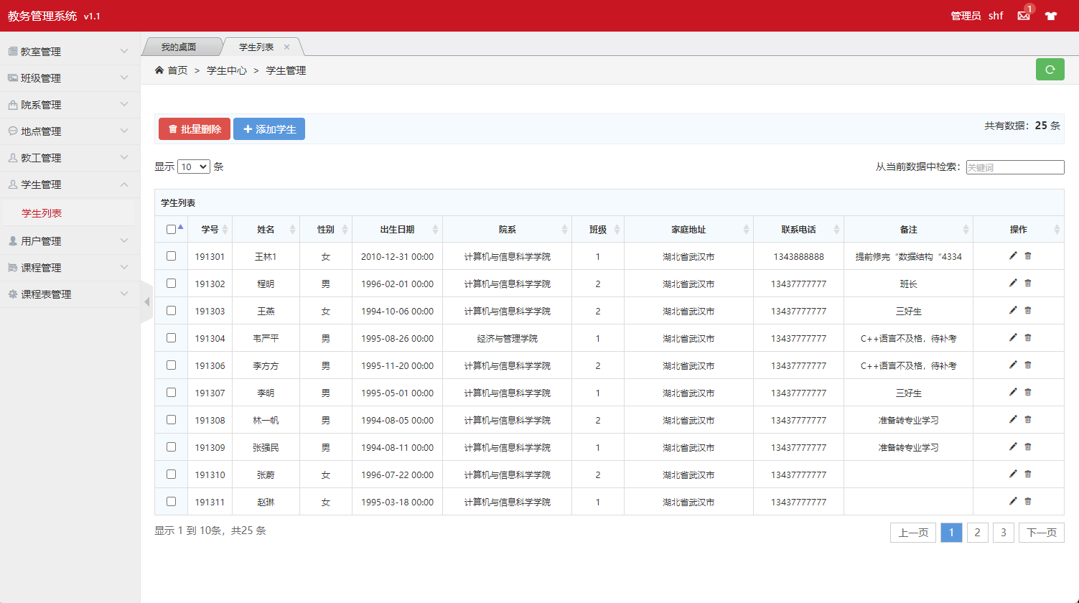

**图3.2.12.1 学生页面**

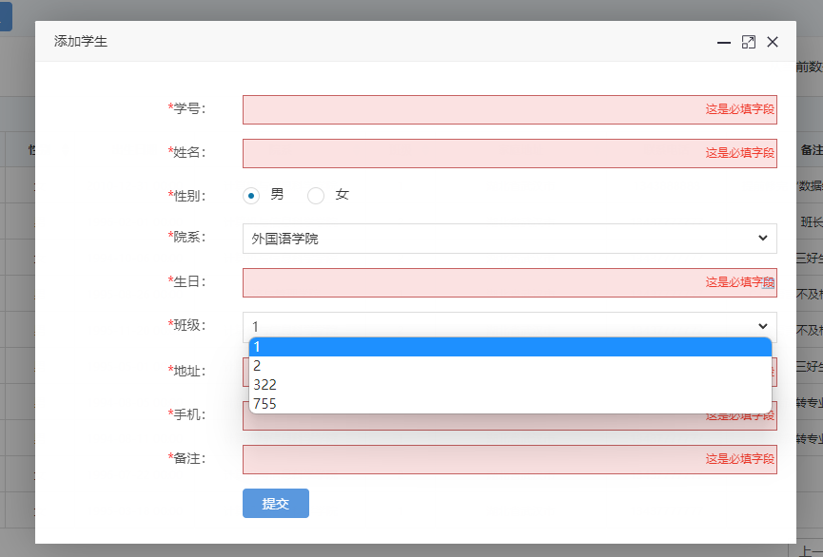

**图3.2.12.2 添加学生页面**

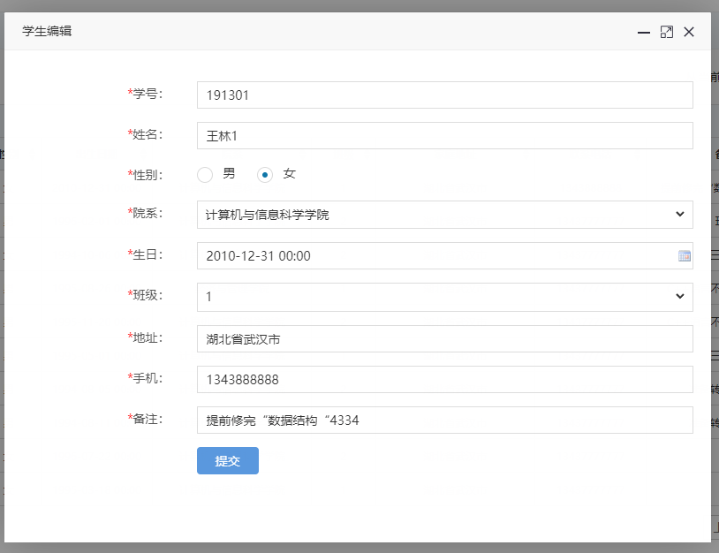

**图3.2.12.3 修改学生页面**

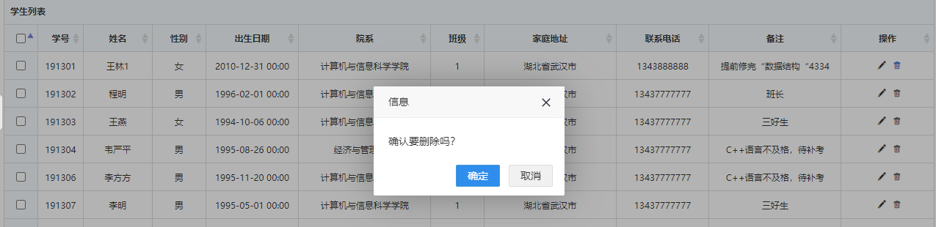

**图3.2.12.4 删除学生页面**

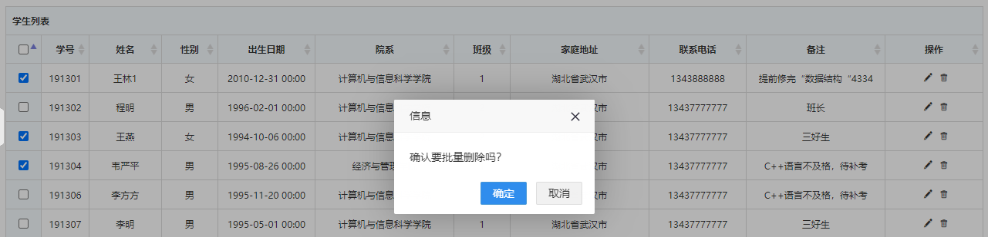

**图3.2.12.5 批量删除学生页面**

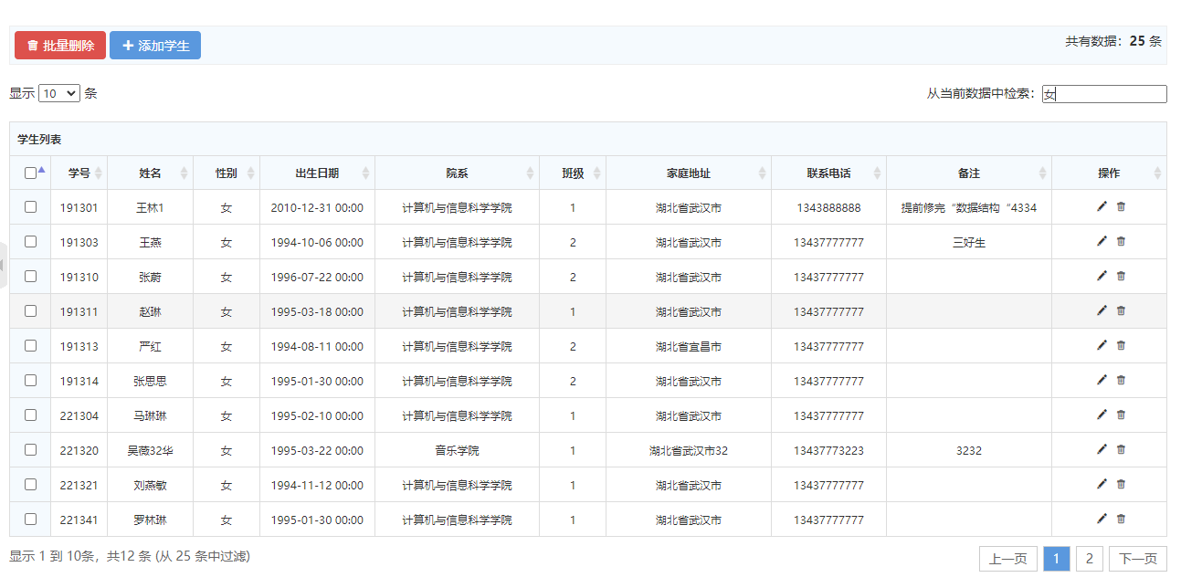

**图3.2.12.6 条件查询学生页面**

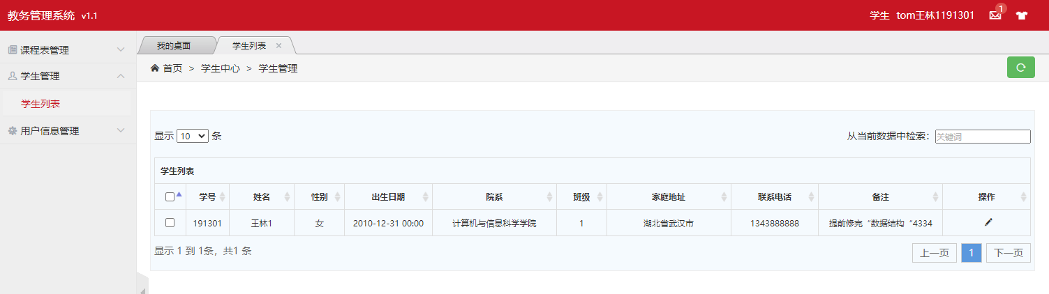

**图3.2.12.7 学生用户学生页面**

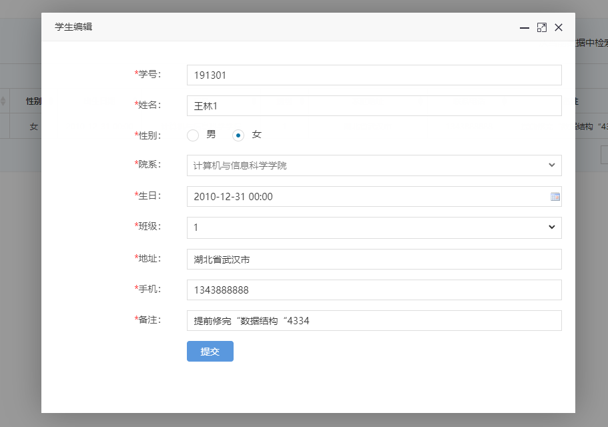

**图3.2.12.8 学生用户修改学生信息页面**

Student.java 学生实体类

@Data  
@NoArgsConstructor  
@AllArgsConstructor  
@TableName*(*"student"*)*public class Student implements Serializable *{* @TableId  
 private Integer studentID; *// 学号* private String name; *// 姓名* private Integer sex; *// 性别* @DateTimeFormat*(*pattern = "yyyy-MM-dd HH:mm"*)* private Date birthday; *// 出生日期* private Integer facultyNO; *// 院系* @TableField*(*exist = false*)* private String facultyName; *//#院系名称* private Integer classNO; *// 班级* private String address; *// 家庭地址* private String phone; *// 联系电话* private String remark; *// 备注  
}*

StudentMapper.java 学生mapper和DAO

@Repository  
public interface StudentMapper extends BaseMapper*<*Student*> {  
}*

StudentController.java 学生控制器

@Slf4j  
@Controller  
public class StudentController *{* @Autowired  
 private StudentMapper StudentMapper;  
  
 @Autowired  
 private FacultyController facultyController;  
  
 @Autowired  
 private ClassController classController;  
  
 public List*<*Student*>* getStudentList*(){* return StudentMapper.selectList*(*null*)*;  
 *}* public Student getStudentById*(*Integer id*){* return StudentMapper.selectById*(*id*)*;  
 *}* @ResponseBody  
 @GetMapping*(*"/student/isAvailableStudentNO"*)* public HashMap*<*String, Object*>* isAvailableStudentNO*(*Student student*){* Student room = StudentMapper.selectById*(*student.getStudentID*())*;  
 HashMap*<*String, Object*>* map = new HashMap*<>()*;  
 if *(*room == null*){* map.put*(*"code","100"*)*;  
 map.put*(*"id",student.getStudentID*())*;  
 *}* else *{* map.put*(*"code","500"*)*;  
 map.put*(*"id",student.getStudentID*())*;  
 *}* return map;  
 *}* @GetMapping("/student/studentPage")  
 public String studentPage*(*Student student,Model model*){* System.*out*.println*(*student*)*;  
 ArrayList*<*Student*>* students = new ArrayList*<>()*;  
 Student s = StudentMapper.selectById(student.getStudentID());  
 s.setFacultyName(facultyController.getFacultyById(s.getFacultyNO()).getFacultyName());  
 students.add(s);  
 model.addAttribute("studentList",students);  
 return "student/admin-list-public";  
 }  
  
 @GetMapping*(*"/student/studentListPage")  
 public String toTeacherList(Model model){  
 List<Student> studentList = StudentMapper.selectList(null);  
 for (Student student : studentList) {  
 student.setFacultyName(facultyController.getFacultyById(student.getFacultyNO()).getFacultyName());  
 }  
 model.addAttribute("studentList",studentList);  
 return "student/admin-list";  
 *}* @ResponseBody  
 @PostMapping*(*"/student/deleteStudentById"*)* public HashMap<String, Object> deleteStudentById(Student student){  
 log.info(student.toString());  
  
 int count = StudentMapper.deleteById(student.getStudentID());  
 log.info(String.valueOf(count));  
  
 HashMap*<*String, Object*>* map = new HashMap*<>()*;  
 if *(*count==1*){* map.put*(*"code","100");  
 map.put("id",student.getStudentID());  
 } else {  
 map.put("code","500");  
 map.put("id",student.getStudentID());  
 }  
 return map;  
 *}* @ResponseBody  
 @PostMapping*(*"/student/deleteBatchIds")  
 public HashMap<String, Object> deleteBatchIds(String ids){  
 System.out.println(ids);  
  
 JSON parse = JSONUtil.parse(ids);  
 int count = StudentMapper.deleteBatchIds*((*Collection*<*? extends Serializable*>)* parse);  
 log.info(String.valueOf(count));  
 HashMap<String, Object> map = new HashMap<>();  
 if (count>=1){  
 map.put("code","100");  
 map.put("ids",ids);  
 } else {  
 map.put("code","500");  
 map.put("ids",ids);  
 *}* return map;  
 *}* @GetMapping*(*"/student/studentAdd"*)* public String toStudentAdd*(*Model model*){* List*<*Faculty*>* facultyList = facultyController.toFacultyList();  
 model.addAttribute("facultyList",facultyList);  
 List<Class> classList = classController.toClassList();  
 model.addAttribute("classList",classList);  
 return "student/admin-add";  
 }  
  
 @ResponseBody  
 @PostMapping("/student/studentAdd")  
 public HashMap<String, Object> studentAdd(Student student){  
 log.info(student.toString());  
  
 int count = StudentMapper.insert(student);  
 *log*.info*(*String.valueOf(count));  
  
 HashMap<String, Object> map = new HashMap<>();  
 if (count==1){  
 map.put("code","100");  
 map.put("id",student.getStudentID());  
 } else {  
 map.put("code","500");  
 map.put("id",student.getStudentID());  
 *}* return map;  
 *}* @GetMapping*(*"/student/studentUpdate/{id}")  
 public String toStudentUpdate(@PathVariable("id") Integer id,Model model){  
 List<Faculty> facultyList = facultyController.toFacultyList();  
 model.addAttribute("facultyList",facultyList);  
 List<Class> classList = classController.toClassList();  
 model.addAttribute("classList",classList);  
 Student s = StudentMapper.selectById(id);  
 model.addAttribute("student",s);  
 return "student/admin-update";  
 }  
  
 @ResponseBody  
 @PostMapping("/student/studentUpdate")  
 public HashMap<String, Object> studentUpdate(Student student){  
 *log*.info*(*student.toString*())*;  
  
 int count = StudentMapper.updateById*(*student*)*;  
 *log*.info*(*String.valueOf(count));  
  
 HashMap<String, Object> map = new HashMap<>();  
 if (count==1){  
 map.put("code","100");  
 map.put("id",student.getStudentID());  
 } else {  
 map.put("code","500");  
 map.put("id",student.getStudentID());  
 }  
 return map;  
 }  
  
}

# 第四章 总结

通过实现本作品，我学会使用SSM框架搭建一个前后端不分离的WEB项目，并且能够把mybatis-plus、thymeleaf、springMVC、druid、lombok、hutool整合进入SSM框架中。在项目中能够使用基于注解的开发模式，减少代码冗余，提到代码复用性。在项目中我使用实体类接收前台传送过来的数据，springMVC自动为我们封装数据，简化开发步骤。在课程表模块中，我们使用SpringMVC的@ResponseBody注解返回给前台JOSN数据并产生课表。还能够使用拦截器对未登录的请求进行拦截，未登录就直接跳转登录页面。并且还对用户的权限进行判断，数据表user中的type字段为权限字段（0学生 1老师 2管理员），管理员用户的权限最大，能够对所有的表进行增删改查，并且能够给课表进行排课，能查询所有学年学期、所有老师、所有班级的课表，学生和老师的权限最小，只能够修改自己的密码和基础的个人信息，并查询自己的课程表，每个用户登录之后的界面不同。在课程表页面我们通过选择课程名称、班级名称、教师姓名、学年、学期、开始周、结束周、星期几、第几节、地点、教师进行排课，排课完成之后就能在我的课程表页面查询出来，学生用户只能查询本班级课表，教师用户只能查询自己的课表。